The Origins of Scouting in Rusthall
1920

“A boy on joining wants to begin Scouting right away”

Lord Robert Baden-Powell
(1857 to 1941)

? | We are seeking :  - Present Rusthall residents who may be related to the Scouts or Leaders shown in the below photo.  - Did our lads compete in the Scout Boxing Championships in the Opera House on 24 April 1920 ?  - Further information regarding Tom Taylor who trained the Troop Band ?  - Reasons why our CLB Company disbanded.  - Further events that occurred this year.  - Copies of the St Paul’s Parish Church Parish Magazine for this year.  - Copies of the Kent & Sussex Courier for this year.  - Any knowledge that you may have of this year.

Can you help ? Please click HERE if you can.

Rusthall Scouts - 1920

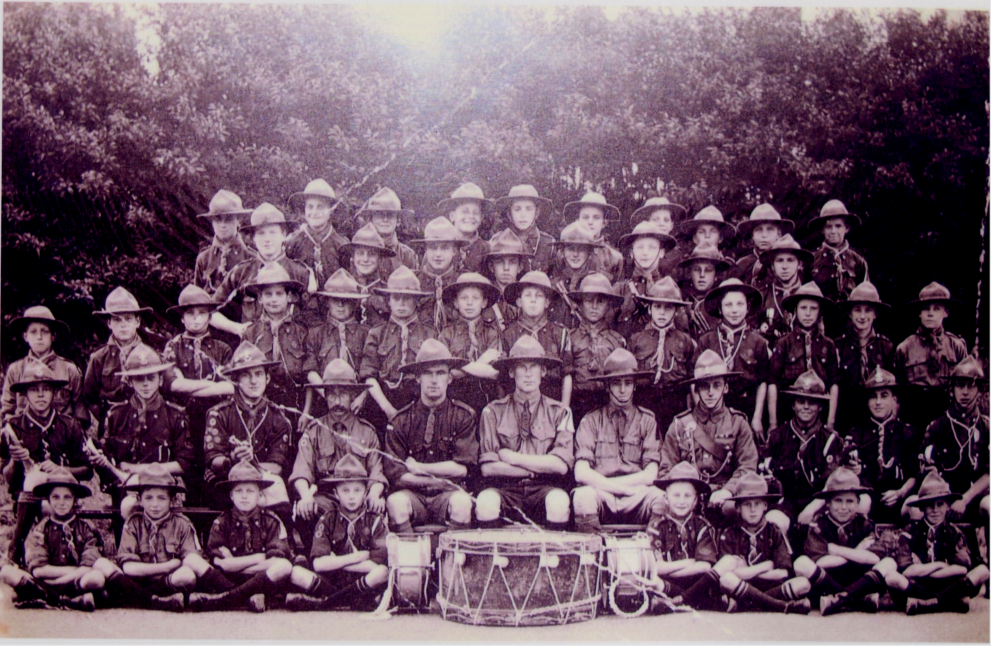
Left to Right

Row 5 (Back) | Frank Wood - Reg Woodcraft - Ron Divall - Cecil Rowe - Fred Crampton - Bert Hill -  Les Blake - Walter Button - Jim Broome - George Price
Row 4 | Don Cunningham - Bert Collip - Archie Green - Tom Button - Don Potts - Harold Taylor - Cyril Wood - Cecil Ward
Row 3 | Geoff Walker - Ernie Friffe (or Frippe) - Cyril Cunningham - Frank Winter - Cecil Vinall - Bill Turner - Bob Plass - Jack Hart - Archie Houghton - Lew Shonfield - Will Luxford - Bill Ward - Leon Piper - Bill Brown
Row 2 (Seated) | Bill Bentley - Pom Howard - Arthur Walsh - Gussy Ward - Vic Wood - Reverend Shepherd - Dennis Copper - Tom Taylor - Jack Strudwick - Bill Wood - Bill Walsh
Row 1 (Front) | Pat Gray - Ted Taylor - Albert Diplock - Gerald Harris - Don Harris - Stan Harris - Tom Baldwin - Reg Coppard

Tunbridge Wells District AGM
Monday 8 March 1920

At the AGM of the Tunbridge Wells Boy Scouts’ Association, it was reported that there were now 16 Troops and four Wolf Cub Packs. It was noted that a lack of Scoutmasters prevented the start up of more Troops. There was a keen interest in promoting football and cricket amongst Scouts since the District lamented the fact that there was no suitable field on which to hold these games.

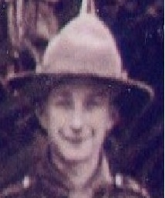  Leon Piper  1920 | Researchers note : In 1993, the late Miss Betty Harris kindly loaned us this remarkable photo for display at our Reunion - having been returned to her safekeeping after the event, we sadly only had a poor quality photocopy in our archives. However, since then Robin Boxall has found the same photo amongst Skip’s memorabilia.  In 1993, we were very fortunate that the late Leon Piper was able to put a name to every face – Leon had been a member of the Incorporated Church Scouts patrol in 1914 – and was still a Scout in 1920. | 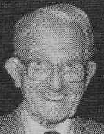  Leon Piper  1994

But we are uncertain regarding Ernie, second from the left in row 3. Was his surname Friffe or Frippe – do you know ?  Many of our 1920 Scouts’ surnames still exist in our village today. Are you related – if so, did they pass on any memories of their Scouting days in Rusthall ? | 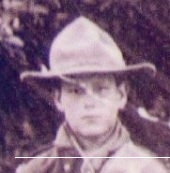

Scout Boxing Championship
The Opera House, Tunbridge Wells
Saturday 24 April 1920

The first Tunbridge Wells Boxing Championship took place at the Opera House as part of a larger Boxing Tournament.

Scouts competed in a 3-round event. It is not known whether Rusthall participated, only that scouts from St Barnabas’ and St Thomas’ Troops reached the final.

The event was thought to be so successful that it was proposed to introduce a special Scouts Silver Challenge Cup in the following year.

A Rusthall Troop Open Evening
Monday 17 May 1920
From Rusthall News, The Courier - 21 May 1920

On Monday the Rusthall Troop held an open evening and gave a varied programme showing some of the different departments of their work.

The Troop fell in at 6.30 and after marching past and saluting the Union Jack, they gave a smart exhibition of drill and physical exercises, under the direction of A.S.M. Victor Wood.

Proficiency badges were next presented by Miss Buckingham, Matron of the Homeopathic Hospital, to whom all Scouts in the town are much indebted for the Ambulance classes held during the winter.

S.M. Rev. H.M Shepherd gave a report of the work of the Troop, since it was inaugurated in August of last year. The first second class badges were won on February 17th and those boys then qualified to gain Proficiency Badges. Great keenness has been shown all round and the 35 boys in the Troop have won 106 in ten months. Patrol Leaders J. Strudwick, R. Walsh and R. Howard have won eight badges each, which gives great promise for the future.

Two examples of rescue and first aid work were then given under the direction of Instructor J.A.Ward. A broken leg was very successfully bandaged, and a dashing rescue effected from a burning hut ; artificial respiration was applied and the patients were removed to safer quarters to recover.

The evening’s entertainment was curtailed by rain but the final episode, entitled ‘The Diamond Thief’ was given, with A.S.M.Copper as leader of the party of prospectors. A tent was pitched, camp fire lighted, and the diamond stolen by thieves, while the sentry and party slept. The thieves however, were tracked and caught, and the whole Troop joined together in singing the Scout Song ‘Boy, Be Prepared’, round the camp fire, followed by the National Anthem.

Rusthall Troop Treks to Maidstone
to Attend Kent Scout Rally
Saturday 22 May 1920 to Monday 24 May 1920
From the Courier - 28 May 1920

BIG SCOUT RALLY AT MOTE PARK
Tunbridge Wells Association Well Represented

A big rally of all the Scouts of Kent was held at Mote Park, Maidstone, on Saturday, Sunday and Monday, by the generosity of Sir Marcus Samuel, the festival being in connection with the forthcoming International Jamboree to be held at Olympia, London.

The Troops and the Wolf Cubs from Tunbridge Wells and District mustered some 300 strong, and were under Mr. W.J. Wheatley, Assistant District Commissioner, and Mr Cecil E. Wheatley, Hon. Secretary of the Tunbridge Wells and District Association. The local Troops taking part in this county festival were St Barnabas’, under Mr C.E. Wheatley; Rusthall and representatives of St Peter’s Troop under the Rev. H.F.Shepherd; 1st Tonbridge, under Mr W. Hoath; 3rd Tonbridge under Mr G. Smith; Paddock Wood and Matfield under Mr F. Carden; Penshurst and Leigh, under the Rev W.E. Horsley; Chiddingstone Hoath; under Miss E. Millburn; St Thomas’, Southborough, under Mr G Aitkens. In addition, there were the Wolf Cubs. St Barnabas’ being under Miss A.M.Wheatley; 1st Tonbridge unde Miss W. Hoath; 3rd Tonbridge, under Mr R.G. Bennett. The Cubs of St Thomas’ and St Peter’s Southborough were also represented. The St Barnabas’ Troop, it is interesting to note, had the second largest contingent at the rally, numbering 58.

The Scouts went into camp on Saturday. Rusthall trekked the distance, while some of the St Barnabas’ Scouts went by car and some by rail. The majority of the other Troops journeyed by rail. The camping site was a fine one, with a wood close at hand, where fires could be lighted and all the cooking done. It was estimated that 1,500 Scouts were under canvas in the Park.

On Saturday the heats for the sports were run off, St Barnabas’ gaining two thirds and a second. On Sunday afternoon there was a big Scout’s Own followed by a march round Maidstone, in which 5,000 Scouts participated.

The morning of Whit Monday witnessed the final sports. St Barnabas’ did remarkably well in reaching the semi-final in the knot tying, being beaten by the Erith Troop.

At 2.30 there was a grand rally of over 7,000 Scouts. Each Troop’s flag-bearer was placed in a semi-circle facing the saluting base, and the Troops were drawn up some 300 yards in the rear under some trees. On the arrival of the Chief Scout, Sir Robert Baden-Powell, all the Troops ran up shouting their patrol cries behind their respective flags. The whole parade was drawn to the alert, the flag unfurled and the National Anthem played. The Chief Scout, in his address, said it was the biggest county rally that had ever been held. He decorated Mr J.Tassell, Assistant County Commissioner, with the Silver Wolf, the highest honour that could be conferred on a Scout, two Scouts for lifesaving, and the whole of the Isle of Sheppey Troop for their bravery during air raids. He afterwards inspected all ranks, and in the displays that followed the Chiddingstone Hoath Troop were successful in obtaining a certificate. This was awarded for an ambulance display.

It should be mentioned that the President of the County of Kent Boy Scout Council, the Most Hon the Marquis Camden, took the salute. The County Commissioner, Sir Samuel Waring Bart., was also among those present.

Formation of
the Rusthall Scouts’ Drum and Bugle Band
May / June 1920

The background to the formation of the Scouts’ Drum and Bugle Band is unclear – maybe some members had gained experience as buglers and / or drummers in the CLB / Church Scouts.

However, from local newspaper reports it is evident that the band was proficient and active by the beginning of June. An announcement was made in the ‘Scout Chat’ column of the Courier of 25th June that the band ‘had recently been formed in the Troop under the experienced instruction of Mr T Taylor, an old King’s Scout of many years service, who has recently taken a very keen interest in the Troop.’ Second C Ward was appointed Troop Bugler

Other news reports around the same time record that in early June, around 50 members of the Troop took part in a route march with the band ‘much to the satisfaction of all concerned’, and they subsequently participated in the Hospital Sunday Parade, when they were commended on their standard of marching.

Researchers’ note – However, a band does not become proficient overnight. Our account of 1919 states that “the once familiar marching band was again seen and heard on the streets of our village and further afield” – indicating that the ICSP or CLB had a band – rather than a “formation”, 1920 may have been its “reformation”.

Friendly Societies Hospital Sunday Church Parade
Sunday 6 June 1920
From Rusthall News, The Courier – 11 June 1920

On Sunday ideal weather favoured the Rusthall Hospital Parade.

The procession formed in the High Street at 5.15 p.m under the able marshalship of Bro. B.Pellet (Oddfellows), assisted by the Committee.

The procession was headed by the Veterans’ Band, followed which came the Borough Fire Brigade, the Oddfellows (with banner), the Boy Scouts (under Assist. S.M. V. Wood) with their bugles, the Town Band, the Equitable Society, the National Union of Railwaymen and banner, and the Buffaloes.

The procession arrived at the Church at 6.30 p.m. The service was choral, and the Vicar (Rev.T.G Gilling-Lax) preached an appropriate sermon, taking for his text part of the 19th and 20th verses of 6th Chapter, 1st Epistle to the Corinthians.

After the service the procession reformed and continued the parade in the same order to Mount Ephraim, returning by Bishop’s Down to the High Street, Rusthall.

The Chairman of the Committee, (Mr A. Pattenden),the Vice-Chairman (Mr A. Saunders), the Hon. Treasurer (Mr T. Taylor) and the Hon. Secretary (Mr G.W. Savage) are to be congratulated on the success of their efforts.

Did St Barnabas “take a dig” at St Paul ?
Friday 25 June 1920
From “Scout Chat”, The Courier – 25 June 1920

The Courier reported the formation of Rusthall’s band. However, a special contribution by the St Barnabas Troop put the following different point of view regarding Scout bands.

“For the benefit of enquirers generally, the troop wishes the fact to be known that it possesses all the necessary instruments for a full drum and fife band, but these are not at present used for two reasons. Firstly, it is the opinion of the troop that proficiency is by far the more to be desired than exhibiting itself as having boys who joined with the sole intention of looking pretty and nothing else. No ! Work and usefulness come first. Secondly, a really good band needs to be practicing for over a year before it is fit to be heard and the troop is at present too busy to waste time on band practice.”

Our Band Continues to Perform
Sunday 27 June 1920

At the end of June the band was again on parade as it led the Troop from the village to St Paul’s Church for a Children’s’ Service. According to an entry in the Rusthall News section of the Courier of 2nd July, this was followed by ‘a special service for the Scouts during which a number of new members were enrolled by the Scoutmaster, the Rev. H Shepherd. The St Barnabas Troop from Tunbridge Wells was also in attendance under Scoutmaster Wheatley’.

In view of their remarks regarding Scout bands in The Courier of the previous week, the presence of the St Barnabas Troop is of interest.

Summer Patrol Football Competition
June 1920

According to Scout Chat in the Courier of 25 June, ‘on recent evenings an inter-patrol football competition has been taking place. The Hippos who drew a bye in the first round, beat the Rhinos and qualified for the final. The Bulldogs and Buffaloes played a pointless draw and will have to replay their tie.’

Camp at Broadwater
Saturday 19 & Sunday 20 June 1920
From Scout Chat, The Courier – 25 June 1920

On Saturday last a good day was spent in Broadwater Forest and a good number camped out for the night. Six degrees of frost and the attentions of a nightjar a little disturbed the peacefulness of the camp, but all enjoyed the experience and hope to repeat it

Baden-Powell prepares for
the 1st World Scout Jamboree
From ‘Twenty-One Years of Scouting’ – published 1929

Although, under its Charter, the Boy Scouts AssociatIon Incorporated was unable to recognise as members any boys who were not of British birth and parentage, the Chief had always given the greatest encouragement and assistance to the Movement in other countries, and had made many tours of inspection of Scouts in other nations.

Interchange of correspondence and visits between Scouts of different nations had always been one of the ideals aimed at, and as early as 1909 British Scouts had camped abroad and had received return visits from Scouts of other nations.

It was not, however, until 1920, when the Movement had had time to settle down to a peace routine and stock was taken of it, that it was generally realised what an important international factor the Scouts were becoming.

On July 26th, 1916, the Committee of the Council of the Association had resolved “That an Imperial and International Jamboree shall be held in 1918 – provided the war is over in 1917”. Although this hope did not materialise, the preparations for the Jamboree went quietly on, and it was eventually decided that it should take place in August 1920 in order to allow time for those coming from afar to make their plans.

“It is my hope,” wrote the Chief Scout in his preliminary leaflet, “to bring together representatives of Scouts of the world in a demonstration which after the example of the North American Indians we call a Jamboree. I want to make this Jamboree an unique occasion as one to mark our appreciation of the restoration of peace towards which Scouts, past and present, have done their considerable bit ; and also to fulfil the objects given below. I want therefore to invite the support and help of all Commissioners and Scoutmasters to make the Jamboree a really outstanding success and a distinct step in the History of our Movement.

The objects of the Jamboree are :

1. To stimulate energy among the Troops.
2. To make our aims and methods better understood among educationists, parents, clergy, and the public.
3. To recruit Scoutmasters and workers.
4. To bring Overseas and foreign Scouts into closer touch with us.
5. To push forward our organisation in the densely populated industrial centres where moral and physical training is so badly needed for the boys.

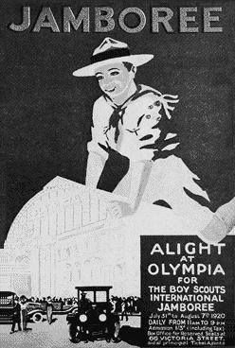 | It is for these objects that I venture to ask for your kind help and support.”  The Chief Scout supplied the inspiration and plans. Major Wade, home from the war, was appointed Organising Secretary, and a body of Directors of Departments formed the Management Committee. These Directors were appointed on the principle that everyone volunteering help was immediately given charge of a department, with more or less a free hand to organise it and appoint his own assistants. The organisation worked smoothly, and the whole thing was a triumph of team work.  Poster advertising the 1st World Scout Jamboree

The 1st World Scout Jamboree  Olympia – 29 July to 7 August 1920  From ‘Twenty-One Years of Scouting’ – published 1929 | 

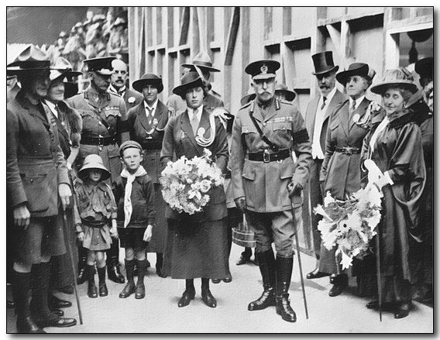  HRH The Duke of Connaught at the Opening Ceremony dress rehearsal.  Accompanied by Princess Mary, Princess Louise, The Chief Scout,  Lady Baden-Powell (Chief Guide), Peter (Chief Cub) and Heather (Chief Brownie).  From The Jamboree Book, 1920, Boy Scout Association | The Jamboree took place at Olympia, London, from July 29th to August 7th. Enthusiastic audiences crowded the immense building day after day to see Boy Scouts of all nations giving their performances in the Arena. Every kind of Scout work was demonstrated by Troops specially selected for their smartness and ability, and the finals were held of various competitions which had been organised throughout the country during the preceding year.  The Duke of Connaught, Princess Mary, and Princess Louise Duchess of Argyll were present at the opening performance, and every day for the duration of the Jamboree distinguished visitors filled the Royal Box.  Volumes could be published, and certainly at least one volume has, describing the happenings of that wonderful ten days ; but perhaps to most people the most impressive and moving spectacle was the March of the Nations which took place at the beginning of every performance, when the boys of twenty-seven countries, wearing the same uniform, but each with their distinctive flags, and giving their national Scout
“calls”, proceeded along the Arena to the music of their marching song, “Scouts of all the World”, written for the occasion by Mr Arthur Poyser.

The performers, ie those Troops which had been selected to give special displays in the Arena, were camped in Olympia itself, under their Commandant, Lord Hampton. Six thousand other Scouts were encamped in Richmond Old Deer Park, with the Rev E Digby in command. In spite of the worst possible weather on August Bank Holiday, when the camp was temporarily flooded out and the residents of Richmond were called upon to provide temporary hospitality, the whole camp was carried through without mishap and was accounted a triumph of “Scout spirit”. | 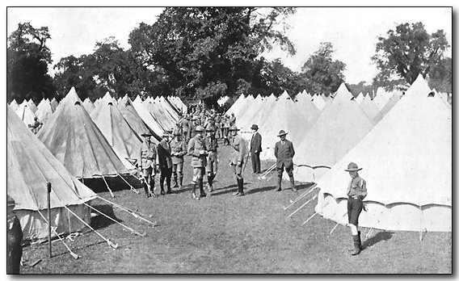  In the British Lines at Richmond Camp.  From The Jamboree Book, 1920, Boy Scout Association

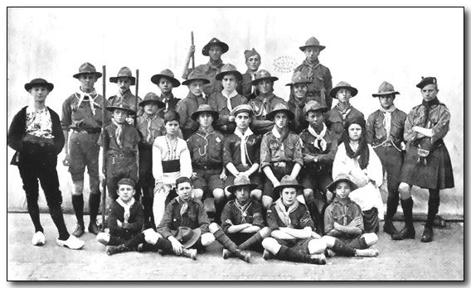  A Group Composed of All the Nations Represented at the Jamboree  From The Jamboree Book, 1920, Boy Scout Association | “In a camp that lasted over a fortnight and at one time had over six thousand Scouts in it”, wrote the Commandant afterwards, “there were only two disciplinary cases to be dealt with, both very minor offences. The real thing of the camp was the true Scout-like spirit shown by all ranks, and the wonderful friendships made. Boys who a fortnight before had never heard of each other parted with dimmed eyes, and though they may never meet again in this world will certainly never forget the brother Scout, often of another race and even colour, whose friendship was so precious for the few days of the Jamboree camp”.

As to the happenings in Olympia itself, it is difficult to say which special side of the Jamboree appealed most strongly to those present.

To some the “Howl of the Wolf Cubs”, carried out daily by five hundred small boys, was the most impressive.  To others the Sunday Service, when the Archbishop of York addressed some twelve thousand Scouts and six thousand public at Olympia amidst a silence when the proverbial pin might have been heard to drop, was an occasion never to be forgotten. “I can understand”, said his Lordship, “the feeling of the Chief Scout as he surveys the wonderful expansion of the Movement which thirteen years ago was hardly thought of. If the Scout spirit were to lay hold of the nations of the world I believe its face would be changed. When you go back to your homes, some of them across the seas, you must labour in harmony with your brother Scouts of all nations to form a band of brothers, all working strenuously with one magnificent goal in view – the peace among the nations of the world. You can and will do it. You are now a great power which can make for that peace. I exhort you to take this as your aim, the bringing in to existence of the peace of the world. | 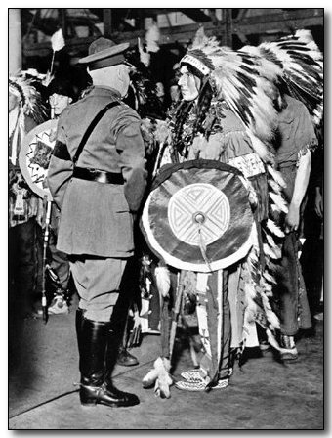  HRH The Duke of Connaught talks  with a Red Indian at Olympia.  From The Jamboree Book, 1920, Boy Scout Association

“This is my message to you, Boy Scouts. Keep the trust”.

Each day in the week which followed the Archbishop’s words seemed to emphasise their truth. Many different languages were spoken during that week in and around Olympia, but there was one language which stood out and was summed up by the Chief Scout as “Jamboreese”, the language of mutual understanding, give and take, and friendly brotherhood which existed between all these many and various nations ; a language which would have been impossible of attainment had it not been for the identical “Scout Law” which bound the boys with a common tie, and the uniform which turned them all into brothers, no matter what their race, religion or rank.

The displays in the Arena were illustrative of every branch of Scoutcraft, as carried out not only in England but other countries, while in the other part of the building Scout handicrafts of every kind were demonstrated on a larger scale and to a wider public than ever before.  The outstanding event of the whole Jamboree, however, and the occasion which had a definite effect on the whole future of the Scout Movement, took place, quite spontaneously and without any sort of previous rehearsal, on the Saturday evening at the final performance.  I cannot do better than quote the description of this published in the Headquarters Gazette by a writer at the time : | 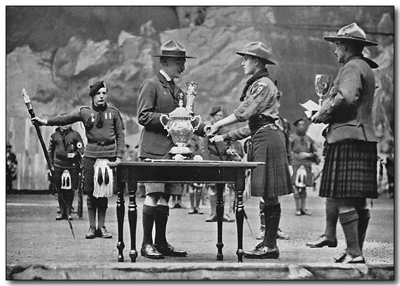  The Chief Scout Presenting the Darewski Challenge Cup to Scotland  for the Best Spectacular Display  From The Jamboree Book, 1920, Boy Scout Association

“The Jamboree came to a gorgeous end on Saturday night. In its closing phase, to the moment when the last Troop defiled from the Arena, this wonderful international Rally remained a brilliant spectacle, a symbol of youth triumphant, a promise of generations of men who should at last achieve that peace and goodwill on earth for which the best in all ages have striven. Enthusiasm, which had marked every stage of the proceedings during the week, grew in intensity as the hour for the breaking up of this vast assembly drew near. For a while the events followed a set programme. There were displays of physical drill, games, camp life, and so on ; the Cubs gave their final howl, and the last trek cart obstacle race took place.

“Then started the great pageant which was to culminate in Sir Robert Baden-Powell being proclaimed by all nations as Chief Scout of the World. Troops representing Britain and America approached from either end of the Arena. They were preceded respectively by ladies dressed symbolically as Britannia and Liberty, and bearing the flags of Britain and the United States. Approaching one another, they embraced, and then, mounting a dais, sat down on gilt chairs. A moment later and the distant sounds of martial music reached the ear. It became clearer and clearer. The tramp of many feet could be heard, and through the mountain pass there emerged the head of one of the most extraordinary processions ever seen. | 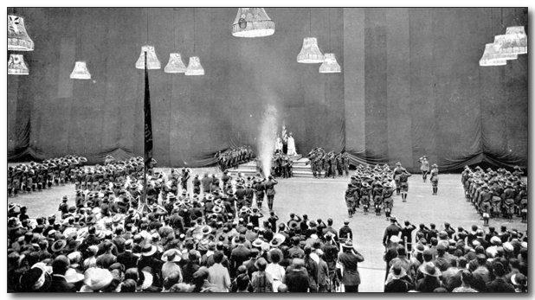  This picture was taken at the precise moment when the Chief was proclaimed  Chief Scout of All the World.  Note the "Pipe of Peace" burning in the centre.  From: The Jamboree Book, 1920, Boy Scout Association  Photo: Tella.

“The Scouts of all the world wended their way down, Troop upon Troop reached the Arena, deployed, and marched to their allotted places. Standard bearers at the head of each company carried the flag of the country represented and the green banner of the Scouts.

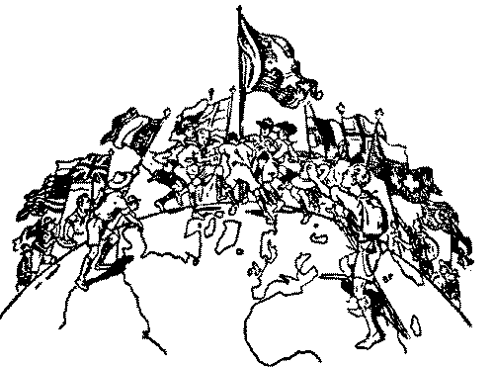  Scouts of the World – Brothers Together  From a drawing by Baden-Powell | “There were the familiar uniforms of the Troops of our own country and of the British Dominions, but there were also the striking dresses of the Scouts of France, Belgium, Esthonia, Greece, Holland, Luxemburg, Italy, Serbia, Siam, Spain, and Czechoslovakia, to mention but a few of the nationalities represented. Their costumes varied from the Red Indians of America, in their wonderful feather head-dress and vivid shawls, to the no less picturesque native dresses of the Balkans and the East, and of the Maoris. But khaki predominated, the loose-shirted uniform, with the Colonial hat, which has become so familiar since the hero of Mafeking launched his great scheme and people doubted to be amused or to take seriously these strangely clad boys, who began to appear among us. People do not laugh now. Much has happened in the thirteen years that have intervened, and a war-weary world is disposed to see in its youth the one great hope for the future.

“The Chief having taken the salute, approached Britannia and Liberty and in turn saluted them. Then in the serried ranks a movement was noticeable. The standard bearers were coming to the front. Separating themselves from their different units, they approached the centre of the Arena and formed an imposing avenue to the dais. The Chief Scout passed under this arch of flags to the stand. The flag of each nation was dipped as he went by in token of fealty. Turning round on the highest tier of the dais, Sir Robert faced the great gathering. For a moment there was an impressive silence, and then his voice rang out. Every word sounded like a clarion note, and reached the farthest corner of the building.

“ ‘Brother Scouts’, he said, ‘I ask you to make a solemn choice. Differences exist between the peoples of the world in thought and sentiment, just as they do in language and physique. The war has taught us that if one nation tries to impose its particular will upon others, cruel reaction is bound to follow. The Jamboree has taught us that if we exercise mutual forbearance and give and take, then there is sympathy and harmony. If it be your will, let us go forth from here fully determined that we will develop among ourselves and our boys that comradeship, through the world-wide spirit of the Scout brotherhood, so that we may help to develop peace and happiness in the world and goodwill among me. Brother Scouts, answer me. Will you join in this endeavour ?  “Like some strange echo which grew in intensity there came back a great shout of ‘Yes !’  “ ‘God speed you in your work’, replied Sir Robert, ‘and fare you well’. | 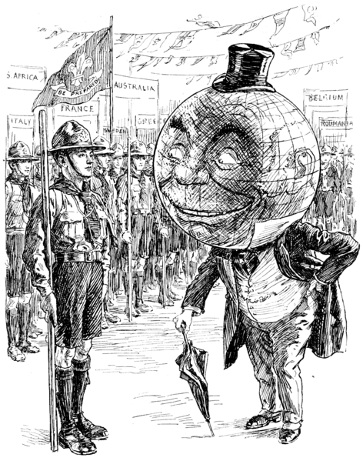  “I was nearly losing hope, but the sight of all you boys gives it back to me.”  (Cartoon in Punch magazine, 4 August 1920 – referring to the Jamboree in the context of the aftermath of World War I)

“Descending from the dais, the Chief stood at the salute, and the whole of the vast audience rose to their feet while the flags were dipped and a huge laurel wreath was hoisted on the flagstaff in memory of the Scouts of all nations who fell in the war. The band then struck up ‘Auld Lang Syne’. In an instant the British lads had clasped hands. Seeing what their brothers were doing, and realising that it was good, the Malay boys took up the chain. From them it quickly ran to the Scouts from Jamaica, and spread with lightning rapidity to all the boys in the Arena. Not stopping there, it passed on to the audience. Everywhere arms were linked as the sentiment of the song spread to every corner of the building.
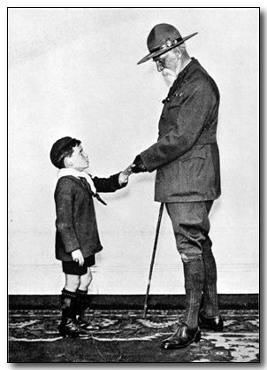  The Youngest Cub and the Oldest Scout at Olympia.  (Leslie McCreadle, aged 8, and the Earl of Meath, aged 80).  From The Jamboree Book, 1920, Boy Scout Association | “To this point there was much in the ceremony that could be attributed to splendid organisation. What followed was spontaneous. Sir Robert Baden=Powell returned to the Royal Box, when there broke out the thunder of cheering which swelled in volume with every second that passed. Louder and louder it grew, until it became a deafening roar. Caps and hats were being thrown into the air in an ever-ending succession. It was a truly extraordinary scene, and one that will live in the memory of all who were fortunate enough to witness it. The Chief returned to the Arena, but in a moment he was swallowed up in the sea of excited boyhood. He disappeared from view, and the next moment reappeared perched on the shoulders of some strong fellows in the centre of a surging throng. By degrees he was borne nearer the side of the Arena. One supreme effort and he was free to climb up the tiers of seats till he could again reach the Royal Box. In the Arena it was still pandemonium. A roar as of thunder filled the whole building, but on a single bugle note it at once subsided.  “The Jamboree was over. With all the excitement of the last day there was a note of sadness in it. Good-byes had to be taken, promises to write were exchanged again and again, and on all hands was heard the one fixed hope that there would be another Jamboree soon”.

So ended a great epoch in the Scout Movement, only to open up a still greater epoch, when Sir Robert Baden-Powell as Chief Scout not merely of the boys of the British Empire but of the whole world should see the work under his hand grow to greater dimensions than he in his most optimistic moments could ever have foreseen.

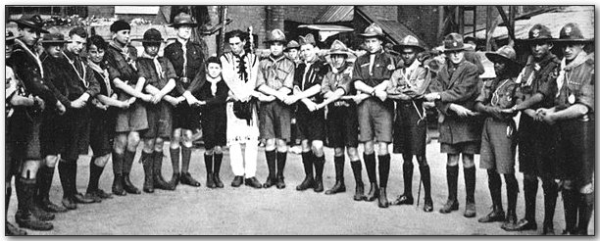
Scouts join together in Friendship at the Close of the 1st World Jamboree.

Our lads took part
From “Scout News”, The Courier - 6 August 1920

Local Scouts at the Jamboree

In connection with the Jamboree, which is being held at the Olympia, where scouts of all nationalities are assembled, a despatch race was organised to take place on August Bank Holiday.

There were six different ‘Ways’ and some of the local troops took part in carrying the despatch along the ‘Norman Way’, viz:. from Hastings to Olympia.

The despatch left Hastings at 10am and was conveyed to Lamberhurst by various Sussex Troops, the Wadhust Troop handing it to a scout from the Rusthall Troop there. Two scouts on bicycles from each troop took part and they were stationed in relays. The Rusthall scouts took it from Lamberhurst to Pembury, the St Barnabas Troop, Tunbridge Wells, from Pembury to Tonbridge (top of Pembury Road over the tunnel).

The distance from Lamberhurst was 9 3/5th miles and the cyclists did this in 29 minutes. From Pembury onwards, scouts were stationed at the branch roads to keep back the traffic. From the top of Pembury Road, Tonbridge, the despatch was taken through Hildenborough to the fountain at Sevenoaks, Tonbridge scouts, a distance of 8 1/2miles in 38 minutes. Considering the hills the scouts had to climb, this was marvellous going, the average speed being about 18 miles an hour. Nowhere on the route did the cyclist walk with the despatch. Each despatch carrier had another cyclist scout with him in case of puncture etc.

When the results were known, Kent came second in the country with an average speed of 17 miles per hour.

Members of the local troops have been to the Olympia this week to see the Jamboree.

Camp and Rally at Paddock Wood
Late August 1920

Rusthall Scouts camped at Mascalls, Paddock Wood and, on Saturday 28 August, they joined Scouts from Paddock Wood, East Peckham and Hadlow Troops in a rally held on the site.

Rusthall presented a number of Scouting Sketches and the Hadlow Scouts gave a demonstration of Indian Club drill. There were a number of games and competitions, some of which must have had a monetary prize, as it was reported that Rusthall benefitted by over £4.

Death of Captain G.L.Dunn
Organiser of
the Scout Movement in Tunbridge Wells and District Commissioner
September 1920

The Courier of 1st October 1920 carried the announcement of the death and funeral of Captain G.L Dunn who as credited as being the first to organise and promote the Boy Scout Movement in Tunbridge Wells.

He was instrumental in forming a large Troop known as the Pioneers and was later associated with the ‘De L’Isle and Dudley’s Own’ Troop, Speldhurst.

He served as District Scoutmaster and District Commissioner and was a recipient of the Silver Wolf.

His Scouting was interrupted by war ervice in 1914 but he returned to Scouting in December 1919, although still a serving army officer.

His funeral was accorded both Military and Scout Honours and a large contingent of Scouts were present. Buglers of the Rusthall Troop under Scoutmaster Rev HF Shepherd, were lined up ready to sound the Last post at the interment.

Scout Movement Milestones - 1920

July | First International Scout Conference and World Jamboree, Olympia, London.
August | B-P acclaimed Chief Scout of the World.

Click HERE if you have any further information regarding this year
or
HERE to return to our Navigation page



