Scouting in Rusthall
1933

“Show me a poorly uniformed troop and I’ll show you a poorly uniformed leader”

Lord Robert Baden-Powell
(1857 to 1941)

? | We are seeking :  - Further events that occurred this year.  - Copies of the St Paul’s Parish Church Parish Magazine for this year.  - Copies of the Kent & Sussex Courier for this year.  - Any knowledge that you may have of this year.

Can you help ? Please click HERE if you can

A new Tenderfoot

We have, in our archives, a pristine, but undated Tenderfoot Test Card, issued to Laurence Foster of the 1st Rusthall Troop. At the time he was living at 13 Ashley Park Road, Rusthall.  The card is not designed to record the dates on which Laurie attained the various standards for the award of his Tenderfoot Badge, but does detail what those requirements were. Summarised, these were as follows :  Test No 1 - Know the Scout Law and Promise and understand their meanings.  Test No 2 - Know the Signs and salutes.  Test No 3 - Know the composition and history of, and how to fly, the Union Jack.  Test No 4 - Certain uses of the Scout Staff.  Test No 5 - Know the following Knots.  Test No 6 - Know how to whip the end of a rope. | 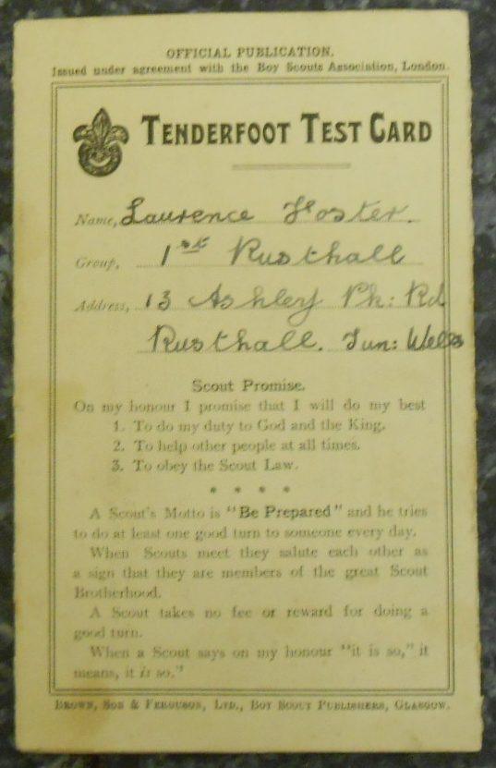

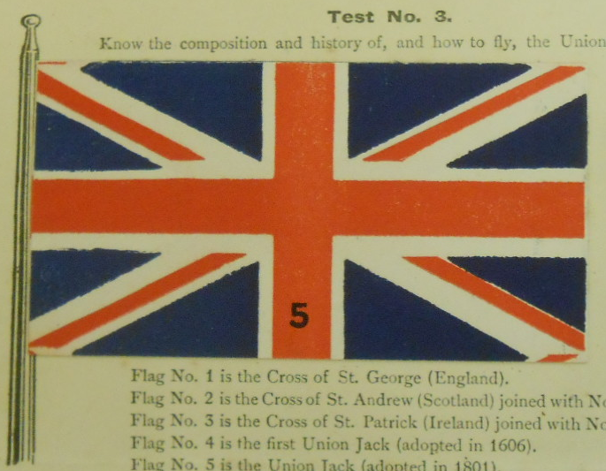  Some extracts of Laurie’s  Tenderfoot Test Card | 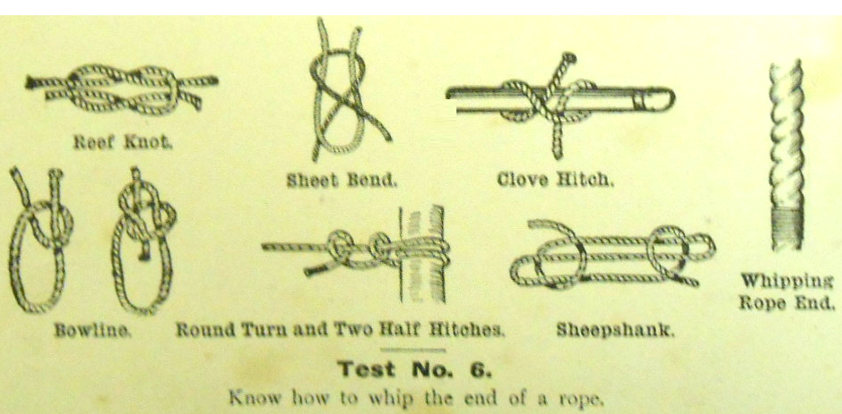 | 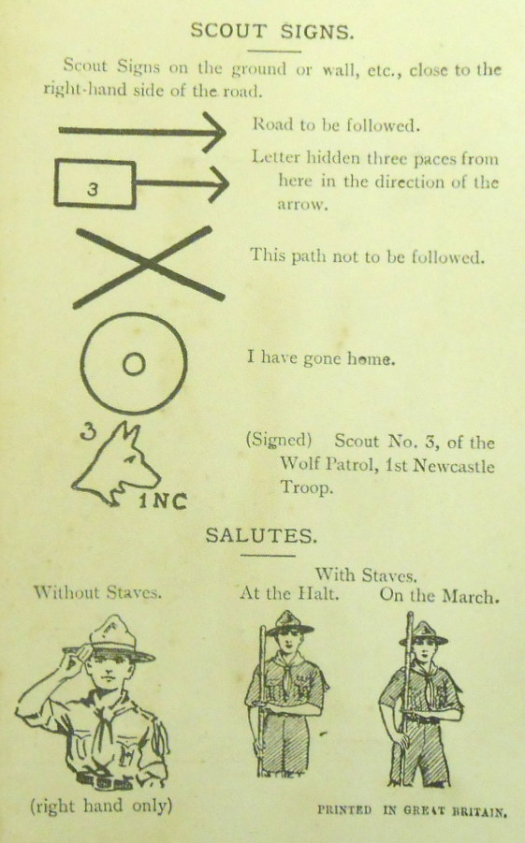

At present we do not know whether or not, prior to this, Laurie had the good fortune to be a Wolf Cub in the charge of Miss Brankston. But we do know that Scouting was a major influence throughout his long life. Beyond his days as a Boy Scout, Laurie was a Rover Scout in Rusthall and served the Troop as both an Assistant Scoutmaster and Scoutmaster. When his career in the Probation Service took him elsewhere, he continued to benefit at least one other Group – the 79/126 Derby (Centaurs) Scout Group.

Born on 4 May 1922 and, from our knowledge of his life, it is reasonable to assume that he was keen to become a Boy Scout as soon as possible – and that he did so when he attained 11 years of age in 1933.

However, our assumptions are made less uncertain by his photograph album (which is also in our safekeeping) is entitled “Rusthall Scouts 1933 to 1950” – indicating that he respectively enrolled and left the Troop in those years.

The nature of Laurie’s subsequent career in the Probation Service leads us to believe that, had he known that he and his memorabilia would be so important to our History, he would have noted the dates of his photos, some of which are below. Hopefully, in time, we will be able to put some names to the faces.

Photos to be inserted

Laurie died in York on 24 May 1913, at 91 years of age.

Ray Latter attends
the 4th World Jamboree
Godollo, Hungary

25,792 Scouts gather in camp.  The Jamboree daily paper was printed in Hungarian, English, French and German, with contributions in other languages.  The unofficial language was "Jamboreese", which consisted mostly of signs emphasized by a happy smile. Each foreign contingent was provided with a "cousin", a local Scout who could help them with the Hungarian language.  Air Scouts participated for the first time. |  | 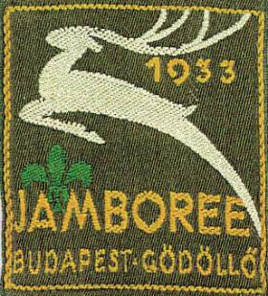
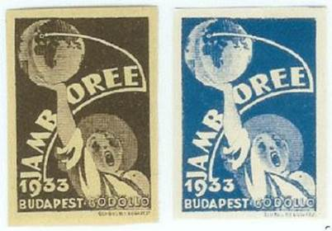 | The jamboree heralded the first issue of commemorative Scout stamps.  The Jamboree badge - the white stag of Hungary.  BP said, "You may look on that white stag as the pure spirit of Scouting, springing forward and upward, ever leading you onward and upward, to leap over difficulties, to face new adventures”.

Transcript of Ray Latter’s log book of
the 4th World Jamboree

August 2nd to 16th, 1933

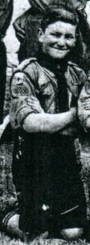 | The journey to Godollo from Tunbridge Wells started from Tunbridge Wells Central at 2.55pm on July 30th. We got on the Dover train at Tonbridge and arrived at Dover at 5.20. We went to “The Sailors’ Bethel” for a good tea. We went onto Dover Station at 6.40. Here Mr Franks, who had travelled down with us, left us. We waited on the station for an hour and a half. At last we made a move and, after drawing a box of rations, we embarked.  The boat left at 8.30. It was a special for Scouts only, and was fairly crowded. We soon left Dover astern, and within an hour were in sight of Calais. Soon we were out of sight of all land. It was getting dark, and very chilly. I found a warm spot against the wall of the engine room, and stopped there for one and a half hours. Soon came in sight of the lights of Belgium. Saw Ostend, a blaze of lights. Passed the buoys and lighthouses, finally docked at 10.10, after turning and manoeuvring into position.  After disembarking we waited for several minutes in the yard. We then went straight through to the train. There were two there, the White and the Blue. We went on the last, the Blue. I was in the fourth from last compartment, in the next to last carriage, the last being the guard’s van. We left at 12.50 for our journey across the continent.

The train was German, containing fifteen carriages. At each end of the carriage was a WC and a wash room. There were two powerful looking locos, probably German. A corridor ran the whole length of the train. The compartments seated eight persons, the seats were of wood, and rather uncomfortable. The luggage racks were quite wide, and strong enough to sleep on. There were small card tables fitted under the windows. We were seven in a carriage. For sleeping this was just enough. One on each rack, one on each seat, one on the floor and one in the corridor with the kit.

We turned in soon after boarding the train. Passed through much of Belgium at night. Passed Bruges at 1.20, Ghent at 1.55, Ans at 4.25. Liege at 4.32. Crossed the Meuse at 4.55. I had a few hours sleep that night, and got up and washed at 5.15am. (The soft-soap in the washroom was not exactly sweet smelling and could be smelt for hours afterwards.) The countryside was very like England so far, except for the absence of hedges. The country now became hilly, small rounded hills, densely wooded, several tunnels on the line.

We now entered the manufacturing area, extensive factories were dotted along the line, some were scent factories. Came into Herbastahl, still in Belgium I think. Crossed the German border, soon afterwards reached Aachan, where we had to wait for the signal. There was a military camp nearby, for we saw a detachment of men in grey-blue marching, and parts of guns being unloaded from a train. Passed in to the country, wheat and grazing fields around, with still a few tall chimneys. Went straight through XXXXXXX (Sarendot ?) , a large junction at 7am. The train was behind the scheduled time.

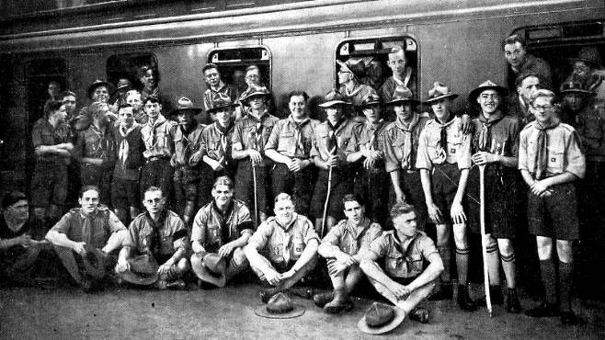  A party of Scouts en route to Godollo | Came into Koln (Cologne) at 7.30. Here we were greeted by a party of Hitler’s “Nazi Youth League”. We were conducted to the station restaurant, where we had breakfast of coffee and rolls. We were obliged to wait for our train to shunt. Meanwhile we were entertained by them singing national songs. We replied with some of ours. Some of us swapped our badges for Nazi badges. We had a send-off from them as the train steamed out. I took a photo of a group, but unfortunately it did not come out. We left at 8.50. Soon left the town and came into the country. It was about the same.

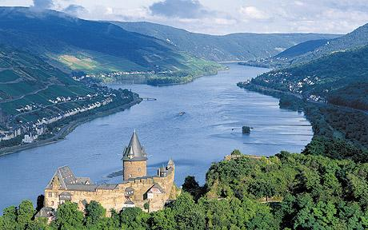  The Rhine Gorge | The sky was cloudy, with occasional bright periods. We now came to the most picturesque part of our journey, the beautiful Rhine Gorge. The country had been fairly flat for several miles each side, but it narrowed down until the hills were about half a mile away. It gradually narrowed down until the hills rose sheer from the river on each side. The ranges of hills now became separate hills, surmounted usually by a ruined castle. The steep sides were densely wooded. In many parts they had been cleared and terraced, and the vine is grown there.

In parts it was so narrow that the road was running right along the bank, with the railway only a few feet away, then a steep slope. Usually traffic on the river, pleasure steamers, barges, etc. We were amazed at the places where the ground was cultivated steep slopes that we should have thought quite impossible to be used. Not a square yard of land that could be cultivated was wasted.

In the river were long thin islands at places. One we noted was the famous island where the Bishop (I forget his name) was eaten alive by rats. The Gorge widened out a bit, wheat grown on both sides.

Arrived in Koblenz-Lutzel at 10.1i5 and at Koblenz 10.17. We had left the river a short way back, but we joined it again at Konigsbacher at 10.30. Here we noted that the peasants were poorer. All the family were working in the fields. The men cut the corn with peculiar scythes, like a rake, but with a scythe knife at the bottom, so that it could be cut and stacked in one movement.

Went through Spay at 10.35. Orchards and cornfields on the banks, with the hills further back. We noted that there were many parties of cycle campers along the road. On top of one of the biggest hills there was a big stone statue. I do not know what it represented. It was a figure of a man, with his arm outstretched. Bullocks used as beasts of burden. The gorge widens again, this is the exit, the railway leaves the river and road. Came to Mainz-Hombach at 11.45,

Mainz 12.15, the land was very flat for a long way on either side. Came to Frankfurt where we received a packed lunch. This contained two hard boiled eggs, one slab of cheese, two rolls, a banana and a bottle of Rosebacher. We thought this was lemonade, but it turned out to be a rather nasty soda-water. Most of it found its way on to the railway track. We were greeted, as at Koln, by “Youth Serguers”. Swapping was again in great progress.  Departed at 1.40 after staying 25 minutes. I missed the next part, as I went to sleep. | 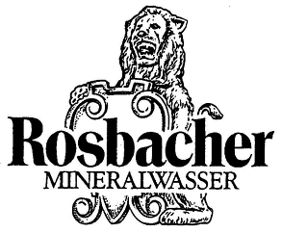

Arrived at Wurzburg at 4.10. Left after a 5 minute stop. Weather fine and hot.

Reached Nurnburg at 6.10, not a very big town. Shifted all my kit into the guards van. Turned in at 9pm. We had quite a fuss as we crossed the border. Nazis swarmed aboard, distributing flags and tokens, and decorating the train. The idea was that we might pass through Austria like it, waving flags (it was propaganda to further the Nazi movement in Austria, but it was foiled – all the flags were collected and destroyed).

I was awakened next by the train stopping. I got up in a hurry and found that we were across the border. Young girls in native dress were distributing plums, heart-shaped biscuits and other tokens. I wanted to keep my biscuit, but someone ate it for me. As we left the station a brass band blared forth, and cheers rang out, a truly warm welcome in to Hungary.

I discovered that I had seen none of Austria. We had passed right through it in the night.

Came into another large town and received the same welcome. We noticed several differences between the land there and what we had seen. There were no hedges anywhere, the railway was open to the land on both sides, the rails for miles were dead straight and flat. The peasant boys had their heads shaven close. As the train passed a guard’s house he would come out and stand alert, saluting with his flag until the train had passed.

We stopped for grub at a station. A mug of coffee, two rolls and butter, a horseshoe of bread and three peaches. Land flat with hills in the distance, the weather was sunny. Every Hungarian seems to welcome us. So far we had seen very few motors. Huge quarry on the left, limestone, with aerial ropeways going up to it. Since I got up I had been ion the little observation car in the rear of the train, it was quite nice there.

Saw the Danube for the first time at 9.30. (It is now “blue” as the song says, but quite as brown as the Thames.)

There are no platforms, except in big towns. A passenger crossed the lines to the train. Land in waves until Budapest. Departed after a short wait.

Arrival

Arrived in Godollo at 12.15. Dumped our kit in a heap to be brought up by lorry. Marched up to our camp site in a procession headed by a band. The route was lined with cheering Scouts.

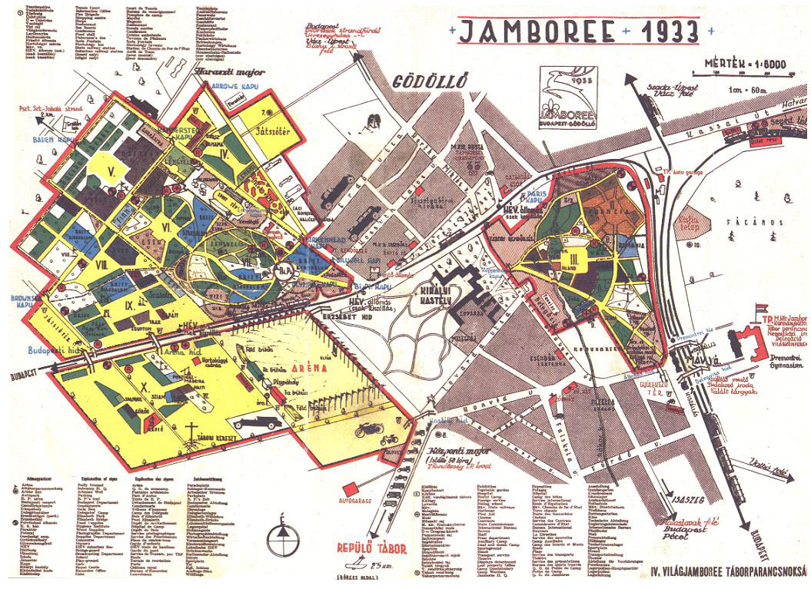

Camp

We had a rest after our arrival, the cook patrol got on with the kitchen. We discovered that our poles for the tepees had not arrived. Had lunch of gulash (tinned chunks of meat in a red sauce). Had a walk round the shopping centre, and changed all my English money, and spent it all. Dinner of stewed veal and French beans and water. Still no tent poles. Moved our kit into the GHQ, and slept there. Turned in 9.30

Wednesday

Woke again at 6.30. Shifted kit back to camp. Washed etc. Brekker at 7.30. Parade for prayers and flagbreak at 8.30. Marched to the General Thanksgiving service on the Sports Grounds. Lasted about an hour.

Came back to lunch, ham, bread and apples, at 12.30.

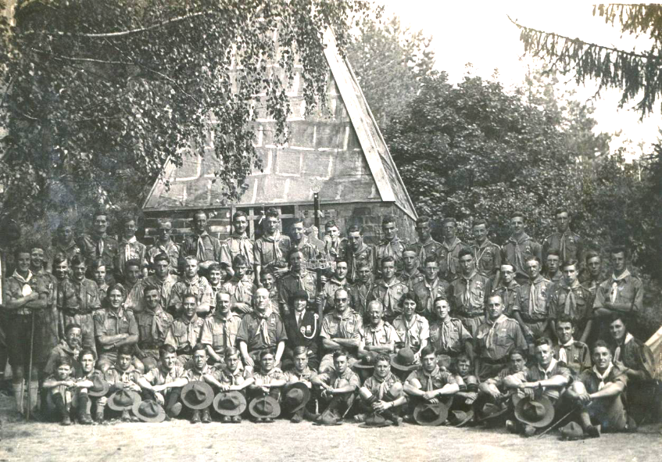
The Kent Contingent

Rest hour until we received a sarcastic note in verse from Major Hooker, at the Divisional HQ, about our tent. We wrote an equal good note in reply, and handed it to him with due ceremony. Sharwood in front with his hunting horn, followed by Hobbs with the note on the end of a long pole, with banners and flags. We did not get a reply to it however.

After rest hour we paraded for the Opening Ceremony. After much waiting we formed up in sub-camps for the march past. As we passed the Chief and the Regent we cheered instead of the usual “eyes right”. The whole column took about two hours to march past (according to the press report).  When we were all assembled again we rushed forward in two great waves, surging inwards towards the Chief’s stand. The sight must have been very impressive seen from the air. After a storm of cheering we broke away, and assembled on the other side of the arena, to march back. | 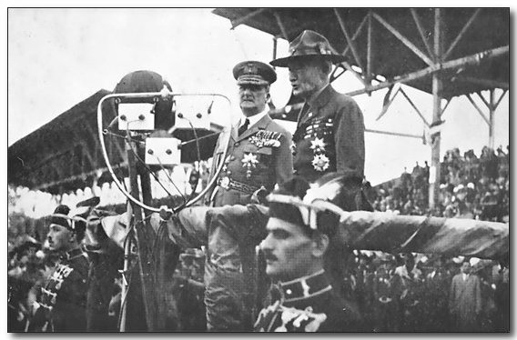  Admiral Horthy and Lord Baden-Powell open the Jamboree

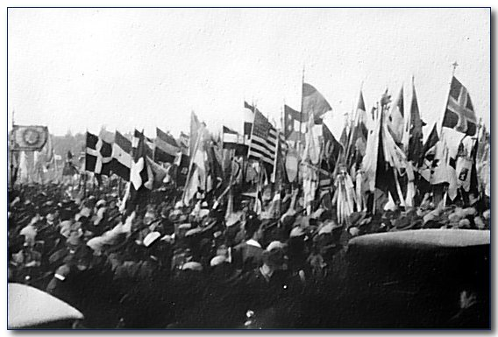  The “Grand Rush” at the Opening Ceremony | Dinner at 7.00. Still no tent poles.  Went to the sub-camp camp fire. Had great difficulty in finding it. National dances by Ceylon and Poland, it was quite a good show.  When we got back the poles had arrived. The Rovers put up the tents while we sat in the kitchen, listening to yarns by Mr White.  Turned in at 11.00pm.

Thursday

Turned out at 7.15. Brekker 7.45. Inspection at 9.15, flag break and prayers at 9.30 at DHQ. There was to be a rehearsal of the pageant, but it was cancelled. I spent the morning in the shopping centre.

Lunch, gulash (phonetic spelling), rye bread and apples. Rest hour 1.00 to 2.39.

Spent the afternoon looking round. Ta, mug of tea at 5.00. Went to see the Sports Ground display, left after a short time. Dinner at 7.30. Turned in at 9.30 after a mug of cocoa.

Friday

Got up early, 5.15, quick wash. Our patrol was on cooks duty. Helped cook the breakfast, sausages, bread and butter, and milk. We started to wash up, but had to leave it half way thro’ to parade for the excursion.

Excursion to Budapest  Started from camp at 1.00. Caught the electric train at 1.30. The journey took about an hour. We embarked in the lorries at the Jamboree Budapest HQ (14 in number, we are on the last).  Crossed the river from Pest into Buda. Under the Hill St Gellert, upon which there stands a monument, facing the river, to Bishop St Gellert, who suffered martyrdom in that place 900 years before. At the foot of the hill there are curative springs, the hill is illuminated at night. There is, as well a bath, built in Turkish times.  We next ascend the castle hill, to enjoy a view of Budapest from the Royal Terraces. We were, however, forbidden to take photographs of them. | 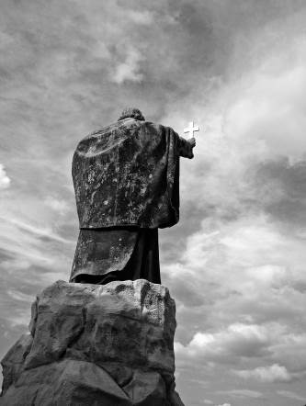  The statue of  Bishop St Gellert

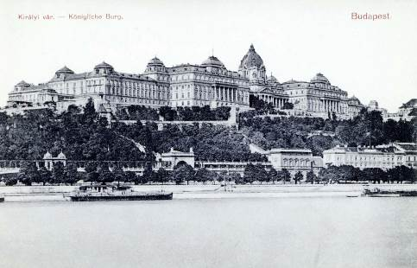  The Royal Palace | We went in the Royal Palace, where the right hand of St Stephen, the first King of Hungary, is preserved. It was a marvellous place. We saw the best of the eight hundred and fifty rooms. They contained pictures and tapestries worth thousands of pounds. There were gorgeous chandeliers measuring six feet in diameter, and about twelve in height. Tapestries, denoting early scenes in Hungarian history and pictures of Kings and Queens of Hungary adorned the walls. The whole building was grand and imposing. The place was unoccupied, but the Regent sometimes lives there.

We went from this to the Coronation Church, in whose crypt are the tombs of the monarchs. There were tombs opened for future rulers.

We embarked on the lorries and crossed the river into Pest. We had a bathe in some baths, not very nice.

We went straight to the restaurant. For lunch we had soup, with a lump of sage stuffing in it, roast pork in a concoction of French beans, onions, potatoes and other things, and two apricots surrounded with dough and fried. On the whole a rather queer dinner.

One thing that struck me was the absence of traffic, there were no traffic jams, hardly any more traffic than in Tunbridge Wells on Saturday night.

We visited the Houses of Parliament after lunch. It is very like Westminster inside. There are two chambers. Each is like an amphitheatre, with the clerks desks in the centre, the President’s and other desks at one end, and the other seats grouped round. In the Parliamentary bar I had a tot of red Tokai wine, it was lovely. We spent quite a long time in here wandering round.

We rejoined the buses and made for the Millennial Monument, surrounded by museums and historic buildings. In the background is the park. We walked through this to Angel Park, an amusement park like “Dreamland” at Margate. We purchased a set of tickets for everything. For the next hour we thoroughly enjoyed ourselves. We were just leaving when one boy found he had lost his sheaf-knife. We asked around to try to find it, but were unsuccessful. We came out by a different gate to the one we went in, and lost ourselves in the park.

The lorries were timed to leave at 7.45, and it was then 7.50. At last, after taking some wrong paths, we came to the monument, too late. The buses had departed ten minutes before, it was 8.15. We were wondering what to do, we had 1 pengo 30 filler between three of us (worth about 1/3). We had no return tickets. We thought the best thing to do was to take the train as far as our money would allow, and hike the rest. However, we asked the way to the station and a gentleman offered to take us there. He could not speak English, but spoke French well. When he saw that we had not enough money for our fare he paid it for us. We asked for his address, but he would not give it to us. He promised to visit us in camp on Monday, but we did not see him. He was a real gentleman.  When we got back to camp we tidied it up and finished washing-up.  The others went on a night trip up the Danube, to see Budapest floodlit. We were very sorry to have missed it, it must have been a wonderful sight. | 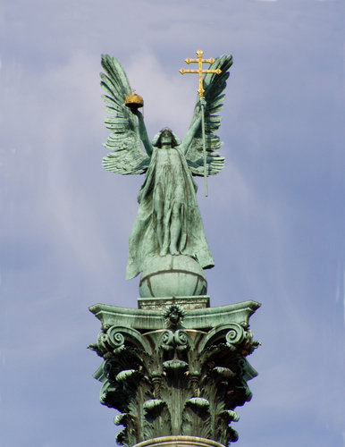  The Millennium Monument

Saturday

I was rather tired after yesterday’s hard day. I got up at 7.30. Breakfast at 8.00.

In the morning we had a rehearsal for the pageant. Things did not go at all well, and we were doubtful about its success.

Lunch at 12.30. Bread and butter, lettuce, tomato and green paprika.

On Saturday the inhabitants of Godollo showed their great joy and appreciation for our visit, they marched past in full force, past the Regent and BP. Forty five thousand people marched across the arena, carrying flowers and fruit which they took to the box occupied by BP. The (indecipherable) fire brigade, young men and maidens in national costume, the town authorities, war veterans and all the other inhabitants of Godollo all came to pay tribute to Scouting. The arena was crowded.

All the rest of the day I stayed in camp and washed some of my clothes. One boy undertook to do some washing for the camp. I am afraid he did not know much about laundry work, for he put two pairs of blue socks, the drying cloths, a shirt, a towel and two lanyards all into one Dixie and boiled them up. Then he went out and forgot them. When we discovered it we took it off. The result was rather amusing, the socks had shrunk, the teacloths, the shirt and the towel were died a light blue. The lanyards were also affected, one was blue, and the other was somewhere between blue and khaki.

Dinner at 7.30.

Turned in fairly early as I was tired.

Sunday

I got up rather late, 7.45. Breakfast at 8.15. Eggs, bread and butter, and cubes of jam.

The public were admitted at 9.00, so we had to get into uniform then. It was very hot, one day it was 102 degrees in the shade.

After lunch we presented our pageant, “The Landing of the Romans”. We marched past first, and then began the show at about 5.00. We got well into our stride, and the show was a great success. A movie of it was taken from the microphone box. Three photographers insisted upon hiding behind the sacrificial altar, and it was very hard to get them out of the way.

BP was to be present, but I did see him.

After the show we went back to dinner

Looked round the camp. Turned in at 9.30.

Monday

Got up 7.30. Breakfast at 8.00. Prayers and inspection.

The time of prayers had been previously altered to 10.30, instead of 9.30. Inspection was therefore at 10.00. Major Hooker announced at prayers that the hiking competition would not take place, but as our team was very keen for a hike, Stanley White arranged one, into the hills. An account of it appeared in the “Magyar Cserkesz”, the camp newspaper, written by one of our fellows.  They started off at 2.30 after a light luncheon of lettuce, tomato, bread and butter. Sausage was served out to us, but this was absolutely inedible. There were three sausages, each about nine inches long, and about two inches in diameter. They had a tough skin on them, and were well poached and tied up with tape. We cut the top off one, but the smell was enough to convince us that we should die soon after if we ate it.  I stayed in the kitchen all the afternoon, so I did not trouble to change into uniform. | 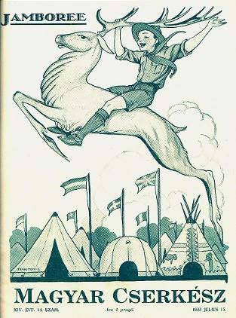  The Jamboree newspaper

I was acting PL of the Peewits, as both PL and Second were away

Turned in about 10.00.

Tuesday

Got up 6.15, washed and lighted the fire. Our patrol was on cooks duty. Breakfast at 7.45. Scrambled eggs (everybody said it was jolly good), bread and butter, jam and tea. The tea is queer-tasting stuff, not like the tea at home.

We had to stop in camp all the morning to prepare the vegetables for dinner. Lunch was at the usual time. Ham, bread and tinned paprika (preserved paprika, stuffed with meat and sweet corn, in a red sauce). The food had various effects upon people, some it made bilious, others had to get an antidote from the hospital for dysentery, others needed laxative medicine. It took hardly an effect upon me. Stayed in the kitchen to tidy up, etc .

At 3.45 we paraded for a Grand Rally to bid farewell to the Chief who was having to go on a tour of the Northern Parts. We formed up as at the opening ceremony. We had a light shower at 4.30. We went back for our raincoats. After giving us a very fine address, he left in his car. We were suddenly pushed out of the way by Rovers, then a car came. This was BP’s car. It came right past me, within six inches of me. It was all over at 6.45.  We assembled at the High Altar to go by lorry to Budapest. It was a very bumpy ride, they were army lorries. | 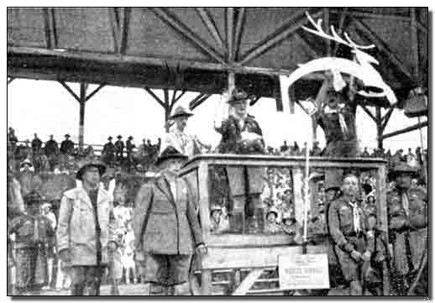  Baden-Powell’s farewell

We went to Angel Park where we dined in the café. We had the usual dinner. When we called for more drink we were all served out with beer by mistake (nearly everyone drank it). We also had free tickets for various shows.

We rejoined the lorries at 12.15 and eventually arrived home at 2.15.

We were glad to get to bed. However, we did not sleep long, we had to turn out again at 5.00am

Wednesday

Had to turn out at 5.00. After a hurried breakfast we rushed down to the station to catch a train. We were going on a 2-day excursion to a town over the Austrian border, Sopron (pronounced Shupron).

We finally arrived there at 11.30. We were amazed by the welcome that they gave us, native-costumed maidens strewing the street before us with flowers, flowers thrown to us. We marched up to the Town Hall where we were greeted by the Mayor. The leader of each section gave us a speech (there seemed to be at least tw dozen contingents). By the time it was over we were sick of speeches, after listening for only an hour.

Small Scout-Guides led us to our dining place. I had a very good place. There was a man and wife, daughter and two sons, all could speak English a little. Lunch consisted of cauliflower soup, beans, potatoes and fried chicken (egg and crumbed and fried). Then apricot rolled in dough and fried.

After dinner we were given our tea, packed, and a lovely bunch of carnations. There were two of us at this house, Collins and myself.

After lunch a coach took us to the wonderful limestone caves in the district. From there we hiked several miles to a bathing pool. We had to undress up in the forest. I was tired of carrying my bunch of flowers, so, for want of something better to do with them, I presented it to a policeman. He was very pleased with them, and went off carrying them, like a bride.

We went back to the Town Hall, and a party of us went up.

Dinner was at a restaurant. The usual dinner, soup, meat and sweets. To supplement this we ordered drinks, but, when I offered to pay for them, the proprietor, a gentleman about five feet in circumference, insisted that we should have them free.

After dinner we were conducted to our sleeping quarters. These were in the officers’ quarters in a military college. The camp fire was held on the cinders of the sports ground. The beds were mattresses on the floor, supplied with blankets and sheets. All of us very dead tired.

Thursday

We were awakened at 6.15 (I went to sleep again). For washing we had to go to a separate building, and wash under a shower. Breakfast, packed in bags, was provided. The best part was the bottle of milk.

The officers allowed us to do what we pleased until lunch-time, 1 o’clock. Four of us wandered around the town until 12.00, then went to the station restaurant, and played a form of skittles until lunch was ready. The sun was very hot, the shade temperature being 94 degrees F. We placed a wreath on the war memorial while at Sopron. After collecting our kit we were all assembled and marched to the station. Our send-off was as cordial as our welcome.

It was 10.00 by the time we arrived in camp.

Friday

We had a slack day after the rush. Got up at 7.15, breakfast was as usual 8.00. I consisted of scrambled eggs (burnt), bread and jam and tea.

I did nothing all the morning except write letters, etc. Inspection was at 10.00 and flag break at 10.30.

Lunch consisted of bread and jam, cheese was served but the smell was enough (it had got bad and rather nasty). Afterwards stewed apples. Rest “hour” was for two hours.

I at last managed to secure a Jamboree pennant, after waiting a week.

Tea at 4.30. There were rumours that the bridging display was to be cancelled definitely (it had already been cancelled twice, and put on again). We had a visitor to tea, an American.

After dinner we went down to the American camp fire, by special invitation. It was a very good show, we learned several new stunts. It ended at 9.30.

After having cocoa we turned in. The PLs and Seconds returned from their day excursion to Eger about 11.00. We were all asleep.

Saturday

I woke early at 5.45 and after dozing for three quarters of an hour I finally got up. Helped to cook the breakfast, eggs, coffee, bread and butter.

It was hard work washing and cleaning up, after which I laid down in the bushes and read and wrote until I was needed for lunch. There was an alternative of tinned paprika or gulosh (“a choice of two evils, choose the lesser”), followed by peaches.

It was announced at lunch that the bridging display was finally cancelled, partly owing to the terrible heat, but mostly because of the trouble of getting suitable trek carts. I intended to go round the Jamboree taking photos, but was unable to do so. Ceylon invited us to tea in the camp theatre, but as we forgot to reply we could not go.

There was an advert in the “Magyar Cserkesz” for a Scout to accompany a French Scout on a cycle tour from the Jamboree to France. One of the Kent chaps applied and was selected. He sent off at once for his cycle, but it is doubtful whether this will arrive in time. He seems to want to go very much.

Turned in about 10.00.

Sunday

Turned out at 6.00 and attended Holy Communion. There were very few there. It was held at the British HQ.

Came back to camp for brekker.

After inspection and flag-break, we marched down to the British HQ for a Scouts Own. After the service a collection was made to buy a present for Rev Pat Leonard who is getting married.

Until lunch I went round the camp, taking photos. For lunch was bread and cheese, the cheese was eatable this time. After rest hour some went up into the Shopping Centre to make final purchases.

Dinner was of soup and stewed peaches.

After dinner Cottrell, Barford and myself rushed off to the town pictures. The film was “Dr Jekyll and Mr Hyde”. The film was on several reels, with a stop in between to change the reels. The speaking was in English, with the explanation underneath in Hungarian. The price of admission for us was thirty filler, about three pence.

We got back into camp at 10.25. Turned in after supper of cocoa and biscuits.

Monday

Woke at 6.45. Breakfast at 8.00.

After flag-break I walked round the other group of camps (where America is) and took several photos.

For lunch we had bread and cheese and peaches. In the afternoon I packed up my kit.

After dinner a party of us went to the pictures, to see “Tarzan of the Apes”. This time the speaking was in German. After about a quarter hour the lights suddenly failed. A main cable had gone. After about 1½ hours it was mended. We only had time to see another ½ hour of the picture, so our evening’s entertainment was rather dear.

Got home at 10.00. Turned in after supper of cocoa and biscuits.

Tuesday

This was packing day.

Breakfast was early at 7.30, boiled eggs, bread and butter and honey and jam.

Paraded after inspection for a united thanksgiving service. On our return we took down and packed our tepees and cleaned up the site.  After lunch we packed up and m arched down to Sub-Camp 11, to assemble. Grub was to be provided there. But when we got there we found that they had none for us. So we left our kit and went off back to our place. The Rovers provided us with tea.  Myself and a few others went up to the arena to see the closing ceremony, but could not get a look in anywhere. Count Pal Teleki, Camp Chief, was to have distributed White Hearts (or Harts, I don’t know which) at the closing, but he did not.  The Rovers also provided us with dinner, cold ham, potatoes and stewed peaches.  At 10.35 biscuits and cocoa were served, after which we marched once more down to Sub-Camp 11. Our kit was loaded on to a trek cart and taken up to the station. We followed it. By the time we were all on the train it was 12.00. We slept as best we could. | 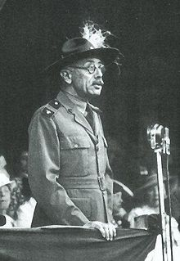  Count Pal Teleki, Camp Chief & Chief Scout of the Hungarian Scout Association speaking at the Closing Ceremony

Wednesday

At 5.00 the train started, that woke up nearly everybody. After several minutes the guard came along for tickets. There was some muddle, and we had none. Mr Collender bought ours, but Yorkshire and Sussex had none. The train could not start again until this was settled. However, it was finally settled and we moved on again. Then the SM in charge of Yorks could not find his rucsac. It was not on the train.

After several hours going we had to stop again, this time for a few hours. Some went bathing, but, as my costume was packed I stayed. This station was a big junction, Ibiscolo (?) Szernily(?) Kiralyudvar, Ibsicok(?) for short. The carriages were shunted about, until they were right. The Hungarian Scouts travelled in goods trucks.

The train was the usual type. Sixty Scouts in one carriage, forty in one compartment and twenty in another. A guard’s seat and a WC at each end, with a small platform outside. Sussex had the small part while Kent and Yorks had the other. A Sussex chap dropped his flannel into the drinking churn, so we had to go thirsty until we reached M-S-P.

At last we arrived at Sarospatak (pronounced Sharoshpatak) at 3.15. Here we were welcomed by Girl Guides and other people, the Mayor and Headmaster, notably. We went straight from the station up to the school. After claiming our beds we went straight down to lunch. I felt very dirty, so I had a good bath, after which I and several others went for a walk along the river bank  Dinner was at 8.30. We went to the pictures afterwards. The film was “Blonde Crimes”. It was going too slow, so that all the artistes had very low voices. It was also in nine pieces, with a stop in between to change the reels. | 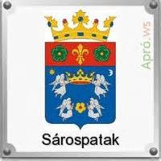

Turned in very tired at 10.30. It was lovely to sleep on a mattress again.

Thursday

The rising bell went at 7.30. Breakfast, rolls and butter, bread and honey and tea (some queer concoction) was at 8.00.

During the morning we visited the interesting parts of the town. First the college. The library was the first place we visited. It was a marvellous collection, worth thousands of pounds. There were several books dating back to Caesar, and even earlier.

Next the Natural History Museum, contained stuffed animals (parts of the human body and so on). After which the science lab with all the (chemistry) chemical and physical apparatus.

From the college we went on to the castle. First the guide took us into the cellars, which are used for storing and making Tokay wine. The air was lovely and cool down there, in the maze of ways. The barrels were stacked up on either side.

After coming up out of the cellars we were invited to taste the wine. We had four grades of the sixteen. It was lovely wine.

We next went up on top of the castle, from which we got a lovely view of the town.

We got back to lunch at 12.45. Lunch was at 1.00.

After lunch we went on the river, in a racing skiff belonging to the college. After rowing about a mile and a half upstream we got out and swam down for a quarter of a mile. Bathed again when we got back. I enjoyed it very much.

Dinner was at 7.00, soup, meat and cake.

Before “lights out” we had a dorm rag. Dorm one against dorm two, just to liven up the day. It ended about 10.45, after which all was quiet.

The town is a typical Hungarian country town. The houses are small and dirty, opening into a roughly cobbled street. The refuse is turned out into the street, and there is consequently a perpetual smell. Geese, animals and chickens stray out in the road. Motors are rare, taxis are horse carriages, something like a hansom cab. There seemed to be two classes, the upper and the lower, no middle class.

Friday

Bell at 7.30. Usual breakfast at 8.00.

This morning’s excursion was up into one of the neighbouring hills. It was a hot day and rather uncomfortable for walking. At the foot of the hill we went into a cottage and had a glass of wine to refresh us. We climbed the vineyards and up rocky paths to the summit. From here we could see across the border in Czechoslovakia.

We descended by a different route and passed a mine. The manager, I supposed that was what he was, took us inside to see it. It was not deep, merely passages into the hillside. This clay is used for pottery.

We got back about 12.45, quite ready for a meal. Lunch was at 1.00 as usual. Chicken soup, with various entrails and fat in it, fried chicken (pieces of chicken egg and crumbed and fried in deep fat), potatoes, tomatoes and lettuce.

Afterwards I went down to the river for boating. We learned a peculiar fact about the bathers there. The Hungarians mainly bathe in the morning, and few in the afternoon, and the Jews in the afternoon.

I had spent the whole afternoon on the river, boating and bathing.

Returned for 7.00 dinner.

From then until bedtime I went into the games rooms, where billiards, draughts, chess, ping pong and other games were provided.

Turned in at 10.00.

Saturday

The rising bell was an hour early, at 6.30. Breakfast was at 7.00.  Just before 8.00 we started off on another hill climbing expedition. Through fields of wheat maize, into a small town. This was of German origin, and the people in it are still really Germans. Here we saw the old pole wells, one is shown in the sketch. The chain is pulled down, and the bucket is lowered into the well, and the weighted end raised. When pressure is released, the heavy end falls, thus raising the bucket.  The Germans use oxen and cows for hauling carts, whereas the true Hungarian uses only horses. | 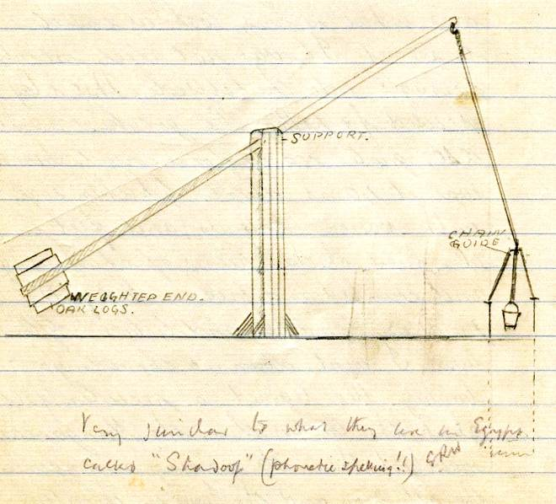

Just after leaving the village we saw some peculiar dug-outs, with stone entrances. These were cellars where the people stored their wine to keep it cool.

We were steadily climbing. The crops were getting poorer.

We then left the open fields and entered the wood. The climbing was stiffer, and the path rather stony. At last after an hour’s climbing we came to a halting place. This was a deliciously cold spring coming out of the hillside. We rested here and had some of our packed grub. Eight of us decided to go back as we were tired, and it was rather hot walking. As I do not do not do much hiking I was tired.

We returned by the same route, and arrived back to the house at 12.30. We felt wonderfully refreshed after a cold shower in the washroom.

After eating what was left of our dinner we went down to bathe. The afternoon was spent in the usual way, on the river. As we had not had much dinner, we dropped into the town’s only café for a feed of cakes and ices.

When we arrived back I had another shower. Until dinner I wrote up my log for the last few days. Dinner at the usual time. Tonight it was a stew, followed by chocolate cake.

Bed rather late at 10.30.

Sunday

Rising bell and breakfast as usual, no laying in on Sunday.

There were no excursions arranged. There was, however, a parade for Church at 9.45. We attended the local Protestant Church. The service was, to us, rather peculiar.

Soon after we returned there was another parade, to lay a wreath on the war memorial. The youngest Scout performed the ceremony, after which we visited the local Girl Guide HQ and swapped and bought various badges.

Lunch of stewed chicken with carrots, fried chic ken and potatoes, followed by a glass of ices of various flavours. It rained until about two o’clock so we were forced to stay in. There was a tennis tournament on at the school’s tennis court. We watched this from the windows.

Dinner was early because of the campfire. We had a variety for dinner, ham, luncheon sausage, cheese and paprika, followed by fruit and cake.

The campfire was at 7.30 in the clearing in front of the gym. The fire would not burn until about a quarter of an hour after it was lit. It was rather ironic, the SM was repeating the Gilwell verse at the opening, “As the flames leap upwards”, and all the time they were dying down. The crowd was so eager to go to the fire that we had to make a chain of hands to keep them back. It was quite a good show, except that there were not many of us to make a noise in the yells and songs, so they sounded a bit weak.

As we were just leaving, one of our chaps fainted and had to be assisted back. There was nothing really wrong, and he was quite alright later.

Turned in about 10.30.

Monday

Today there was an excursion to a town on the Czech border. Had to turn out at 6.30. Caught the agricultural train at 8.10. This was a narrow gauge rail like the Dymchurch one, except that the carriages were larger.

There was the usual large crowd to welcome us. A guide took us round the interesting buildings in the town, the monk’s church, the museum and several others. In the museum I changed my four pengo Jamboree knife for a knife, like a skene dhu with a deer’s foot as a handle.

We also went to the actual border. The guide said that in one place it passed right through a farmer’s pear tree. Some of the people have to draw water from a well across the boundary, to do this they have to have to passports. The guide tried to persuade the officials to allow us to go across the bridge (half of which was Hungarian, the other Czech), but they would not. I and one of the others had however got across, at another place, when nobody was looking, we had our photos taken half in each country.

The last place that we visited was the wine cellars, here again we tasted some of the wine.

We got back in time for lunch. Bean soup, cheese, ham and sausage (which smelt rather of garlic). After lunch I felt rather drowsy, the effect of the wine, so I had a nap. I felt much better after it.

I packed up all spare kit in readiness for leaving. Just before lunch a party of us went up to see the potteries. We saw a man making decorated tiles, flower pots and other articles.

Dinner at 7.00.. Afterwards we had another small rag.

Turned in about 11.00.

Tuesday

Packing up Day.

We turned out at 7.30. I was early, this was rather lucky, because the water was turned off at 7.30 and some had to go without a wash.

After breakfast the SM gave a speech of thanks to the Headmaster and the staff. The Headmaster also spoke, expressing his appreciation of our visit and said that he was very sorry that we were leaving.

After assembling we marched down to the station and were there presented with small tokens of flags. We left amid cheers, in a reserved carriage.

After a slow journey we got into Budapest station, just at 7.30. We marched out to our lodgings, the longest possible way. These were in a medical school. After leaving our kit we marched right back to a restaurant near the station.

Turned in directly I got back. The beds were made of paliasses of straw, on the floor.

Wednesday

Woke at 6.30. Had a makeshift wash under a tap. Breakfast was at the same place, rolls and butter and jam, and tea.

After breakfast we were free until lunch. A party of us wandered round the city. We met one man who spoke English, he took us round. We went into the new hospital near the station. This he said was the pride of Budapest. It was a fifteen storey building built in 1930.

Dinner was at 1.15. Bean soup, pork in a soup of French beans and cake.

We rested in the afternoon, and went down to the restaurant for tea. After a three quarter hour wait we at last got it. Another queer concoction followed by chocolate cake.

We went back for our kit and marched to the station. We boarded the train about 8.40, and left half an hour later. The train was the same as before, German. I soon went to sleep on the hard seat.

Thursday

We woke up in Vienna station at 3.45am. Here we had coffee, rolls and fruit. One boy fell off the carriage steps, and cut his head rather badly.

Mr Wilson, our SM, who had been spending a few days in Vienna, rejoined us. He left us on Sunday.

We left here at 4.15. The train was on time so far. The land was much the same as that of Germany. There were large fields of a root crop which looked like beet. The weather was rather dull before sunrise, but it brightened up later.

We crossed the border, the River Inn at 11.50, and came into Passau. Here we had packed lunch, the same as usual, two eggs, two rolls, two slices of ham, one piece of cheese, one pat of butter, and a bottle of soda water. We composed a round about these packed lunches. It is sung to the tune of “London’s Burning”.

“Packed lunches, packed lunches,
Soda water, soda water,
Boiled eggs, boiled eggs,
And they all go thro’ the window”

The weather was very cold. We were all wrapped up in blankets and sweaters. This was rather a contrast to the outward journey, where we were all standing looking out of the windows. I had several short naps on the rack.

For dinner we stopped at Wurzburg at 5.00. Same old stuff, packed.

We stopped at Frankfurt at 7.50 for a mug of coffee. The train was usually one minute ahead of schedule.

Turned in rather late at 10.30. Had a disturbed night. The train kept stopping and waking me up.

Friday

Got up and washed in what water was left, about two mugs full. It was very misty and rather cold.

We passed a wireless transmitting station about ten minutes after passing through Ghent. We wondered what the name of it was.

Finally arrived in Ostende at 6.15. After leaving our kit on the quay we went into the station café for rolls and coffee.

After breakfast we had a look round the town. The fishing fleet had just come in, and the night’s catch landed. The fish women were buying and selling the catch.

Reassembled and went on board at 9.45. We were all put into the stern. The boat left at 11.15, fifteen minutes late. The sea was very calm, calmer than before, no one was ill.

We were soon out of sight of land. The first sight of land was Calais, some time later, Dover. It seemed to take ages to reach those cliffs.

We docked at 2.40. We all passed easily through the Customs. Mr Franks has ordered a tea for us at the “Sailors Bethel”, but we did not have time to have it. We had a cup of tea and some cake in the station restaurant.

Boarded the Tonbridge train at 3.40, after saying goodbye to all the rest of the chaps.

Got home about 6.30.

And so I arrived home after a most enjoyable holiday, which I shall never forget.

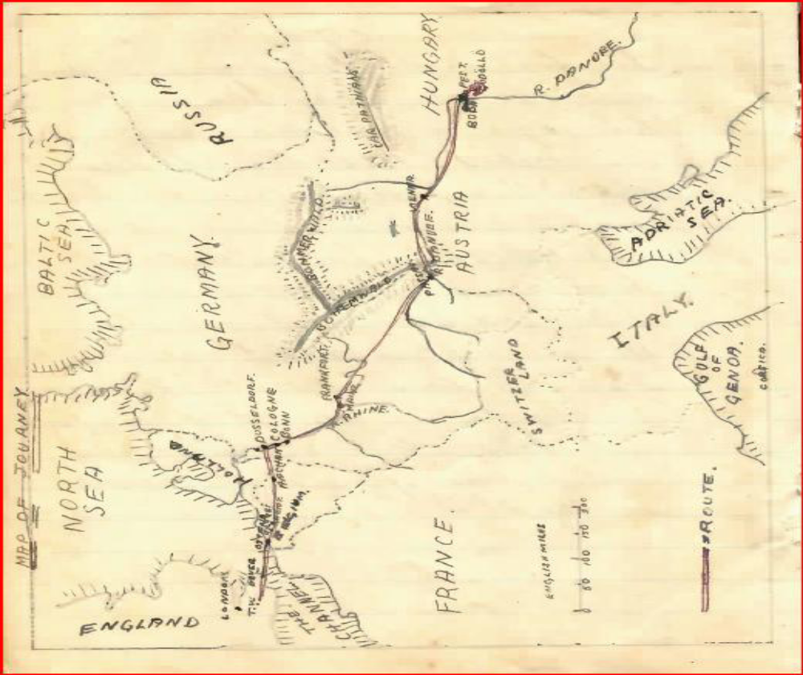

Report on the 1933 World Jamboree

From the United Kingdom Scouting Magazine, The Scouter
By F Haydn Dimmock, Editor of The Scout

The Jamboree of smiling faces and loving hearts! That, I think, sums up the fourth World Scout Jamboree at Gödöllõ, Hungary.

Never has there been a happier gathering of the world's Scouts, and never has kindness been showered upon guests in such overwhelming abundance as by the Hungarian nation. I say that fearlessly, remembering all past Jamborees, and am confident that no one will deny it. From peasant to the Regent himself we received a welcome and an ever-flowing stream of kindness. To Count Paul Teleki, the Jamboree Camp Chief, to Dr. de Molnar, International Commissioner for Hungary, and to their gallant band of organisers, we owe a very deep debt of gratitude. They worked well and truly in the cause of world Scouting.

Having said that I must hasten to add that once again it was the boys themselves who made the jamboree the tremendous success it undoubtedly was. The Hungarian Scouts set themselves out to make us feel at home; what we should have done without our "cousins" in the camp I do not know! They acted as interpreters and guides, and taught us how to cook the Hungarian food which was supplied to us.

The camp itself was delightfully situated, the majority of the tents being pitched under trees. The only complaint was the dust. Mud at Arrowe—dust at Gödöllõ.

In the neighbourhood of Sub-camp IX, where George Carter and his stalwarts from the Tyne held sway, the dust blew like a desert sandstorm whenever there was a high wind. The most delightful and peaceful(!) spot in the whole camp was British H.Q., the tents being pitched around a small tree-bordered clearing—a really beautiful setting— and the most peaceful man, "G.F.," invariably to be found sitting in his camp chair reading. G.F. had a loyal and hard-working staff and everything according to plan. The Chief's tent, set up on a raised terrace in the shadow of a rocky monument, practically in the centre of the camp, commanded a fine view.

As at Arrowe, it was a camp of gateways and fences, some of them very elaborate affairs, and most of them telling a story of national or county industry. It would take Pages of the Scouter to describe them. Again, as at Arrowe, there was a market of shops under a covered way which provided welcome shade from the blistering sun. Yes, it was a sunny Jamboree except for two days when we had showers, and one of these was the opening day, when the Chief was present but the rain held off during the a opening scenes. So the Jamboree became the "Sunboree."

Close to the market were several open-air restaurants, where one sat under the shade of a wooden roof and took much-needed liquid refreshment. The arena was set in an open field, the ground sloping gently away from the three huge stands built specially for the occasion to the edge of a thick wood, which provided a beautiful natural background.

Facing the stands, and just in front of the wood, was a magnificent altar where the Roman Catholic services were held and on the extreme right, towering a hundred feet, rose a great white cross.

The opening day was a day of triumph for the Hungarian Scouts, a realisation of all they had worked and planned for during the past two years. But it was also a triumph for us of the British Contingent. We glowed with national pride when the Chief entered the arena. He had brought the world of youth together in a common fellowship for the fourth time. We had a right to feel proud.

The welcome accorded to the Chief by the Hungarians was almost riotous. When he had difficulty in dismounting from his horse there was an audible gasp of sympathy. The Chief limped rather badly to the dais, but stood for more than an hour and a half while the contingents marched past.

The March Past was a most impressive and picturesque sight. Many of the Scouts wore their national costumes-Belgian peasants, Polish fishermen with a huge net, Armenians in hafayah and tabash, and Czechoslovakians in quaint, colourful dress. The Cairo Scouts carried bunches of pampas grass, and each of the Swedish boys carried a coloured balloon; these we're simultaneously released as they passed the saluting-base, 10 float gaily away over the stands and out of sight. Ireland marched to the skirl of its pipes and secured a special cheer. Austria carried weird instruments made from tree branches and pieces of wood, and those from Tyrol a mighty crucifix of solid wood twenty feet high. It took more than an hour for the representatives of the thirty-four nations to pass the saluting-base.

The excited Hungarians in the three stands, rose time and again to their feet to cheer the Scouts as they passed. the British Empire contingent received a tumultuous burst of cheering as they marched past the Chief, hats raised high, and shouting a welcome.

I have been to all but one of the International Jamborees, and each seems more splendid, more awe-inspiring more thrilling-twenty thousand boys, white black, tan, Catholic, Protestant, Mahommedan, Jew, marching along together towards a new world Of hope and peace. As the van passed into the distance I felt that they were marching into the generation that is more priceless than greed of gold or lust for power, and that national pride is useless without international understanding.

Then from the distance they came charging back, shoulder to shoulder, their voices rising to a crescendo as they raced madly back to the stands, twenty thousand boys telling the world that happiness comes from love and goodwill. It seemed that they, were trying to make the echoes of their voices circle the world so that all might hear their mighty supplication that there be peace in our time.
"Oh, it is beautiful," murmured a Hungarian to me. "I am overwhelmed! These boys are so happy, so friendly. I have seen them in their camps. Would that all the statesmen of the world could come and live with them at this jamboree. Much would they learn."

Indeed, we were all learning.

At a signal the multitude was silent to listen to the address of the Regent of Hungary, Admiral Horthy who, with the Chief, had previously inspected the Scouts His Serene Highness first spoke in English, then in Hungarian.

"You have come to Hungary from all parts of the world to testify to the magnificent and uplifting power of the Brotherhood represented by Scouting. The noble ties of friendship I believe me stronger among you through the Fourth World jamboree. I am convinced that the Jamboree will do much towards the promotion of human good. will and peaceful co-operation for the general good of humanity.

The Hungarian nation offers you these wood-girt fields with best wishes for your camping. The Hungarian nation welcomes you and your leader, the founder of the World Scout Movement Lord Baden-Powell. Welcome to you all I hope you will feel at home."

Then it was the Chief's turn. He spoke in English. There was not a movement in the vast crowd.

"It is a real joy to me to see you all again, assembled here on the hospitable soil of Hungary. His Highness the Regent has done a very high honour to us, and through us to our whole Movement by coming here in person to greet us. Further than this, he has also granted us the use of this beautiful camp for our camping ground. You would naturally want to show your gratitude by cheering His Highness and Count Teleki, but there is something they would value more highly. It is up to all of us to show him, by our conduct here, that we do fully appreciate the honour he has done to us and the belief he has in us.

You have come together here to make personal friendships with your brother Scouts of other nations, as peacemakers in the world. There is no time to waste. Make the most of the few hours you are here in getting into touch with the other follows. I hope that each one of You has a note-book in which to enter the names and addresses of the now friends you make each day, so that when you are back home again you can continue and keep up the friendship by letter and, if possible. by exchanging visits I want to see men of all countries at peace with one another. You are the future men of your countries-so be friends. You will notice that I haven't brought the rain today!

See all you can of this wonderful country while you are here, and above all, make friends. Good luck, and good camping!"

The Jamboree was opened. Crowds surged about the cars as the Regent and the Chief drove away, the Chief standing up that all might see him.

In the evening shadows the fires of many circles lit the dark sky and tinged the trees in a ruddy glow. As in primitive days, when Earth was young, these boys of many lands gathered round their fires to sing the joys of life and to make merry after the day's toil. From one to another I went. moving quietly through the trees. As the singing and laughter died away, other new sounds were born in the distance. The whole world was singing. The jamboree spirit was working.

Day by day the merry round of activities went on-displays in the great arena, and on the sports ground; shows in the large airy theatre; cinema entertainments, autograph hunting (despite the ban put upon it); the constant clicking of cameras; swopping; impromptu shows in the different camps; camp fires; and excursions.

Will our boys ever forget those wonderful trips, or the welcome they received wherever they went? Crowds lining the railway tracks to cheer them, brass bands blaring, civic receptions, feasts, dancing-the whole country stirred to a great emotion, inflamed with the desire to make us happy and to show us that we were among friends.

I am not attempting to write a full story of the Jamboree. The best I can do is to give you glimpses and impressions. To me, the greatest moment of the jamboree was when Chief bade us farewell.

In front of the stands, massed in close ranks, the Scouts sat to hear their Chief. From the saluting-base he thanked all those who had helped towards the success of the Jamboree-the Scouters who brought the boys, the jamboree staff, the Regent and the Hungarian people-with a word about the friendships which had been made. A word of more solemn thanks- "Let us pause for one moment for each of us silently to thank God for bringing us together as a happy family at Gödöllõ." The impressive silence was unbroken, save the rustle of flags, until the Chief said good-bye.

"My brothers—Those of you who were at the last Jamboree in England will remember how the Golden Arrow was handed out to each country as a symbol of Goodwill flying forth to all the ends of the earth through the Brotherhood of Scouting. Now at Gödöllõ we have another symbol. Each one of you wears the badge of the White Stag of Hungary. I want You to treasure that badge when you go from here and to remember that. like the Golden Arrow, it also has Its message and its meaning for you.

The Hungarian hunters of old pursued the miraculous Stag, not because they expected to kill it. but because it led them on in the joy of the chase to new trails and fresh adventures, and so to capture happiness. You may look on that White Stag as the pure spirit of Scouting, springing forward and upward, ever leading you onward and upward to leap over difficulties, to face new adventures in your active pursuit of the higher aims of Scouting-aims which bring you happiness. These aims are to do your duty to God, to your Country, and to your fellow man by carrying out the Scout Law. In that way, each one of you, help to bring about God's kingdom upon earth-the reign of peace and goodwill.

Therefore, before leaving you, I ask you Scouts this question—Will you do your best to make friends with others and peace in the world?"

Like a rumble of thunder the answer rang out, in a wonderful promise, as the figure of the White Stag was raised aloft.

How they cheered the man beloved of all the world. "Chief! Chief! Chief!" they shouted, and yell upon yell went up through the multitude. They pressed round the car as the Chief drove away.

That night there was a farewell camp fire when torches were carried to the many other camp fires in the mighty camp. It was a symbol of friendship that the fires of many countries should be kindled from the heart of Scouting as represented by the Chief's own fire. When the Chief had gone from Gödöllõ, more than one felt the jamboree had ended. But the shows went on the camp continued to draw thousands of visitors—over 360,000 people passed through the gates during the fortnight—the camp fires burned at night, the displays were carried through, and the Jamboree breathed out the Scout Spirit.

And so we came to the last day, with the arena once again the scene, and thousands upon thousands to see the Scouts bid good-bye, to hear their mighty shout of "Brothers! Brothers! Brothers!"

We came, we saw, and seeing thought it good;
We came, we heard and hearing knew
We had not journeyed here in vain.
We came, we sang. united harmony;
We came, we laughed, and laughing knew
We met as brothers once again.
We go, and going, offer you our hand;
We part, and parting, say with all our heart
God bless us till we meet again.

The Jamboree in the Media

Fortunately, Ray’s log book contains a number of press cuttings, reproduced below.

Cuttings to be inserted

Scout Movement Milestones - 1933

August | Fourth World Jamboree, Godollo, Hungary.

Click HERE if you have any further information regarding this year
or
HERE to return to our Navigation page



