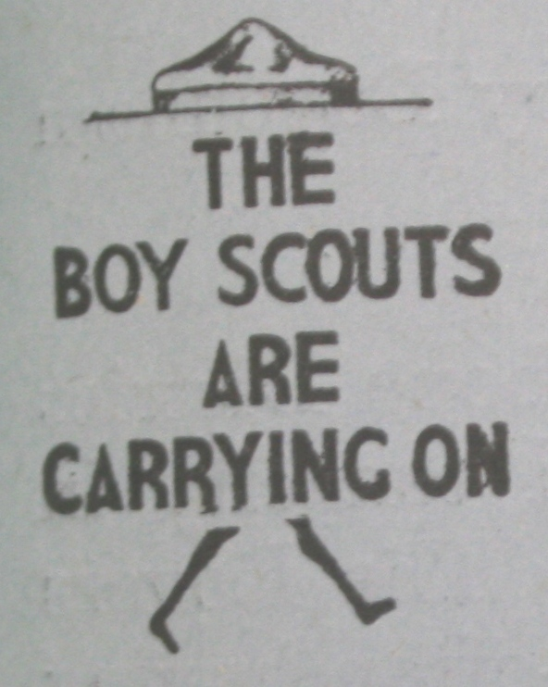
Scouting in Rusthall
1939

“In all of this, it is the spirit that matters. Our Scout Law and Promise, when we really put them into practice, take away all occasion for wars and strife among nations”

Lord Robert Baden-Powell
(1857 to 1941)

? | We are seeking :  - Events that occurred this year.  - Copies of the St Paul’s Parish Church Parish Magazine for this year (except July).  - Copies of the Kent & Sussex Courier for this year.  - Any knowledge that you may have of this year.

Can you help ? Please click HERE if you can

Mr PA Godfrey Phillips visits Rusthall
Thursday 26 January 1939

Mr P.A.Godfrey Phillips – Tunbridge Wells District Commissioner in the 1950s - 70s was a frequent visitor to the Rusthall Troop and often used to ‘drop in’ on the weekly meetings. The following brief notice from The Courier of 3 February 1939 indicates that he had a long-standing association with Rusthall.

Mr P. A Godfey Phillips Returns
From The Courier – 3 February 1939

Mr PA Godfey Phillips was warmly welcomed when he addressed a meeting of the Rusthall Working Men’s Conservative Association at the White Hart Hotel last Thursday.

Mr Phillips mentioned that that was the first public address which he had given since he returned from his extended tours abroad, and a fitting subject for the evening was a description of those tours. Mr G Price, the chairman, said how pleased both he and the members were to again welcome Mr Phillips to Rusthall, and it was clear from the extended applause that this was unanimous with the meeting. Mr Price was supported by Mr HA Shepherd, Secretary of the branch, and Mr G. Goldsmith, Conservative Agent for the Division.

Scout numbers increase
St Paul’s Annual Church Meeting
February 1939

The Rev G.Gilling- Lax made special reference to the work of the young people under their various leaders. The Rev. B.Hughes (Assistant Curate) was responsible the youth welfare including the Scouts and Cubs. The numbers and activities of these organisations had increased in the last year.

Camp Fire Sketches
Tuesday 14 February 1939
From The Courier – 17 February 1939

Camp Fire Sketches were enacted by Rusthall Scouts at their show at the Parish hall on Tuesday evening.

The event was in aid of Lord Baden-Powell’s Fund and local funds, and the hall was packed with about 200 people.

Arranged by the Reverend B Hughes, the Scoutmaster and his assistant, Mr R. Latter, the programme consisted of camp sketches by each patrol, items by a mouth organ band, a display of physical training and boxing, and a short play entitled ‘The Annual’.

Apart from the desire to raise funds the show was staged in order to get parents interested in the Scout movement, for under the energetic leadership of popular Mr Hughes this now 20-strong troop is making rapid strides after a period of idleness.

Scout membership in Kent
increases by 1,000 in a year
From The Courier - 10 March 1939

A report of the Kent Scouts’ Annual General Meeting showed an encouraging increase in membership of just over 1,000. Numbers are now as follows :

Scouts – 16,545
Wolf Cubs – 5,863
Rovers – 1,286

There is no separate record of Leaders

Fighting in Shadwell Woods
Saturday 29 April 1939
From The Courier - 5 May 1939

Local Scouts in Action

On Saturday the larch-studded slope of Shadwell Woods, Rusthall, re-echoed with the sound of battle. Passers-by, however, need have had no fear, for the disturbance was caused by local Boy Scouts letting off their natural excess of energy in a district wide game.

News had been received by local authorities that a gang of terrorists had stolen important documents and were hiding in Shadwell Woods while awaiting an opportunity of leaving the country. These terrorists were masquerading as Scouts, and the Tunbridge Wells Association had been asked to assist in capturing the scoundrels and recovering the documents.

The terrorist leader, however, hearing that Scouts had been called in, did not make the mistake of underestimating his opponents and sent one of his men up a high tree with the documents, surrounding this tree with a picked bodyguard of fighting men to make doubly sure. He also gave another man a set of false documents hoping that the Scouts would capture these and leave the terrorists at large to carry out their dastardly scheme.

The Scouts, however, were systematically combing the woods, ‘killing’ every terrorist they encountered, but search so they might, they were unable to locate the real documents. They did, however, locate the bodyguard owing to the fact that the bodyguard had tired of sitting down doing nothing, and had gone out in search of blood.

They drew blood but one small Scout escaped, and carried the word back to the main body of Scouts, who immediately rushed some thirty strong, to put the terrorists out of action. The terrorists, realising they were outnumbered, decided to run for it, and drew the Scouts away from the vital tree. This they succeeded in doing, and, having drawn the Scouts about half a mile down the woods they suddenly turned, and a pitched battle ensued, many lives were lost, the terrorists fighting desperately as wave after wave of Scouts poured into the fight.

By this time, both Scouts and terrorists were feeling hungry, and the terrorists who turned out to be a decent lot of fellows after all, sunk their differences and joined the Scouts in tea and buns which had been prepared by CM Mrs LE Jackman and ACM RJ Marsh.

Credit was due to the terrorist who sat in the tree for one and a half hours, and to the Scouts for their courageous fighting.

The whole game was arranged by District Scoutmaster LE Jackman.

Researchers’ note - LE ’Jackie’ Jackman was later to become ADC Scouts in the mid-late 1950s and was a regular examiner at the Camper, Cook and Backwoodsman Badge weekend camps held at Frant Bottom.

Shadwell Woods
From Crescent Moon

Between Rusthall and Speldhurst lie Shadwell Woods, which take their name from Chad's Well nearby. These woods and the ancient bridleway cutting through them are mentioned in the following wonderful historical sketch by one lifelong resident, NM Bailey, who was born close to Bull's Hollow.

By NM Bailey

Long distance pack-horse lanes had to weave their way through the thick forest which then covered this part of the country. It was called Andredsweald. If we walk down what is now called Nellington Lane, just past Rusthall Cemetery turn right and we are on one of these very old tracks which smugglers used, storing their contraband brought from France to Newhaven in the old cottages nearby. The cottage, which has been renovated and enlarged, is now called Hole Farm. In the field opposite one can still see the old St Chad’s Well, which it is said never dries up and always keeps the same temperature. The woods nearby are called Shadwell Woods.

Numbers continue to increase
Early May 1939

Over recent months membership of the Troop has continued to increase and by the beginning of May it was possible to form four patrols.

The Patrol Leaders were A Singyard, J Watt, E Cross and F Lavender.

A note in the Courier of 5 May 1939 recorded that Mr F Crundwell was applying for a warrant as Assistant Scout Master and so there would soon be two ASM.s in the Troop. It was further noted that Mr L Foster would continue to act as Troop Leader.

Researchers’ note – Although The Courier refers to Mr Foster as “Troop Leader”, he may actually have been the Scout Master.

Rusthall Hospital Sunday
Sunday 4 June 1939

St Paul’s Rusthall Scouts joined Guides and Brownies at the Hospital Sunday Parade. through the streets of the village. The parade included the Tunbridge Wells drum and fife band, the West Kent and East Sussex Corps of the Sea Cadets, the Wadhurst Town Band, Rusthall Football Club, the Sons of Temperance and members of the British Legion, the Foresters, Equitable and Oddfellows Friendly Societies.

The parade terminated at the War Memorial where a wreath was laid.

Kent Scouts Flag Competition
Saturday 17 & Sunday 18 June 1939

The Kent Scouts’ County Commissioner’s Flag Competition was held at Court Lodge, West Farleigh. Thirty teams entered the competition which consisted of tests in camp craft, camp gadgets, cooking, message passing, knotting, erecting a flag pole with staves and estimating distances.

Tunbridge Wells District Camping Competition
Buckhurst Park, Withyham
Saturday 15 & Sunday 16 July 1939

By kind permission of Mr.George Schichte, the district camping competition was held amongst the beautiful surroundings of Buckhurst Park, Wlthyham, for the fifth year in succession on Saturday and Sunday last.

There was an excellent entry, some 15 teams of four boys each taking part in a competition which included general camping efficiency and tests in first aid and observation. Mr Brian Dixon, ADC. Wadhurst, acted as principal judge.

The Old Skinners' Rover Crew were responsible for carrying out a preconceived "IRA Plot,." which involved a bomb out-rage and a broken jaw, thereby furnishing sufficient data for the rendering of prompt first aid.

Dr. Buchan, assistant medical officer of health, expressed his surprise at the knowledge and efficiency shown on the part of the boys, and it is not unlikely that their extra training for national service stood them in good stead.

More than 30 boys enjoyed a bath in the beautiful lake and there were no casualties.

Amongst those who were responsible for this successful week-end might be mentioned Mr F. Barnham, who supervised the erection of a rope bridge, D.S.M. Jackman, who led the camp fire concert, G.S.M Palmer, who, assisted by T.L. Elphick. acted as staff cook.

At the Scouts Own held on the Sunday afternoon when about 100 were present, the Rev. Fraser gave the address.

The results of the various competitions showed a Skinners’ team as winners, with Christ Church in hot pursuit.

Researchers’ note – It has yet to be established whether Rusthall participated in this event. Ray Latter was a member of the Old Skinners’ Rover Crew in 1939 and was also ASM with Rusthall by July of that year – he may well have been present.

From St Paul’s Parish Magazine - July 1939

The Reverend B Hughes was the Scout Master and Mr RA Latter Assistant Scout Master – later to be the father of Mike Latter who was born in 1947 and became a Queen’s Scout.
The Cubs and Scouts are now fully occupied with their summer programmes. Both organisations took part in the local Hospital procession on Sunday 4th July and the Scouts’ decorated a lorry to represent Scouting activities.  The summer camp will be held this year at Normanhurst near Battle, where we have been able to secure a very attractive site.  We are glad to report that the Rover Crew is now meeting regularly and we hope to have a Rover Investiture before long. Mr F Gasson who is one of our former Crew is kindly acting as Rover Mate. | 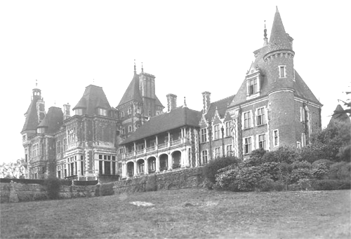  Normanhurst Court

(During World War I, Normanhurst Court was used as a military hospital and then, having been used as a girls’ school between the Wars, it was used as a Prisoner of War camp during World War II. The house was demolished in 1951 and the grounds are now used as a caravan park.)

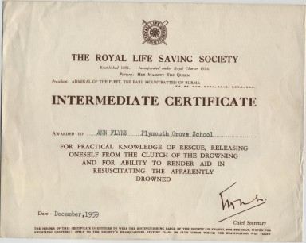 | Boys’ School – Swimming – On Friday June 16th, the following boys were examined at the Baths for the Royal Life Saving Society’s Certificates : George Mitchell, Edwin Wright, Alan Norris, and George Watson. They were all successful in gaining the Elementary Certificate and in addition to this George Mitchell and Edwin Wright were awarded the Intermediate. The Examiner expressed his great satisfaction at the very efficient manner in which the various exercises were performed by the lads.

6 Scouts gain the  National Service Badge  From The Courier - 11 August 1939  Rusthall News - With the Scouts | 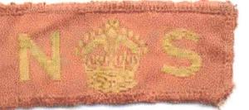  The Boy Scout National Service Badge

Six older members of the St. Paul’s Scout Troop have passed their test for the National Service badge. This is awarded for successful training in messenger duties in the event of air raids.

The Troop’s chief concern at present is the summer camp for which the boys are due to leave tomorrow (Saturday 12th August). After a week under canvas at Normanhurst near Battle they will return to Rusthall next Saturday.

The Outbreak of the Second World War
1 September 1939

On the outbreak of the Second World War, many of the older Scouts became Air Raid Precaution (ARP) messengers, based at a number of local strategic locations – the then Council Yard (now Audrey Sturley Court) at the top of Grange Road – the Wardens’ Hut on the steep twitten that runs between Grange Gardens and the lower end of Grange Road – and the hut that once stood at the top of Major Yorks Road.

The Coffee House in Harmony Street, Denny Bottom (much later to become our Group’s Headquarters), was used by the Home Guard – where the late Charlie “Sub” Simpson (our to-be Senior Scoutmaster) recounted many vivid memories of times there spent – keeping watch for enemy heading for the Toad Rock Retreat, and also of chilly nights fire-watching from the tower of St Paul’s Church.

Many of our Scouts were enlisted into the Armed Forces during the course of the War, but Scouting in Rusthall remained active throughout.

Scouts are encouraged to wear uniform
September 1939
From The Courier - 8 September 1939

Boy Scouts In Uniform At All Times

Lord Somers, the Deputy Chief Scout is anxious that Boy Scouts should wear their uniform at all times during the war.

He appeals to employers to give permission for boys to wear uniform during work hours, as all members of the movement are occupied with National Service in one form or another in their spare time.

It will help these boys if permission can be given, as they will then be able to be ready for their war work at a moment’s notice.

Tunbridge Wells Boy Scouts in the War
October 1939

The District Commissioner for Tunbridge Wells, Mr E.R. Wood, contributed a short column to the Courier of 13 October 1939, drawing attention to the work of local Scouts during the early weeks of the war.

He explained that whilst all Scouts were keen to offer their services and get involved from the outset, the Home Office had issued a Decree that no boy under the age of 16 would be allowed to take part in Civil Defence work.

He praised the efforts and enthusiasm for helping the country so far and was sure that this ruling would disappoint many younger local Scouts.

He drew attention to some of the work undertaken by local Scouts. Scouts had quickly responded to a request from the Chief Air Warden to form a messenger corps of 200 plus boy cyclists who would provide a quick and accurate means of communication between ARP posts and the central control. Others were providing assistance by working as orderlies at the ARP offices, the Control Centre and the Kent and Sussex Hospital. Scouts were engaged in other activities such as canteen work and filling sandbags.

There was much to be done and the Assistant District Commissioner, Mr R.E. Thomson was praised for his organisation in co-ordinating the work of the Scouts.

Advance notice was given of the nationwide programme for collecting wastepaper that had been entrusted to the Scouts and Mr Wood called upon residents to set aside newspapers, periodicals, magazines etc. ready for collection by Scouts at a later date.

In the following week, to ensure that waste paper collection got off to a good start, another notice was issued in the Courier confirming that Scouts would be collecting waste paper and asking for people to deliver paper direct to the Scouts’ depot at the Victoria Hut, Victoria School, Calverley Street, off Camden Road, on Wednesday afternoons or on Saturdays between 11.30 and 1.00, or 2.30 until dusk. Mr E L. Frank, (Hon. Sec of Tunbridge Wells Scout Association) of Wallingford Lodge, Forest Road was identified as a co-ordinator and people were invited to send a card to him if collection needed to be arranged.

Later, in order to optimise collections, the general public were asked to store at least half-a-hundredweight of paper before calling for collection.

A Special Remembrance Service
Sunday 12 November 1939
From “Rusthall News”, The Courier 17 November 1939

A special Remembrance Service was held in St Paul’s Church on Sunday morning.

Prior to the service ex-Servicemen laid wreaths on the War Memorial. The service, which was attended by a large congregation including ex-Servicemen, Scouts, Guides, Toc H members and ARP workers, was conducted by Canon Gilling-Lax, and a collection was taken for funds beneficial to ex-Servicemen.

The Roll of Honour was read.

Christmas Programme for Evacuees
December 1939

In December 1939, The Courier reported that Scouts and Guides assisted in a special Christmas programme for evacuees billeted in Tunbridge Wells. The programme included special cinema performances, Christmas parties a visit to the pantomime and entertainment by Scouts and Guides at various functions. No particular Scout Troops are mentioned but it is possible that Rusthall may have participated given that they had an active drum and bugle band, a mouth organ band and were skilled in putting on camp fire sketches.

Waste Paper Collection suspended
20 to 29 December 1939

The Scout Waste Paper Collection Scheme got off to a good start and the Local Secretary of the scheme Mr EL Frank had to publish a notice in December 1939, thanking everyone for their support but indicating that collections would be suspended between Wednesday 20 and Friday 29 December. He was anxious to increase the supplies by taking advantage of the accumulation which was likely to occur during the holidays

Supporting the War Effort – Recycling & Saving
Author : Ian Lockhart
From WW2 People's War - an online archive of wartime memories contributed by members of the public and gathered by the BBC. The archive can be found at bbc.co.uk/ww2peopleswar

As an island nation, when war broke out in 1939, Great Britain was dependent for so many of its supplies on imports by sea. The days of significant air cargo traffic had yet to arrive but would have been equally vulnerable to enemy attack. Although the term was not used in those days, there was an immediate recourse to recycling to conserve scarce resources. Garden railings were removed for their scrap metal and aluminium kitchen saucepans were collected for their potential in the aircraft industry. Whilst there may have been undue optimism of some of the benefits, nevertheless, the whole population was involved in a practical way in helping the war effort.

An ongoing effort that was well organised was the collection of waste paper. Scout troops and their associated cub packs had groups out with their trek carts collecting waste paper on established rounds. As a cub, I regularly went out with a group of scouts from the early days of 1940. When our cart was full, we would trundle off to a collection depot in Wallington where the paper was weighed and appropriate credit given. Not only was the quantity of paper collected recorded but also the time that was spent on the collections. After 100 hours, one qualified for the Scouts’ National Service Badge which I was very proud to wear.

Later in the war, we had some more sophisticated collection vehicles. The local council organised “salvage weeks” and scouts manned the council dust carts to make large, well-publicised summer evening collections. This was the high spot of a voluntary salvage collector’s career.

The Government understandably put a great emphasis on personal saving. To this end, special weeks were organised with an emphasis on each of the services in turn. There was “Salute the Soldier”, “Wings for Victory” and “Warship Week”. A smarter aspect of our involvement as Scouts was the participation in parades that accompanied these special weeks. All of the Troops from Carshalton, Beddington and Wallington, together with the Girl Guides, Boys Brigade, the Air Training Corps, the Sea Cadets and the Army Cadets and other organisations paraded through the town complete with their bands. They could be an impressive sight as they marched past appropriate local dignitaries.

Ray Latter – Rover, Assistant Scout Master & Soldier

At this time, the Reverend B Hughes was the Scout Master and Mr R A Latter Assistant Scout Master. It is not known whether Ray Latter started his Scouting career in the Cubs at Rusthall, but he did join the 7th Royal Tunbridge Wells (Skinner’s School) Troop.  In 1933 he was a member of the Kent Contingent at the Fourth World Jamboree at Godollo near Budapest, Hungary. (His experiences at the Jamboree were faithfully recorded in a personal log book – see Volume 3.) Although Ray was serving as ASM with Rusthall he, like many Scouters at the time, were also serving Rover Scouts. Ray was a member of the Old Skinners’ Rover Crew, which was registered as a separate unit – the 16th Tunbridge Wells.  Nationally, the first scheme for “Senior Scouts” was introduced in May 1917, this being changed to “Rover Scouts” in August of the following year. It was not until October 1946 that the “Senior Scout Section” officially started – and a new plan for “Rover Scouts” introduced. In effect, Ray was of an age to be a Rover Scout, the title that stood at the time – which in later years would have been “Senior Scout”. Although historical fact, this is a little confusing - but not that it would have confused Ray at the time. | 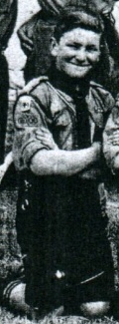  Ray at the 1933 Godollo World Jamboree
  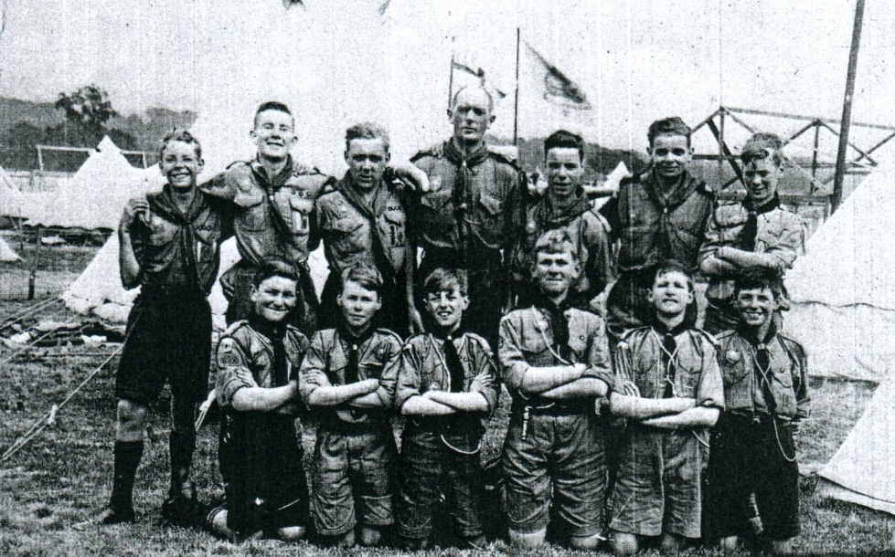
  1933 Part of the Godollo Jamboree contingent. Ray Latter front row left.
  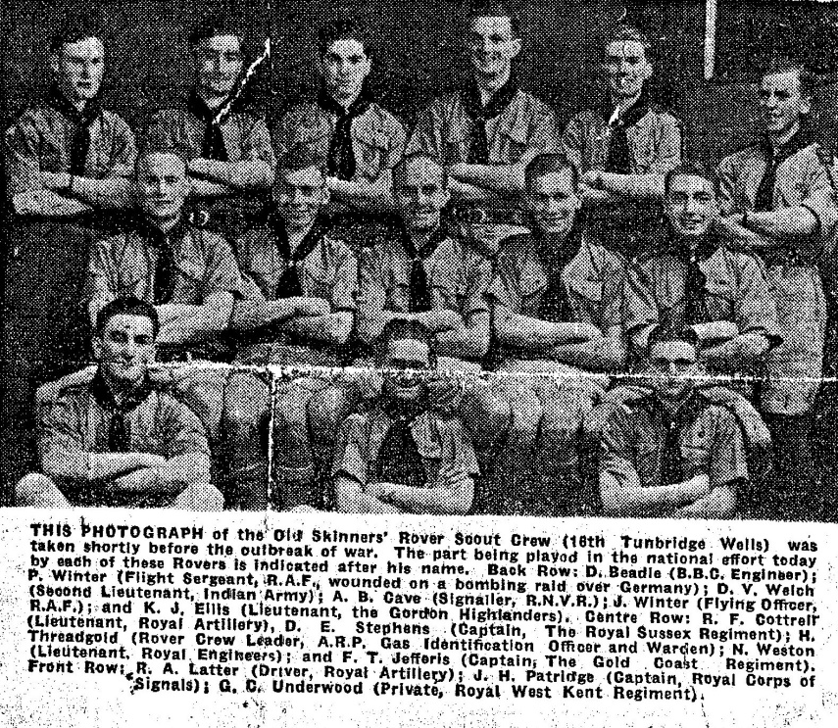
Ray was later to become the father of Mike Latter who was born in 1947 and followed in his father’s footsteps by joining the 7th Royal Tunbridge Wells (Skinner’s School) Troop. but only after completing his Cub training with Rusthall. Mike returned to Rusthall as a Senior Scout and became a Queen’s Scout.

In 1939 Ray Latter was a member of the Territorial Army (Kent Yeomanry) and consequently was one of the first to be called up for active service at the outbreak of the War. He first served as a driver with the Royal Artillery as part of the British Expeditionary Force. Then, after the evacuation of Dunkirk he became a tank driver in the Kent Yeomanry and served as part of the 8th Army (7th Armoured Division – Desert Rats) in North Africa and later in Italy. | 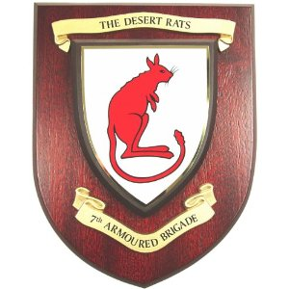

At the outbreak of hostilities in 1939, the District Commissioner for Tunbridge Wells, Mr E R Wood, was keen to keep in touch with Scouters and Rovers who were serving in the Armed Forces and began to send out regular newsletters at about 3 monthly intervals. These letters were often personalised by being addressed to individuals and included post scripts of both a general and personal or local nature. (See below)

TUNBRIDGE WELLS BOY SCOUTS ASSOCIATION

Womborne,
Speldhurst
Kent

December, 1939

Dear Latter

Greetings from the Royal Borough!

Although, it falls to me to write this letter, I want you to feel that I am only doing so as the spokesman of all of us in our Association.

At a recent meeting we agreed that we wanted to keep in touch with you till you were able to join us once more in the old game. Miss Wheatley - that hall-mark of quiet efficiency -undertook the job of secretary and I wish her luck, because to collect your addresses is no easy task. You may be a well-known brass hat; in fact there was a rumour knocking about that Ray Latter, who may be on the staff, bumped into Lord G-ort recently - or you may be hiding in a tank or driving a lorry, but the postal authorities may not know you personally, without an accurate address, even though you may have been quite a big bug (e.g. an A.S.M. or a Rover Squire) here amongst us.

I may forget the main object of this letter, if I don't say at once that everyone of us here will be thinking about you this Xmas. We hope you will deign to wear the enclosed little souvenir, which brings our love and good wishes. We are proud to remember how quick you were to jump off the mark to do your duty.

We like to imagine that you are proving a better hand at boiling spuds than most, though actually, I suppose, you just wait for the grub to be placed before you. Perhaps you will feel a bit superior when we, who are left behind, start being rationed in butter and bacon but, mind you, we are not to be stopped blowing ourselves out until after 2mas. What's the betting old Eddie tries to start a Rover crew or perhaps a pack of French Cubs? Having been scouting for about the last 50 years (how do we know it was not he who put it into B.P 's mind to start the Scout movement?'), he will feel a bit lost unless he has someone to teach how to smile.

Well, we are trying to keep the home fires warm for your return to the fold. We are knee deep in evacuees and waste paper. Mr. Prank is proving himself a star turn among rag and bone men. How we should get on without him, goodness knows! Already he has delivered pretty well 20 tons, so the paper shortage is not likely to become acute. Rovers and even lady C.M.s have been helping him magnificently. Our training in thrift and the possibility, in spite of our efforts, of a paper famine ever before me, prevent me from attempting to recount individually the unassuming, though none the less heroic, efforts of our Scouters and Rovers at the present time.

The least we can do here is to do our best to keep scouting alive for the younger generation while you are away and to hope that we may all, wherever we -are, stick closely to our common ideals until we can foregather again when peace is assured. God bless you all.

Ever yours,

E. R. WOOD.
D. C.

P.S. 1) Doc.Vint has just blown in like a refreshing sea breeze, (or was it a whirlwind?) and sends his greetings.

2) Allen Cave is about to be, or is already, spliced. Jolly good luck to them both

3) We are hoping to use the Old Skinners’ Den as a rendez-vous for Rovers now serving in H.M. Forces quartered locally.

4) Will you kindly notify Miss Wheatley, 31 Eridge Road, Tunbridge Wells, of any change in your address.

Similar newsletters were sent by the Old Skinners’ Rover Crew – giving news of life at home in general, Rover Scouting activities and news about the progress and exploits of former Crew members.

The Newsletter for December 1940 brought news of Ray Latter - ‘Raymond has been home on seven days’ leave. He is still in Wales and still putting on weight. Collar studs with his old civvy shirts are now quite out of the question; the collar band just won’t come to ! I think Raymond had mastered the art of making himself comfortable whatever the circumstances better than anyone I know. His letters are full of plots and devices whereby blankets have been scrounged, hot meals wangled, and comfortable billets ensured! I take my hat off to a Master !’

Our thanks to Mike Latter for sharing his memories of his late father.

Scout Movement Milestones - 1939

June | First Scouts’ Soap Box Derby staged at Brooklands Race Track. (suspended during the war years)
July | Third World Rover Moot, Scotland.
November | World Scout membership – 3,305,149.
 | Admiralty request for Scouts to volunteer for Convoy signaller duties.
 | Other war duties undertaken.
Click HERE if you have any further information regarding this year
or
HERE to return to our Navigation page



