Scouting in Rusthall
1949

“Trust should be the basis for all moral training”

Lord Robert Baden-Powell
(1857 to 1941)

? | We are seeking :  - Further events that occurred this year.  - Copies of the St Paul’s Parish Church Parish Magazine for this year (except October, November & December).  - Copies of the Kent & Sussex Courier for this year.  - Any knowledge that you may have of this year.

Can you help ? Please click HERE if you can

Laurie Foster’s Note Book

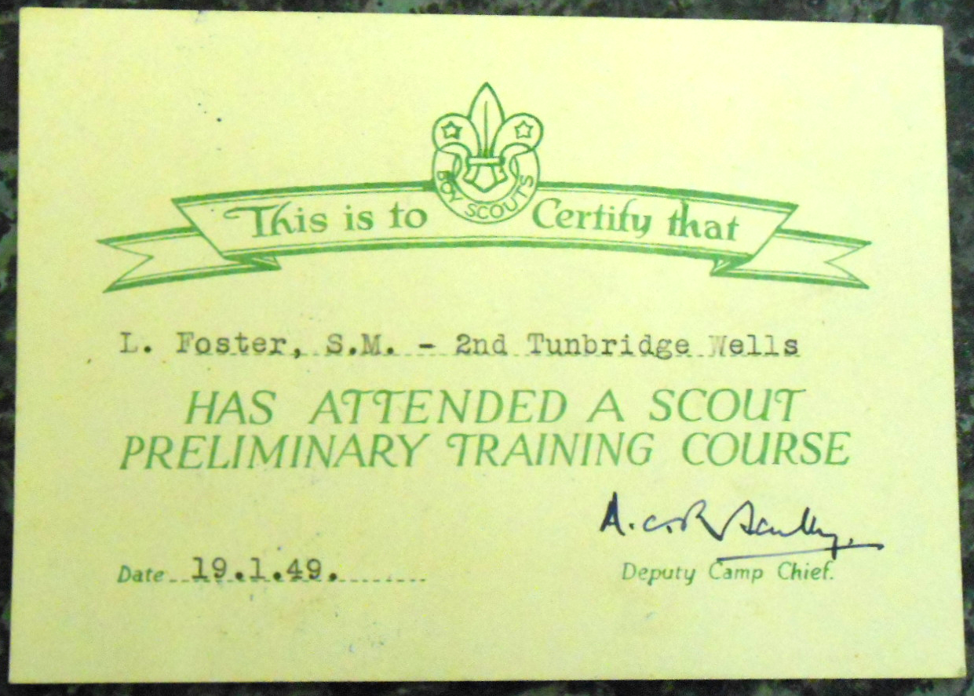  Laurie’s Training Course certificate | On 19 January 1949, Laurie Foster, Scoutmaster attended a Scout Preliminary Training Course.  We do not know that he used his Note Book (“For ‘Recognised’ Scouters Training Camps”) on his course, but it certainly contains invaluable guidance for leaders – woodcraft, method of approach, to maintain interest, estimating, knots & lashings, traditions | 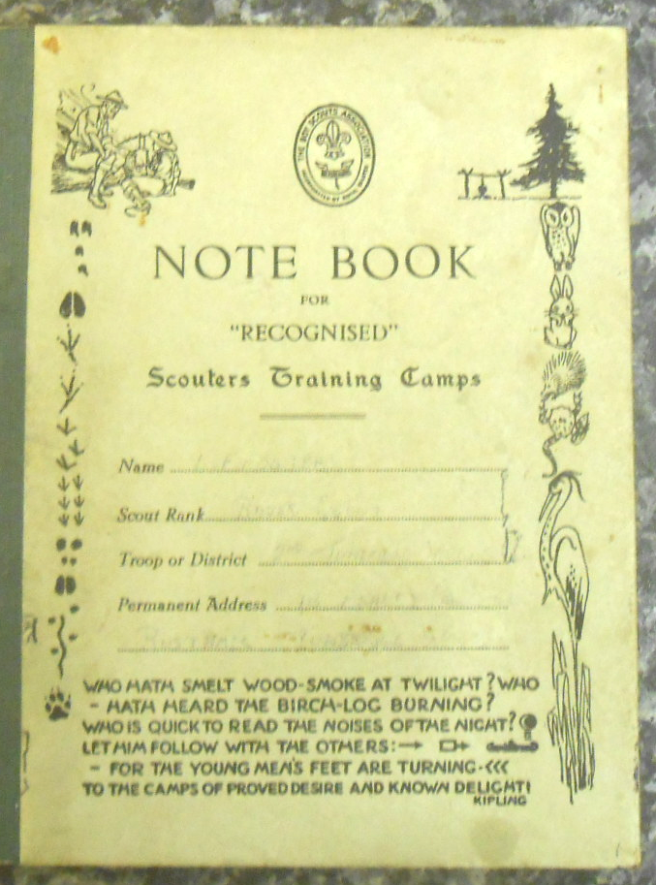  Laurie’s  note book
& good order, town troops, lessons to be learned from Nature – and much more.

He pays great attention to “Feeding and Cooking”, telling us that each boy needs the following average quantities per day – 1lb of bread, 1oz of porridge or breakfast cereal and 1/3ib of potatoes per meal.

His note book also lists quantities of ingredients necessary to satisfy 30 lads – for example 5lbs of flour, 2lbs of suet, 1/2oz of baking powder, 1 gallon of milk per day, 3lbs of sugar per day, 1 large tin of mustard per week.

Having detailed the burning properties of eight types of wood, Laurie provides recipes for suet pudding and pastry.

Laurie uses the remainder of his note book to record information regarding some of his Boy Scouts :

- David Ballard (born 1932) of 36 Grange Road – printer, Wood Press, Tunbridge Wells – badges attained : First Class, Naturalist.
- Antony J Farrer (born 1932) of 86 Grange Road – Skinners’ School - badges attained : Missioner, Artist, F of A ?, Venturer, Camp Warden, Ambulance, Interpreter.
- James Hollamby (born 6.3.30) of 54 Grange Road – apprentice compositer, White Friars Press – badges attained : Ambulance (under 15), Missioner, Engineer, Carpenter, Metal Worker, Blacksmith, Venturer, Forester.
- Harry Howard (born 1932) of 119 Lower Green Road – printer’s general hand – badges attained : Pioneer, Leading Signalman, First Class.
- Dennis Thake (born 1931) of 24 Common View – dental mechanic, Fox, Mount Ephraim – badges attained : Ambulance, Swimmer, Marksman, F of A ?, Missioner, Camp Warden, Venturer.
- Ronald E Pring (born 1932) of 38 Grange Road – GPO messenger – badges attained : First Class.

Perhaps an indication of his future career in the Probation Service, Laurie also records his personal evaluation of some of his lads – apparently regarding a task that he has set them – possibly an essay about Scouting. In different order to the above :

- Probably the most thoughtful of all. Has some idea of what lies behind Scouting.
- Muddled thinker. Inclined to shirk difficult tasks. Will respond to pressure.
- Vague idea of what is required in a Troop Leader. Hasn’t yet thought very much about “Why ?”. Lacks self confidence.
- Good essay. Has obviously taken plenty of trouble over it. Is keen. Lacks power of mental concentration. Is good at sports. Quite intelligent.

Researchers’ notes – What was the F of A badge ?

Each page that details a lad is noted with a duration (eg : 9 months, ½ year, 4½ years). Is this the length of time that, at the time of writing, the lad had been a Scout ?

Being undated, we are uncertain as to the year(s) in which Laurie used his note book. However, we have assumed this to have been between 1946 and 1950

Our Leaders

The October / November 1949 Parish Magazine records :

- The Reverend JMT Griffiths as the Vicar (and we assume Sponsor).  - The Reverend AC Sparling as Curate and Scout Master (the Reverend Sparling left the Parish in 1951 to take up post at Spelsbury, Oxfordshire after 5 years at St Paul’s).  - C Foreman as Assistant Scout Master.  - L Weston as Assistant Scout Master (appointed Scout Master in 1951). | ROBIN B TO INSERT COURIER PHOTO OF MR GRIFFITHS

Rusthall Wins the Franks’ Points Trophy - again

Extract from the October – November Parish Magazine

The Tunbridge Wells Scouts’ Annual Swimming Gala was held on Wednesday, November 2nd at the Monson Road Baths. Our Troop competed in twelve of the twenty events and put up a very commendable performance. The Franks’ Points Trophy, which was awarded to the Troop with the highest number of points, has again been won by Rusthall for the third year running. There was only one point separating the first and second places.

I would like to take this opportunity of thanking our ASM, C Foreman, for his assistance in preparing the entries and coaching the swimmers.

Congratulations, Scouts on a great and sporting performance.

ACS (AC Sparling)

Scout Movement Milestones - 1949

April | First “Bob-a-Job” Week.
August | First International Camp for Handicapped Scouts, Holland.
 | Fourth World Rover Moot, Norway.

Click HERE if you have any further information regarding this year
or
HERE to return to our Navigation page


