Scouting in Rusthall
1960

“Chivalry, one of the first duties of a Scout”

Lord Robert Baden-Powell
(1857 to 1941)
? | We are seeking :  - Further events that occurred this year.  - The March issue of the St Paul’s Parish Church magazine.  - Copies of the Kent & Sussex Courier for this year.  - Any knowledge that you may have of this year.

Can you help ? Please click HERE if you can

A car for the Vicar
From the St Paul’s Parish Magazine - February 1960

Good progress has been made with the fund which was started at the beginning of December.

As a result of the kindly interest and generosity of a large number of parishioners, the total of subscriptions has reached £628.

The car (a Morris Minor) was ordered early, and will be delivered during the first week of this month. A further £41 is required to cover the cost.

News from the Guides – our joint annual party
Saturday 23 January 1960
From the St Paul’s Parish Magazine - February 1960

On Saturday 23 January we had our annual combined party with the Scouts.

The Parents Committees excelled themselves, and gave us all a wonderful meal and very enjoyable programme. Their never failing interest and support is of the greatest possible value, and very much appreciated.

Scouts gain awards – and Cubs become Scouts
From the St Paul’s Parish Magazine - February 1960

Congratulations to Jack Paine – another Queen Scout !

Congratulations to the following Scouts who have obtained their First Class : Mick Cotton, John Bridger, Peter Bass.

Also a good number have obtained their Second Class in record time.

There has recently been a going-up ceremony and R Balls, P Atherall and S Hogben have left the Wolf Cubs. In due course the Cubs will be getting a flag of their own.

We would like to record our appreciation of all that the Committee and parents do to help the Scouts. Many thanks !

Rovers needed - New members of the group would be welcomed.

Annual General Meeting – 7.30pm, 2nd February, all are welcome.
NB

Our Annual General Meeting
2 February 1960

Do you have a copy of the minutes or reports presented at the meeting ? If so, please click HERE .

Scout News
From the St Paul’s Parish Magazine - April 1960

A Night Hike - Three Patrol Leaders and two Seconds attended a PLs’ night hike with other PLs of the District on Saturday 12 March 1960, leaving at 6.30pm and returning at 10pm to a hot supper.

All gained experience in map reading and finding their way by night.

Everyone enjoyed themselves in spite of the mud.

Thanks to John Twort, Assistant Cub Master, Michael Cotton and David Hogben for their assistance in this.

Training – Excellent work is being done with the Second and First Class tests and also Proficiency Badges.

Waste Paper – We have passed the 1 ton mark with paper and many thanks to all for their old newspapers.

Dances – These have been a good fund raiser and over £30 has gone into the funds from them

Scouters Conference, Canterbury – “Sub” Simpson, John Cotton and myself had a wonderful and very interesting day at this.

Senior Scouts – Investiture : Michael Redhead, Michael Cotton and Ian Stacey.

Scout Promotions - Robin Snook to Patrol Leader, Panthers.
- Norman Redhead to Second, Woodpeckers.

Congratulations to both.

The Group would like to wish Miss Coppard every happiness in her married life and the Cubs are very sorry to lose her.
NB
Skip & John “educate” Rusthall Rangers
Monday 14 March 1960
From the St Paul’s Parish Magazine - April 1960

An enjoyable evening was spent with the Tunbridge Wells Ranger Unit when Miss Bunyard explained the formation of clouds in relation to the weather, and how to make a reasonably accurate forecast. Most essential information for hiking and weekend camping !

In return, the Rusthall Rangers extended an invitation to the Tunbridge Wells Ranger Unit for an evening on Map Reading and Squad Drill. This took place on Monday 14 March, and we wish to thank Mr Boxall (Skip) and Mr John Cotton (ASM) for two very interesting sessions on these subjects.

The remainder of our Meetings for this month have been spent in rehearsing a One Act Play to be included in the Guides Jubilee Concert in May.
JP
Blessing of the Cubs’ new Flag
Mothering Sunday
Sunday 27 March 1960
From the St Paul’s Parish Magazine - May 1960

The most important news to report this month is of the Blessing of the Cubs’ new Flag at Evensong on Mothering Sunday.

It was indeed a happy occasion for the whole Group - very many thanks for the generous donations which enabled us to purchase this flag.

News from the Guides
30 May 1960
From the St Paul’s Parish Magazine - July 1960

On 30th May, Mr Boxall (Skip) gave us squad drill in preparation for the Jubilee Rally and also for the March Past of the Tunbridge Wells Guides through the town on 23rd July.

Our Jubilee Rally is to be held at Ramsgate on 2nd July and is for all Guides throughout the County of Kent.

More Scouting news
From the St Paul’s Parish Magazine - May 1960

Bob-a Job Week – At the time of writing we are approaching Bob-a-Job Week, and it is hoped that this will be as successful as last year. More news of this next month.

Four camp at Frant Bottom – John Bridger, keith Lulham, Peter and David Bass have recently had three days camping at Frant Bottom. John and Peter succeeded in obtaining part of their Backwoodsman Badge. Congratulations to both.
The Senior Scouts joined with Crowborough District in a night exercise on Ashdown Forest on Saturday 2 April. Mr Birchmore was very welcome on this “do”.

Seven Seniors assisted with the collection for World Refugee Year at the Essoldo Cinema on April 9th. A total of £34 was collected.

Rovers – I am delighted to say that we have news of Mr Graber’s warrant at last, and hope that he will soon be receiving it.

A Jumble Sale will be held on Saturday 14 May at 2.30pm in the Parish Hall.

We would be very grateful for gifts of jumble. Collections will be made during the week commencing 9 May. Messages may be telephoned to any of the following – Mr Bowler, Mrs Bavin, Mrs Cotton, Mr Ongley.
NB

Cyril “Cy” Graber receives his Rover Leader warrant
Thursday 16 June 1960
From the St Paul’s Parish Magazine – August 1960

All of our readers will, we are sure, be pleased to hear that the Group is now complete so far as warranted Scouters are concerned.

The latest warrant holder to be invested was Mr Graber, our Rover Leader. In the presence of the DC, the Vicar and the Crew, the ADC Mr Jackman re-invested Mr Graber as a Rover. Our DC then presented him with his long-awaited warrant. The ceremony occurred on 16th June in the Parish Church.
JHC & NAB
A report from the Scouts
From the St Paul’s Parish Magazine – June 1960

This month has been one achievement in several spheres. The most important developments have been with our camping sites and one of our hopes looks certain to materialise. Mr Perkins, the proprietor of the Beacon Hotel, has most kindly given us permission to use the majority of his extensive grounds as our own Troop Camping Site. This has led to a great deal of activity, and work has been started on clearing paths, etc (see Seniors Report below).

The summer camping site has also been arranged, and a survey was carried out in April b y Skip (Scoutmaster) and Sub (Senior Scoutmaster). The site is on the outskirts of Bournemouth, and is the camping ground of of the Bournemouth District Scouts. The official name of the site is Butchers Coppice and, although the name does not lead one to consider the site as particularly picturesque, it really is beautiful. Camp, by the way, will be during the second week in August.

The Scouts, together with the Youth Fellowship, took part in the Refugee Fair at the Assembly Hall on 21st May, which was opened by Glubb Pasha. Our thanks to all those who contributed towards our bookstall an d supported this worthwhile endeavour, marking the end of World Refugee Year.

Bob-a-Job Week achieved a grand total of £65 1s 0d, a Troop record ! A certain contribution is levied on the Troop and, after Headquarters has deducted their share, our funds were boosted by £55 17s 6d. A special mention must be made of one of our newest recruits to the Troop, R Jones, who earns our congratulations for his excellent effort in attaining the highest amount. We do hope housewives found that during this week we were perhaps able to lift some of their more onerous burdens and also that we did not impose any extra ones !

Researchers’ note – For his supreme effort, Rick Jones was presented with an award – a small sum or voucher from Simmonds, with which he purchased a pair of long Scout socks. To this day Rick still has them and has undertaken to provide us with a photo of his lower limbs wearing them when he finds them (the socks).

On 14th May, we held a Jumble Sale. This was well attended and raised £25 10s 0d, thanks, of course, to the support we received, which is greatly appreciated.

On 30th April, we held a successful dance for members and friends of the Scout Committee.

On the 1st May, all attended the St George’s Day Service, this year held at St John’s Church and, as usual, the Church was absolutely packed. Although the afternoon was a little cold for shirt-sleeves and shorts, an excellent number paraded.

One note of regret is that M Cotton, one of the few people with the Troop in its infancy, has left the Senior Troop to join the RAF. We are sure that you will all join with us in wishing every success to Michael in his chosen career.

We are immensely proud of Jack Payne who went to Gilwell to receive his Queen’s Scout Badge from the Chief Scout.

There is also another item involving our Senior Scouts as they are representing the District at the Portuguese Jamboree this August. There are only two patrols attending from the whole of this country, and both are from our District. Three boys are from our own Troop and we wish them every success.

The only other items to record this month are two investitures, namely R Jones, Junior Troop, and H Sharp, Senior Troop, and various badges awarded as follows :

Second Class - P Roffe
Woodcraftsman - J Bridger & P Bass
Swimmer - B Knock & R Snook
Bookbinder - N Redhead

A report from the Seniors
From the St Paul’s Parish Magazine – June 1960

This month has been spent in a number of activities by the Seniors, ranging from night operations to clearing the newly acquired camp site.

Already a great deal of work has been put in at the grounds behind the Beacon Hotel. Many paths had to be cleared, quite apart from draining a bog and an overgrown swimming pool. (Editor’s comment : Should anyone wish to see this amazing phenomenon, I am sure the Scouts will be willing to arrange a sightseeing tour !)

On 7th May, 80 Seniors took part in “Operation May-Day”, a night hi ke incorporated in the Venturer badge, in the High Brooms area. The incidents en route varied from foil cooking to patching up injured cyclists. The hike lasted from 8pm Saturday night until 2am Sunday morning, when eight weary Seniors started back towards Rusthall !

JHC (John Cotton)
NAB (Skip Boxall)
More Scouting news
From the St Paul’s Parish Magazine – June 1960

The Girl Guides report tells us of their Jubilee Concert which they had been rehearsing since February.

Unsurprisingly, Mrs Stacey’s remarkable skills proven at our Gang Show were put to excellent use – she was the Producer of the Guide and Brownie items. Other parents and friends made for a very successful show by providing stage management, music, props, costumes, lighting, make-up and scenery – amongst them, the Senior Scouts and Rovers looked after stage carpentry and “front of house”.

The magazine also includes a very vivid history of Rusthall Girls School, written by Miss EV Pearson, the then Headmistress.

She tells us that “A large hall for recreation and leisure use was built in the field for the wounded soldiers’ use. The only part of this now left is the Scout Hut. This section was the Operating Theatre attached to the VAD Hospital.

Researchers’ note – This suggests that the Operating Theatre (later to be the Scout Hut) was part of the large hall, the rest of which was later demolished. However, the following supports the theory that it was a separate building :

- A report of the winding up, which appeared in the Courier of 30th June 1922, states that: ‘Owing to Mr and Mrs Yates having allowed the Committee to earmark their donation of £400 to the building fund of the huts to secure one for the Boy Scouts when the Hospital was closed in the Autumn of 1919, the present Scout Hut had been handed over to the Vicar of Rusthall for the use of the Scout.’
- Our recollection that the Scout Hut had its entrance in one wall and windows in the three others.
- We feel that the work of the Operating Theatre would dictate that it was located separately, as a building in its own right.

In time we will be examining the documents held by Tunbridge Wells Museum that relate to the sale of the hut(s) in the early 1920s.

Meanwhile, do you have any photos or knowledge that would resolve our doubt ? If so, please click HERE.

Some of us were members of the Youth Fellowship too
From the St Paul’s Parish Magazine – June 1960

If it’s proof you want – here it is ! A group oif our young people on their Easter Monday Hike to Bayham Abbey. In this photograph they look reasonably fresh – but this was taken quite early in the day. After 20 miles we were all feeling rather less energetic !  During the few weeks before 21 may, No 6 Ashley Gardens became a book store and in consequence the Youth and Scout stall at the May Fair was swamped. Very many thanks to all those who sent books and who gave time and energy in the preparations for the Fair. It was a great success.  Our Sunday programmes during May started with talks from another trio from the Parish - this time men. | 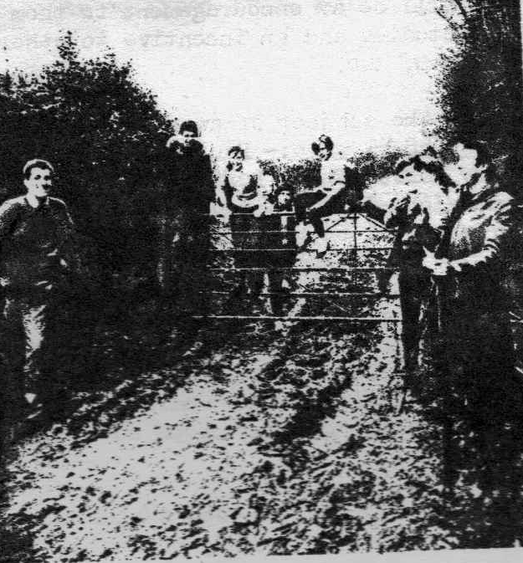

Messrs G Draper, W Bowler and N Boxall (Skip) each spoke of their life and experience as Christians, and the conclusion we came to was quite definite – being a Christian can make all the difference to life, and if it doesn’t – then there is something wrong !

On Sunday 15th we discussed two rather topical questions “Apartheid” and “American Spy-Plane Incident”. What should the Christian’s attitude be towards those things ?

Then on Sunday 22nd May we were very pleased to welcome the Rev Pears, Rector of Penshurst, who spoke to us on the subject “The Science of God”.

One final point – like the Scouts, we will miss Mike Cotton as he goes off to join the RAF as a Boy Entrant, and our thoughts and prayers and best wishes go with him.

Brian Birchmore

Researchers’ note – The Parish Magazine of February 1960 tells us that John Cotton was Chairman of the Youth Fellowship and John Twort the Treasurer – and that they were to attend a Rochester Diocesan Federation of Youth youth leaders’ weekend.

That of November 1960 tells us that more members of the Scout Group became increasingly active within the Youth Fellowship, whose AGM was held on 20 October. At the meeting, the following were elected :

- Chairman : Eric Simpson (on the retirement of John Cotton)
- Secretary : Kenta Powell
- Treasurer : Bob Brown : (on the retirement of John Twort)
- Under 16 representatives : Peter Wale & Pamela Herbert
- Over 16 representatives : Malcolm Coppard & Betty Cptton
- Leaders : John Twort & Jean Tucker

More news from the August 1960 Parish Magazine

Scouts – Since Whitsun, very little has been achieved as everybody seems to be thinking about our Summer Camp. However, on a wet Tuesday evening the Troop descended on the Hurst Woods for a “wide game” (for the uninitiated, this is a general rough and tumble where one team endeavours to “kill” the other).

We have just launched a Troop Patrol competition 1 or 2 lines missing from photocopy (to be checked on next visit to Kent Archives) sketching ; a 10 mile patrol hike; producing a 15 minute Onplay and organising a Troop programme.

A heartening crowd turned out for Church Parade on the Dedication Festival when we heard the Bishop of Tonbridge give an excellent address.

One of our most promising Senior Scouts, Jack Payne, is now tackling another badge. This time he had to look after a small Troop by himself for 48 hours amongst other things.

It should be mentioned that Nicholas Fairhall has now completed his Tenderfoot and Graham Marchant his Second Class.
JHC & NAB

Our Cubs are awarded the District Sports trophy
Skinners’ Southfields playing field
Saturday 2 July 1960
From the St Paul’s Parish Magazine – August 1960

On 2nd July, our Cubs were awarded the trophy as runners-up to Pembury in the Sports which were keenly contested by 18 Packs during the Annual District Rally on Skinners’ School playing fields.

Our points, obtained by three firsts and two seconds, were all gained during the second half of the programme so our final success, especially with 7 Cubs competing for Rusthall School at Ramslye, was quite a surprise and all the more rewarding.

This is the third time since Mr Godfrey Phillips presented the trophy in 1946 that it has been carried off to Rusthall, previously on the 81 ‘bus – but this time, by the kindness of Mr Marks and ACM John Twort, there was added the thrill for us all of being driven home by car.
EF Brankston
XI National Scout Camp - Portugal
5 to 15 August 1960

Three Rusthall Senior Scouts, Jack Payne, Dave Green and Robin Boxall were invited to join a small contingent from Tunbridge Wells to represent Kent County Scouts at the XI National Scout Camp at Estoril, Portugal. The contingent was led by Mr Quinn Williams, Group Scoutmaster of 7th Royal Tunbridge Wells (The Skinners’ School), and included some of his Senior Scouts and others from 1st Royal Tunbridge Wells (Pathfinders) Troop. The members of the contingent are shown below :
 |   Camp Logo
  Contingent Leader
  Mr Quinn Williams - 7th Royal Tunbridge Wells (The Skinners’ School)
  Assistant Leader
  Mr Paul Welch 7th Royal Tunbridge Wells (The Skinners’ School)
  Rusthall  2nd Royal  Tunbridge Wells  Jack Payne  Dave Green  Robin Boxall | The Skinners’ School  7th Royal  Tunbridge Wells  Colin Hayward  Tony Neale  Dennis Court  Peter Hitchin | Pathfinders  1st Royal  Tunbridge Wells  Bob Constable  Keith Goodyear  Colin Scott
On arrival at the camp site in Portugal, the Kent Scouts were joined by a group of five Senior Scouts from Solihull, West Midlands, thus swelling the UK contingent to 16.
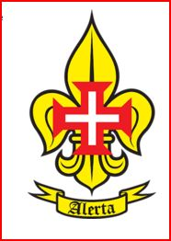  CNE  Membership  Badge | The camp, organised by the Catholic Scout Association of Portugal (Corpo Nacional de Escutas – CNE), was attended by around one thousand Scouts, mostly from Portugal, Angola, Mozambique and Brazil although Finland, France, Spain, Germany and the USA were also represented. The attendance of the Spanish Scouts was of interest since Scouting in Spain was still effectively an ‘underground’ movement. Spanish Scouts were founded in 1912, but formal recognition was withdrawn in 1938 due to the political situation and was not reinstated until 1978. (Interestingly, in 1979, members of Rusthall Group witnessed the ceremony in Madrid which recognised the establishment of the Federation of Scouting in Spain. Nonesuch Green – Rusthall’s folk group were guests of the Spanish Scouts, performing at a national Scout and Guide music festival).  The group travelled by rail to Lisbon via Paris and Hendaye/Irun and the journey took over 36 hours. Dave Green remembers that he and Jack Payne had to endure the hardship of sharing a compartment with six Belgian Guides on the overnight journey across France.
The change of trains at the Spanish border was somewhat chaotic and the onward train journey through Spain and into Portugal was slow and uncomfortable. The coaches, mostly with wooden seats, were crowded and quite stifling during the intense daytime heat. There were innumerable stops to allow local passengers on and off. Among them a few ‘characters’ like the old woman carrying her prized chicken under arm and a couple of farmers on their way to a market who taught some of us the art of drinking wine from the traditional ‘bota’ or wineskin bag.
The group was met in Lisbon by local Scout representatives, who arranged a transfer by high speed taxis across town to the local train station for the final leg of the journey to the campsite at Estoril. The party was relieved to find that none of their belongings had dropped off the roof-racks or from the insecure boots of the taxis.  Camp fare was varied to say the least although there was a standard daily ration of sardines, bread, water melon and flagons of wine. The daily wine ration was a novelty at first but by the end of the stay most were glad to swap the wine for a decent cup of tea. |  |  |  |  | 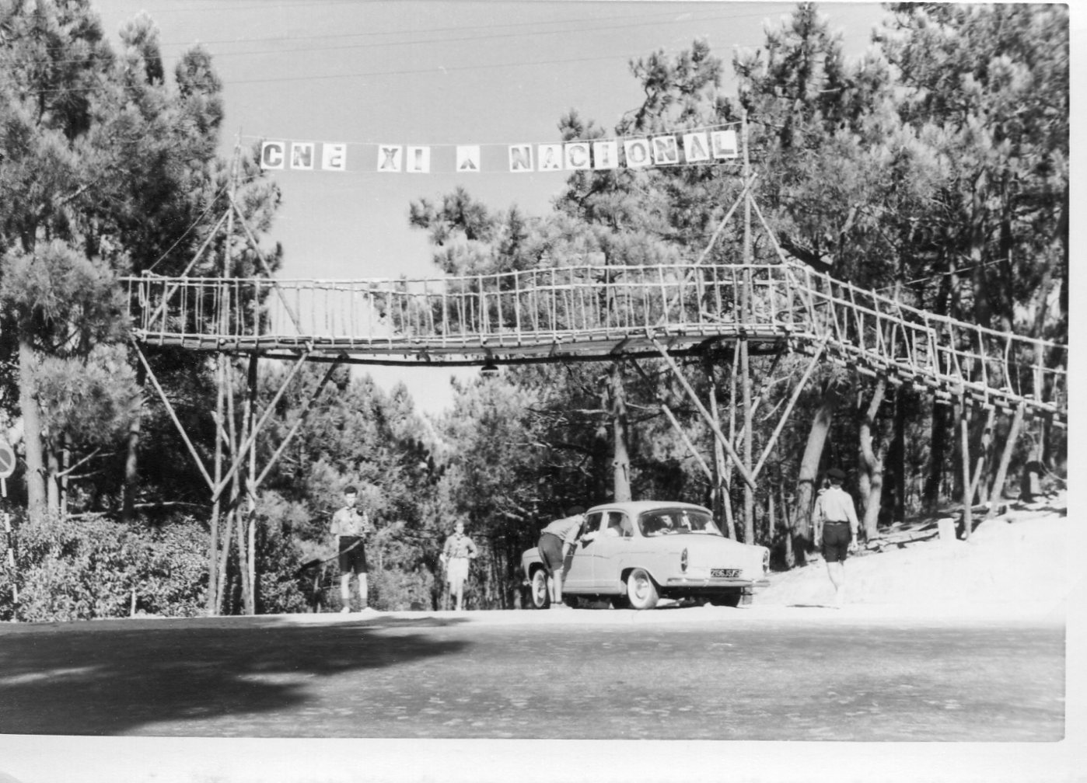  Camp Entrance  Estoril
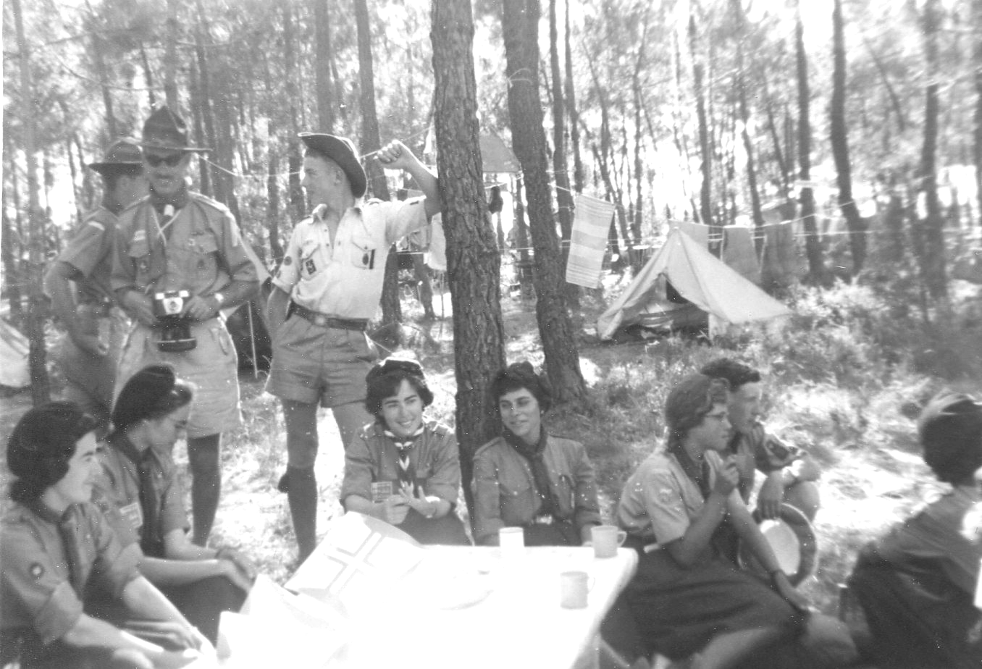  Tea Party |  |  | Camp activities included a number of sporting and scouting competitions, a treasure hunt, camp fire sessions, hosting and visiting other groups for | 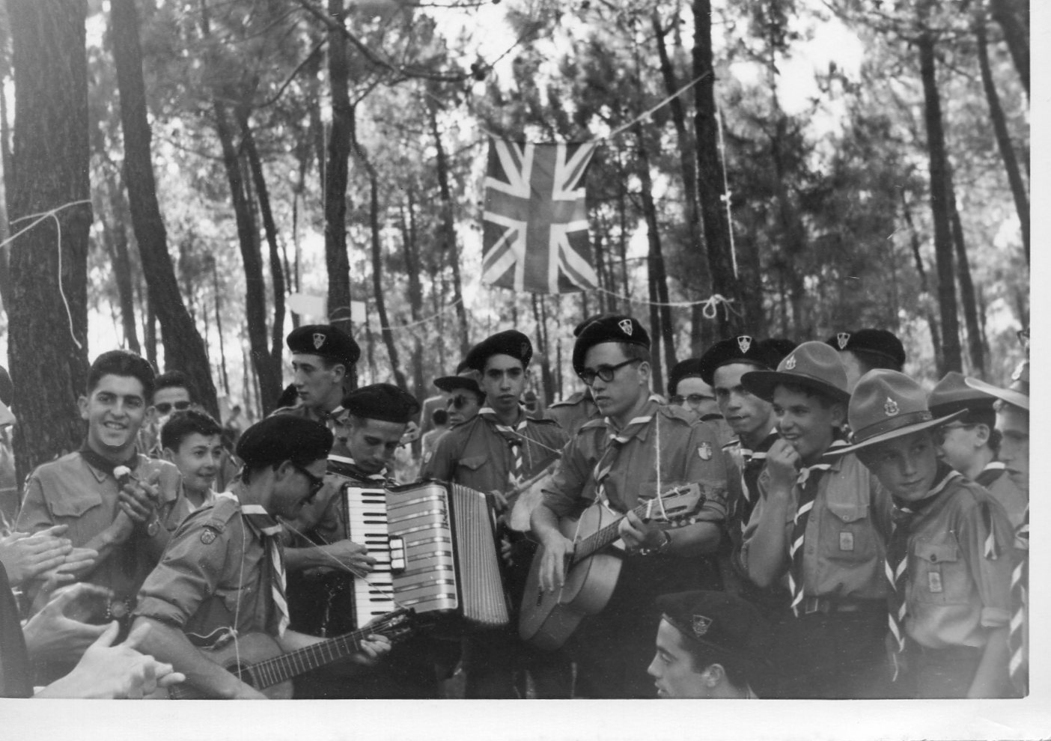  Wandering minstrels entertain the UK Contingent
lunch and afternoon tea, the usual visits around camp to swap badges, belts and in some cases complete uniforms. Overall there was a relatively relaxed atmosphere, thus allowing ample free time for visits to the beach at Estoril, to Lisbon and the nearby fishing village of Cascais.
The Scout Camp was arranged to coincide with the Portuguese International Youth Camp in Lisbon and around 300 Scouts were invited to lunch as guests of the Portuguese Youth Organisation (Mocidade Portuguesa) before going on to participate in the parade and ceremony to mark the inauguration of the Discoveries Monument, also known as the Monument of Prince Henry the Navigator, in Lisbon.  The Monument which stands on the north bank of the River Tagus River commemorates the 500th anniversary of the death of Prince Henry the Navigator. It represents a three-sailed ship ready to depart, with sculptures of important historical figures such as King Manuel I, the poet Camões, Vasco da Gama, Magellan, Cabral, and several other notable Portuguese explorers, crusaders, monks, cartographers, and cosmographers, following Prince Henry the Navigator |  |  |  |  |  | 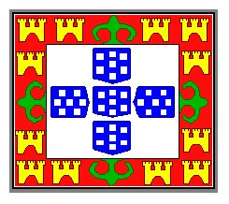  The Mocidade  Portuguesa Banner
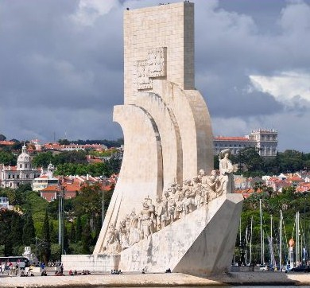  The Discoveries Monument  Lisbon |  | A visit was also made to the nearby Belem Tower, built in 1515 as a fortress to guard the entrance to Lisbon's harbour, it was the starting point for many of the voyages of discovery, and for the sailors it was the last sight of their homeland.  A short cruise on the river Tagus followed during which there was lot of singing and musical entertainment from some of the Portuguese Scout bands. The cruise included a viewing of the newly opened Salazar suspension bridge (renamed in 1974 as the 25th April Bridge) and a visit to the statue of Christ the King on the south bank of the river Tagus. |  |  |  | 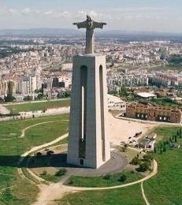  Statue of Christ  Lisbon
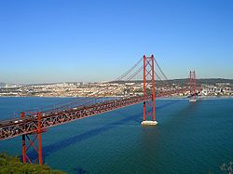  Salazar Bridge  Lisbon |  |  |  |  |  | 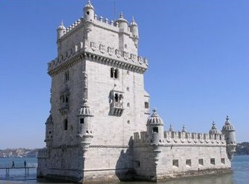  The Belem Tower  Lisbon
Other official excursions during the week included visits to the villages of Setubal and Sesimbra and the Mount Arrábida National Park, a protected area famed for its pine trees, rich Mediterranean vegetation, and a 6th century monastery at the peak.
From the St Paul’s Parish Magazine – October 1960

On Tuesday 2 August, a party of ten Senior Scouts (three from Rusthall Troop) and two Scouters set out from Tunbridge Wells on the first leg of our journey to Portugal. At Victoria, the full UK contingent assembled, a total of 16, we were the largest overseas contingent at the camp

After two days travelling through France and Spain we arrived in Lisbon. The journey was fairly comfortable, although the temperature reached 95 degrees through Spain !

Camp officially opened on Sunday 7 August in true military style with a parade of colours.

Autograph hunters were all over the place. We tried to keep count of the number, but gave up when it passed the 150 mark !

Camp life was easy. During the many free periods international competitions were organised. Of the overall total our UK team finished ninth out of 72, Portuguese teams taking the first eight places.

Invitations to wine parties were innumerable and so, in return, we sent out invitations to tea parties, which were enjoyed by many foreign contingents.

The camp closed on 14 August and, at almost midnight on 15 August, we bade farewell to Lisbon and the party of Portuguese Scouts on the platform, and began our 1,800 mile journey back to Tunbridge Wells.

13th Kent County Jamborette
Knole Park, Sevenoaks
6 August 1960

Did our Cubs take part ? Please click HERE if you know.

Summer Camp
Butchers Coppice, Bear Cross, Kinson, near Bournemouth
6 to 13 August 1960

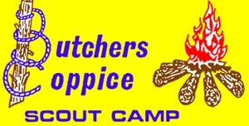 | This was a large camp which included 30 Scouts, 6 Senior Scouts, 1 Rover Scout and 5 Scouters.  There are Summer Camps with a difference that one will never forget – Butchers Coppice was certainly one. Perhaps our wettest Summer Camp ever !

On arrival, Johnny Bridger claimed a comfortable, lush, shallow hollow for his patrol’s tent – “A good spot – nicely sheltered”. Within a couple of nights of persistent rain, Johnny’s inflatable Lilo was seen floating out of his tent! His and the other patrols (except the Panthers) necessarily relocated to the Butchers Coppice Scout Hut for the remainder of the week.

Two of our Senior Scouts cycled the 134 miles from Rusthall and, upon their arrival, entertained us with awesome tales of their epic “voyage” – not least, of having sheltered under a large oak tree which was then struck by lightning.

Was this the year that Roger Graber, Patrol Leader of the Ravens, was prescribed light duties - in fact that he perform no domestic chores whatsoever? Was his walking stick really sufficient evidence that he had just had his appendix removed?

Rod Bavin performed culinary wonders with ingredients from our Quartermaster’s Stores. Donald Hartwell (of the ever ravenous Panther Patrol) asked for more custard (that Rod had accidentally [?] mixed with methylated spirit).

However, our Leaders miraculously adjusted our intended activities to a wet weather programme – in many ways better fun than had the weather been good. What better than swimming in the open-air pool in the pouring rain – John Twort had come well-prepared – with his snorkel and face mask !

Because of the rather inclement weather, the visiting Commissioner was unable to carry out a full inspection as he could not get to the site on the day that he intended. He subsequently made a brief visit. In his report he stated that the Bailiff was very pleased with the standard of the camp and that the Scouts had coped well in the difficult conditions and had made the most of their opportunities on the fine days.

From the St Paul’s Parish Magazine – September 1960

News this month is almost solely confined to the Summer Camp, held this year at Kinson, 4½ miles from Bournemouth.

It was our biggest camp with 31 juniors, 4 seniors and 6 Scouters. Quite a family !

Unfortunately, the weather did not do the camp justice – 58 hours of rain ! During the “monsoon period”, the majority of the lads evacuated to a hut on the site. Despite the cramped conditions everyone was surprisingly well-behaved, although a riot nearly broke out on Saturday morning when they were asked to rouse a Troop from Dunstable. Well, what would you expect …… ?

Looking on the bright side, we do remember seeing the sun on one or two occasions and “a small amount of tan was obtained”.

We were indeed very lucky to have an official Scout camping ground at our disposal – with small swimming pool and all mod cons !

We were very pleased to have Mr Birchmore with us for the first half of the week and the Vicar for the second. Mr Birchmore turned out to be a great help with the swimming activities. He even extended his enthusiasm to his return journey ! The Vicar set us all a good example in cooking in the rain. He even set about the “Blue whitener” on the washing.

Another good bunch of swimmers were our parents who swam in like a tidal wave early Wednesday afternoon. All were very pleased to see them and the afternoon was brighter for their presence. (Editor’s note – One correspondent tells of this “parental outing” with details of cloudbursts, fish and chips and “getting lost”. In all the rain, the coach driver seemed a little “at sea” – and what with passing through “snow-covered” Haywards Heath, taking the wrong turning and ending up “in Russia”, our parents seemed to have passed a stimulating and hilarious day !!!)

One noteworthy achievement was that, during the Camp, John Bridger was awarded his Scout Cord (Congratulations, John). The next step is his Queen’s Scout Badge.

Thanks to the high morale of the Troop and everyone’s hard work, the local DC signed a certificate known as “Camping Standards” (this shows that the camp as a whole was up to the standard expected by Headquarters).

Our Scout Group will be holding an Autumn Fair on Saturday, 10th September at the Rusthall Girls; School to be opened at 2.30pm. We hope that you will support us on this day – because we are trying to raise sufficient money for a new Scout Headquarters.
JHC & NAB

Vicar’s Viewpoint
From the St Paul’s Church Parish Magazine – September 1960

One often hears it said, “What’s wrong with the young people of today ?”

I have just spent a few days in camp with our Scouts and I came away enormously impressed with these young people. It was at the same time a most refreshing and humbling experience.

Given the right leadership, with a purposeful sense of direction, young people will make an immediate response. They are, however, quick to see through anything third-rate or meretricious, and here lies the challenge.

The question properly phrased is not so much “What’s wrong with the young people of today ?”, but “How have we, the previous generation, let them down ?”.

Mr Darwin, the Principal of the Royal College of Art, in a recent speech reported in the Daily Telegraph, said, “Young people today are offered unprecedented opportunities of material welfare and mass extinction, with equal generosity. Thus the ‘beat’ generation, denied the opportunity of carrying any burden, or of shouldering any responsibility, are making a virtue of travelling light”. He goes on to say, “I have no doubt at all that it is we, of an older generation, who by some lack of discipline perhaps, or by some failure to define the boundaries of belief, have left the young with so little sense of direction”.

On the first Sunday of each month we have a Youth Service at 6.30pm. The Church is packed with our young people. If all the mothers and fathers came too, I really do not know where we should put them, but that would be a happy calamity.

If you are a parent, will you give this your prayerful thought ?

The New Churchyard
From the St Paul’s Church Parish Magazine – September 1960

Those who have relatives buried in the New Churchyard are seriously inconvienced by the lack of water there.

If we make this a “do-it-yourself job”, it has been estimated that a water supply could be laid on for about £50.

The matter was discussed at the last Church Council Meeting and it was decided to invite contributions at 10/- per head from those who would benefit by the supply. Contributions to me or the Wardens, please.

Researchers’ note – In total £59 was donated, sufficient to cover the cost of materials. An account of this tremendous voluntary task of digging the trench may be seen in our account of Scouting in Rusthall in 1962.

Our Autumn Fayre
Rusthall Girls’ School
Saturday 10 September 1960
From the St Paul’s Church Parish Magazine – October 1960

Yet more grey hairs have accumulated thanks to our Autumn Fayre but, looking at the results, they are worth it !

This time the Scouters were given a rest so far as organisation went and the back-breaking task was undertaken by the Chairman of our Committee, Mr Latter, and his ever-valiant family of Mums and Dads. We cannot thank them all enough,

We were also very grateful indeed to Miss Daphne Padell who judged the fancy dress and Mr Maples who opened the fayre for us.

The final result is not yet available but a figure of £75 has been given by our Treasurer. This does not look much when one considers the cost of building a new headquarters, but the incentive has now been given for further ventures of this nature.
JHC & NAB

More Scouting News
From the St Paul’s Church Parish Magazine – October 1960

Operation Challenge cometh – By the time you read this report we shall have taken part in one of the nation’s hardest yearly Senior Scout activities – Operation Challenge.

This requires the utmost perseverance and continuous physical and mental effort – day and night. This is no small request for lads of 15 years and we hope that the results will be as good as last year.

A series of dances – During the coming winter months we intend running a series of dances as we have in the past, so keep a look-out for notices of these !

Badges awarded - ● Second Class - Mick Priest, Graham Marchant, Clive Webb
● First Class - Robin Snook
● Athlete - Norman Redhead, Dave Bass, Peter Roffe
● Cook - John Bridger
● Camper - John Bridger
● Metal Worker - Rod Norman

Congratulations to all on attaining a very good standard.

Rovers – Have you got any old toys lying about in your home ?. If you have, please let us have them for renovation and distribution to needy children at Christmas time.

We will arrange to collect them if you contact Mr Cyril Graber, 8 Weller Road (Tel 20630) or Mr Rodney Bavin, Central Stores, Rusthall.
JHC & NAB

Rusthall Guide Company Summer Camp (Bexhill, 27 August to 3 September) – We were very grateful to four of our Scouts, Robin Boxall, John Bridger, Keith Lulham and Peter Bass who camped nearby, and were most helpful in many ways. We have never had such a wonderful stack of logs !

They returned home after the weekend but came back at the end of the week and we were very glad of the extra help when the rain made things difficult.

We had wonderful camp fires which were enlivened by some Scout songs and yarns. These were very popular with the Guides !

We are often asked why we make such a point camping. It is the place where all the Scout and Guide training can find the fullest expression, and the fellowship that exists between us after a camp is not possible in our comparatively short weekly meetings.
MEM

From the St Paul’s Church Parish Magazine – November 1960

Now that the dark evenings have arrived, our activities have been mainly indoors, but we did manage one torchlight “wide game” on Happy Valley.
JHC & CS
Operation Challenge
Saturday & Sunday, 24 & 25 September 1960
From the St Paul’s Church Parish Magazine – November 1960

This took place over the weekend of 24 and 25 September and about 80 teams took part. They started out from four separate points during the Saturday evening and hiked for a considerable distance.

They were asked to construct a “Purpose”, which took the form of a sort of wheelbarrow.

Later they had to cook supper by primus stove – how would you like fried herrings at 2am on Sunday morning ?

The last three miles of the hike were undertaken with the “Purpose” loaded with 28lbs of earth. It was now found that “Purposes” do have a purpose ! (The Editor is still a little in the dark !)

During the Sunday morning, the teams were asked to perform various tricks and, out of a cocoa tin, three pieces of wood and and a length of sisal, they constructed an automatic candle snuffer which would operate from a distance of 20 feet.

By the side of a river, the “Purpose”now had to be launched with the aid of polythene bags, and their load was supposed to be clear of water !

At the end of this somewhat energetic endeavour Tunbridge Wells came home feeling rather proud; one of the town Troops, the Pathfinders, came first and one of our teams came 12th, only five points behind the leaders ! Our second team, which entered mainly for the experience, came 42nd, 16 points behind the leaders.

Congratulations to all concerned.
JHC & CS

9 Scouts are Confirmed
St Paul’s Church, Rusthall
Sunday 4 December 1960

The Confirmation Service, held in St Paul’s at 6.30pm on Sunday 4 December, was conducted by Bishop JC Mann.

Amongst the 32 candidates were Bert Hyder and the following Rusthall Scouts :

Peter Bass | Philip Cotton | Barry Pride
Richard Boxall | Nicholas Fairhall | Peter Roffe
Malcolm Coppard | Roger Hyder | Ian Stacey

The majority of the remainder were Rusthall Girl Guides.

New Year’s Eve

The Group staged a successful New Year’s Eve Dance – much appreciated by friends and village residents.

Scout Movement Milestones - 1960

August | National Sea Scouts' Jubilee Camp.
 | Third World Scouters' Indaba, Netherlands.
 | World Scout Membership - 8,876,707.

Click HERE if you have any further information regarding this year
or
HERE to return to our Navigation page


