Scouting in Rusthall
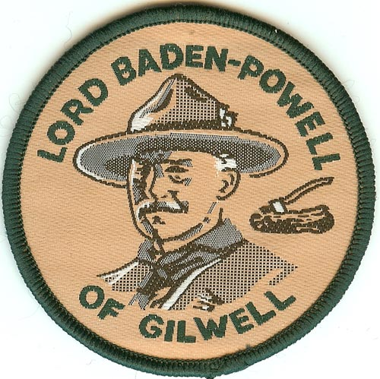
1961

“Follow me and we'll pitch our tents under the open sky. We'll light fires, cook our own grub, send signals, and read the meaning of tracks and signs. We'll find our way by the sun and stars and blaze trails through the wilderness.”

Lord Robert Baden-Powell
(1857 to 1941)
? | We are seeking :  - Further events that occurred this year.  - The September issue of the St Paul’s Parish Church magazine.  - Copies of the Kent & Sussex Courier for this year.  - Any knowledge that you may have of this year.

Can you help ? Please click HERE if you can

Four of our Seniors attain the Queen’s Scout Award | 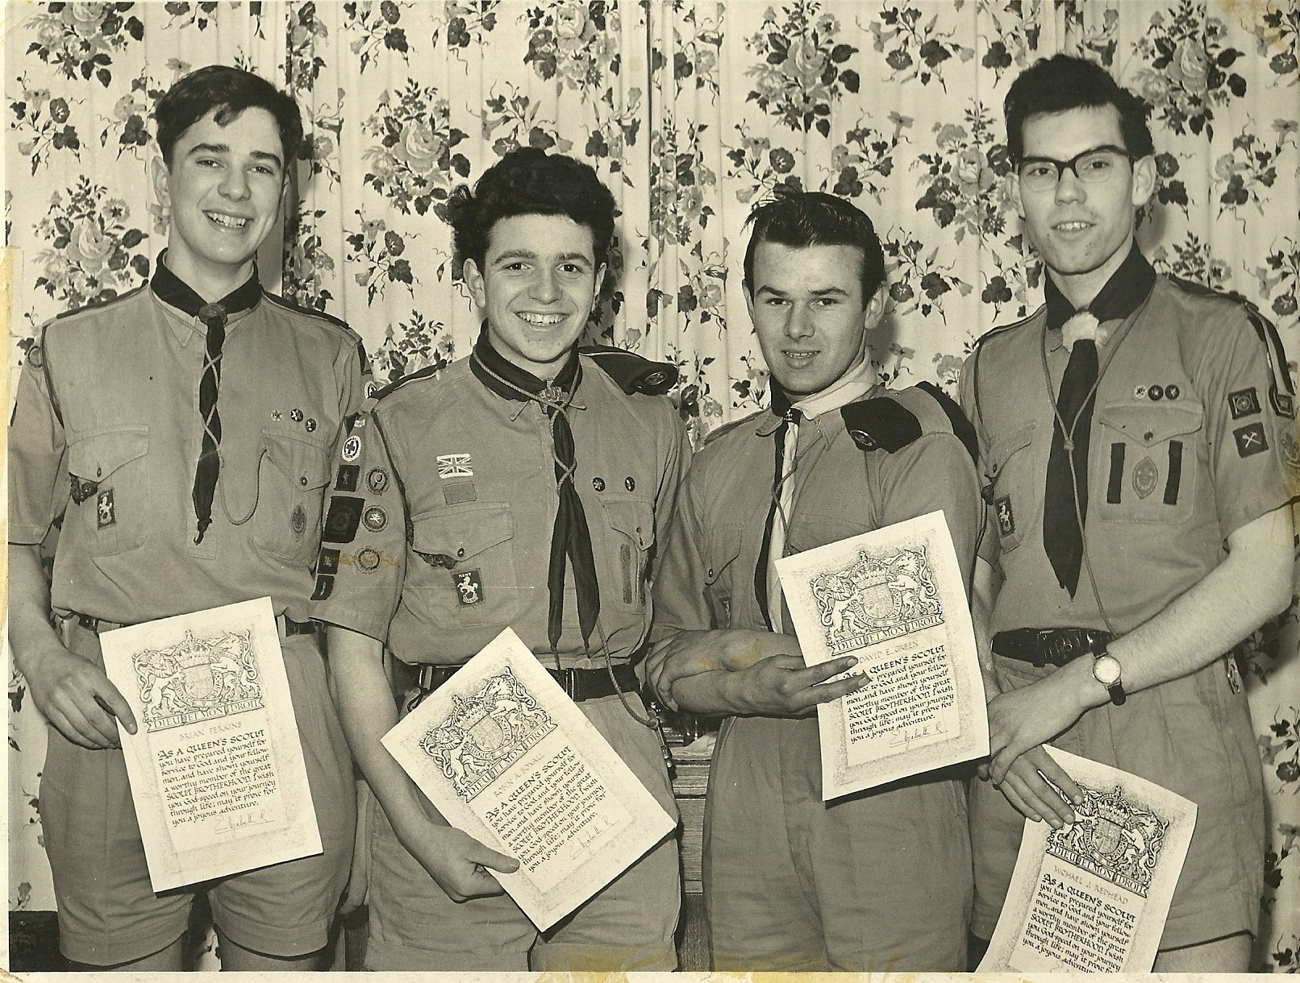  Brian Robin Dave Mick  Perkins Boxall Green Redhead
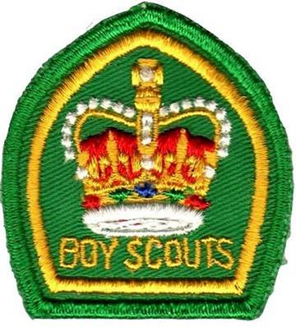

Party Time !
January 1961

The Scouts Parents Committee arranged two parties this month – a Scout and Guide party on 21st January and a Cub party on 28th January. The Scout and Guide Party included dancing and games with a buffet supper, whilst the Cub party was devoted to games. Tea included hotdogs and cakes.

Our first Rover Investitures
January 1961

The Parish Magazine records the first investitures of Rover Scouts – John Twort and Terry Wale. The investiture took place in the Mission Church and was the first to be conducted by Rover Leader Cy Graber. Rev. Brian Birchmore also participated and closed the ceremony with prayers.

Rover repairs
January 1961

The Rover Crew were undertaking a project to repair and renovate donated toys and similar items to be presented to local hospitals.

Search for a new Scout Hut ?
February 1961

According to an entry in the Parish Magazine the Group was actively searching for a new Scout Hut. Several potential buildings had been seen and the general style had been agreed.

Second Class Badges awarded
February 1961

Second Class badges were awarded to Ricky Jones, Philip Cotton and Ian Revens.

Scout & Guide Valentine Dance
Mission Hall
Saturday 11 February 1961

The Scouts and Guides greatly enjoyed a Valentine Dance in the Mission Church on Saturday 11 February.

Visit by Ilford Scouts
Friday 10 to Sunday 12 February 1961

Rusthall entertained a small group of Scouts under the leadership of Mr Palot from Ilford. The visitors arrived on Friday 10th February and ‘pitched camp’ in the Mission Hall. Rusthall Scouts accompanied their guests to a swimming session at Tunbridge Wells swimming pool on Saturday morning and rock climbing at High Rocks on Saturday afternoon and Sunday morning. The visitors also joined the Scout and Guide Valentine’s Dance at the Mission Hall on Saturday evening.

Senior Scouts brave the winter chill
February 1961

Five Senior Scouts, Jack Paine, Brian Perkins, Dave Green and Mike and Norman Redhead undertook a 30 mile, 2 night hike.

Tunbridge Wells Senior Scouts ‘Lernantaro’ weekend
Saturday 18 & 19 February 1961

Rusthall Senior Scouts joined with others from Tunbridge Wells and Crowborough District at the ‘Lernantaro’ (Esperanto for ‘a collection of learners’) event at St Barnabas Hall.

Participants were able to try out a whole range of sports and activities, some familiar and others less so. Rusthall Rover Crew were on hand to provide assistance and catering for the event.

Astivities at the Beacon
March 1961

The Scouts and Senior Scouts spent a lot of time clearing the training ground below the Beacon Hotel.

Two Saturday afternoon Scout training sessions were held. Activities included pioneering, tracking, and backwoods cooking.

Skip noted in a report for the Parish Magazine that the cooking was of a very high standard. Several pigeons were baked in clay or spit-roasted and different vegetables were cooked without utensils.

First Aid, another First Class Scout
and 4 new Seniors
March 1961

Over the past few months Scouts and Senior Scouts have received first aid training for First Aider and Ambulance badges from Mr Pat Gray. The final exams were held this month and the following awards were made :  First Aider badge - Trevor Barker, Richard Boxall, Stephen Hogben, Graham Marchant, David Ongley and Kevin Sheldon.  Ambulance Badge - Mike Redhead, Norman Redhead, Brian Perkins and John Bridger. | 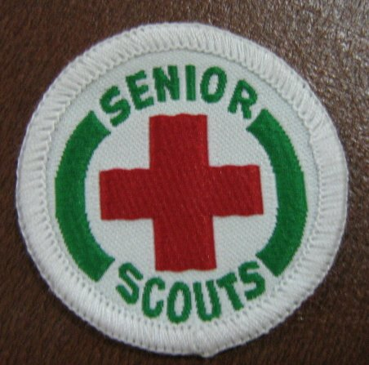

Researchers’ note - The Ambulance Badge was a Public Service badge that was an obligatory requirement towards the Queen’s Scout Award.

In the Senior Scout Troop, Ian Stacey gained the First Class Badge.

New members, Peter Bass, John Bridger and Roger Graber were welcomed up from the Troop.

Further Training
Saturday 1 April 1961

A practical training session in map reading and tracking was arranged for Scouts working for the First Class badge.

Three parties set out from Rusthall for Holtye Common, via Withyham and taking in the Roman Road near Holtye. The first party laid the trail for others to follow.

The exercise was completed successfully and in good time. All returned home by bus.

Senior Scouts’ Cultural Experiences
April 1961

The Senior Scout programme has included some more unusual activities.

Mr Tom Bass gave a stimulating talk on North America, focussing on the struggles between early white settlers and the native Red Indians.

On 8th April the Senior Scouts spent an evening in London which included a visit to the Whitehall Theatre to see a performance of Brian Rix in the farce ‘Simple Spymen’.

A month of Church Parades
April 1961

The Troop and Senior Scouts joined a number of Church Parades this month :  - A parade for the Oddfellows Church Service at St Paul’s Rusthall.  - The District Scout St George’s Day Parade in Tunbridge Wells.  - The Commonwealth Youth Service which saw Scouts join with other local Youth Organisations to parade from Rusthall to St Paul’s Church.The parade was led by the bands of the Tunbridge Wells Sea Cadets and the Boys’ Brigade.  District Commissioner Mr PA Godfrey Phillips presented Queen Scout Badges to Robin Boxall and Dave Green after the District St George’s Day Parade. | . 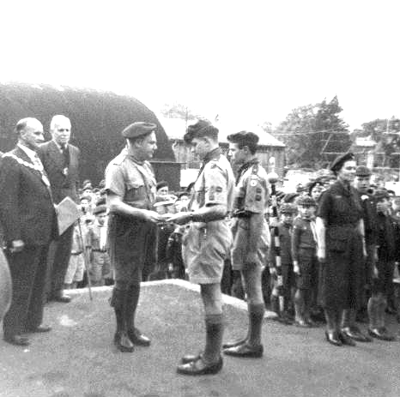

Whitsun Camp
The Beacon
May 1961

The Troop Whitsun Camp was held in the grounds of the Beacon Hotel.

The camp was arranged as a patrol training exercise and each patrol was expected to be self-contained – and responsible for arranging menus and activities.

However, the weekend included some joint activities and a working session to clear more of the undergrowth from the site.

A Queen’s Scout and
Duke of Edinburgh’s Award holder
May 1961

- The Queen’s Scout Badge is awarded to Brian Perkins

- The Duke of Edinburgh’s Silver Award is gained by Mike Redhead

Senior Scout Community Service  16 June 1961  Clearing and restoration of the swimming pool (the top of the three lakes) at the Beacon grounds.  Skip gets stuck in with the work to clear the ‘swimming pool’ | 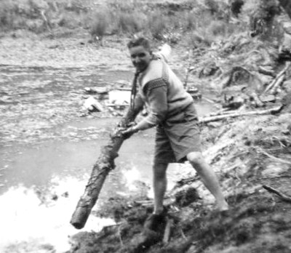

Rusthall recognised as a Founder Group of
Baden Powell House
4 May 1961

Baden-Powell House, the hostel and conference centre for Scouts was built in South Kensington, London, as a tribute to our founder. It was completed in July 1961 at a cost of £400,000. Funding for the building and furnishings was raised between 1957 and 1959 through public appeals, personal appeals by the then Chief Scout, Lord Rowallan and a collection of donations from Scout Groups in 15,000 red brick-shaped boxes.

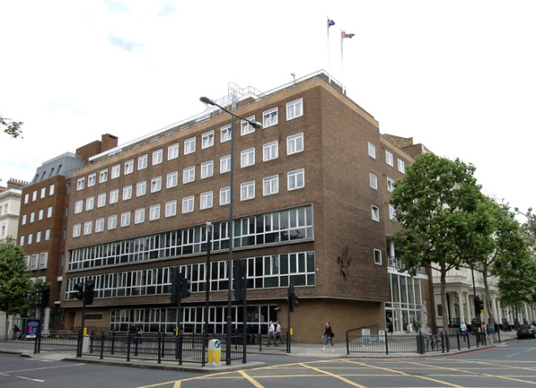  Baden-Powell House  Kensington, London | 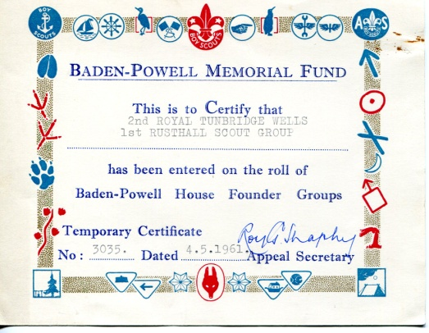  Our Founder Membership Certificate

Our Seniors & Rangers “artificially resuscitate”  Rusthall Fire Station  May 1961  Trained by Bert Hyder, our Senior Scouts & Rangers undergo examination for the Royal Life Saving Society’s Artificial Resuscitation Award at Rusthall Fire Station.  All six Senior Scouts (Dave Green, Robin Boxall, Dave Hogben, Mike Redhead, Norman Redhead and Malcolm Coppard successfully completed the 8-week course and qualified as Artificial Respiration Operators - as did the Rangers  For numerous years, Bert was Officer in Charge of Rusthall Fire Station and a staunch supporter of the St Paul’s Rusthall Scout Group. | 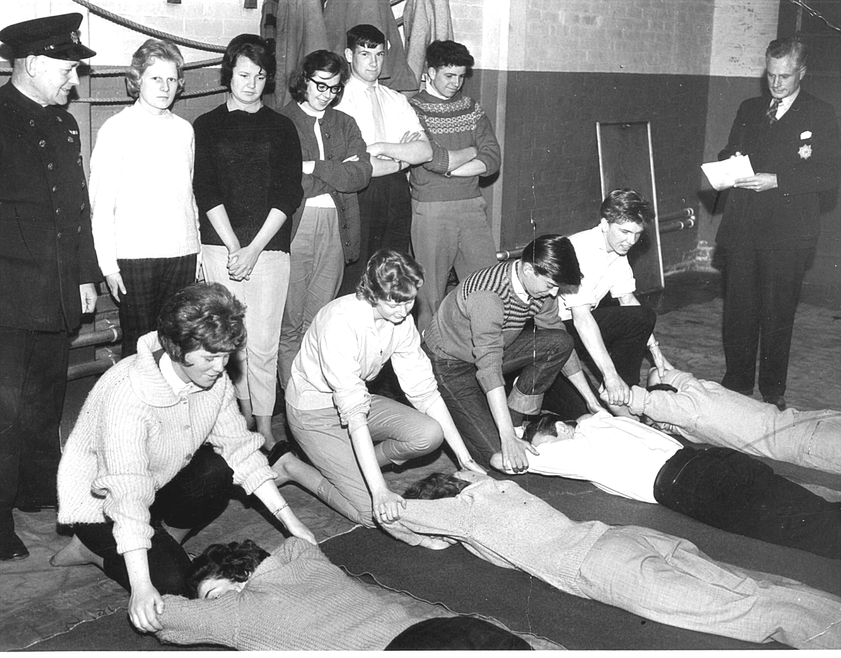  Standing : Bert Hyder – Janet Roffe - Janet Rogers – Betty Cotton – Joe Redhead – Robin Boxall – their examiner  Kneeling : Jean Tucker – Yvonne Bridger – Roger Hyder – Dave Hogben  Those being saved : Kenta Powell – Doreen Diplock – Dave Green – Malcolm Coppard

In addition to also training and examining our lads for their Firefighter and Fireman proficiency badges, he often hosted very informative visits to the Fire Station.

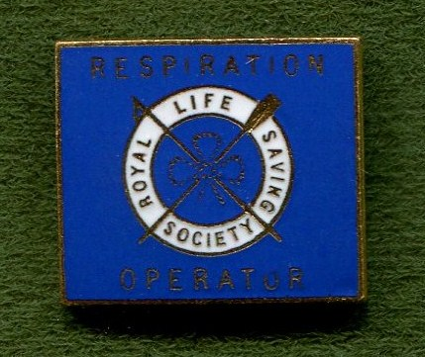  Janet Roffe’s badge …… | 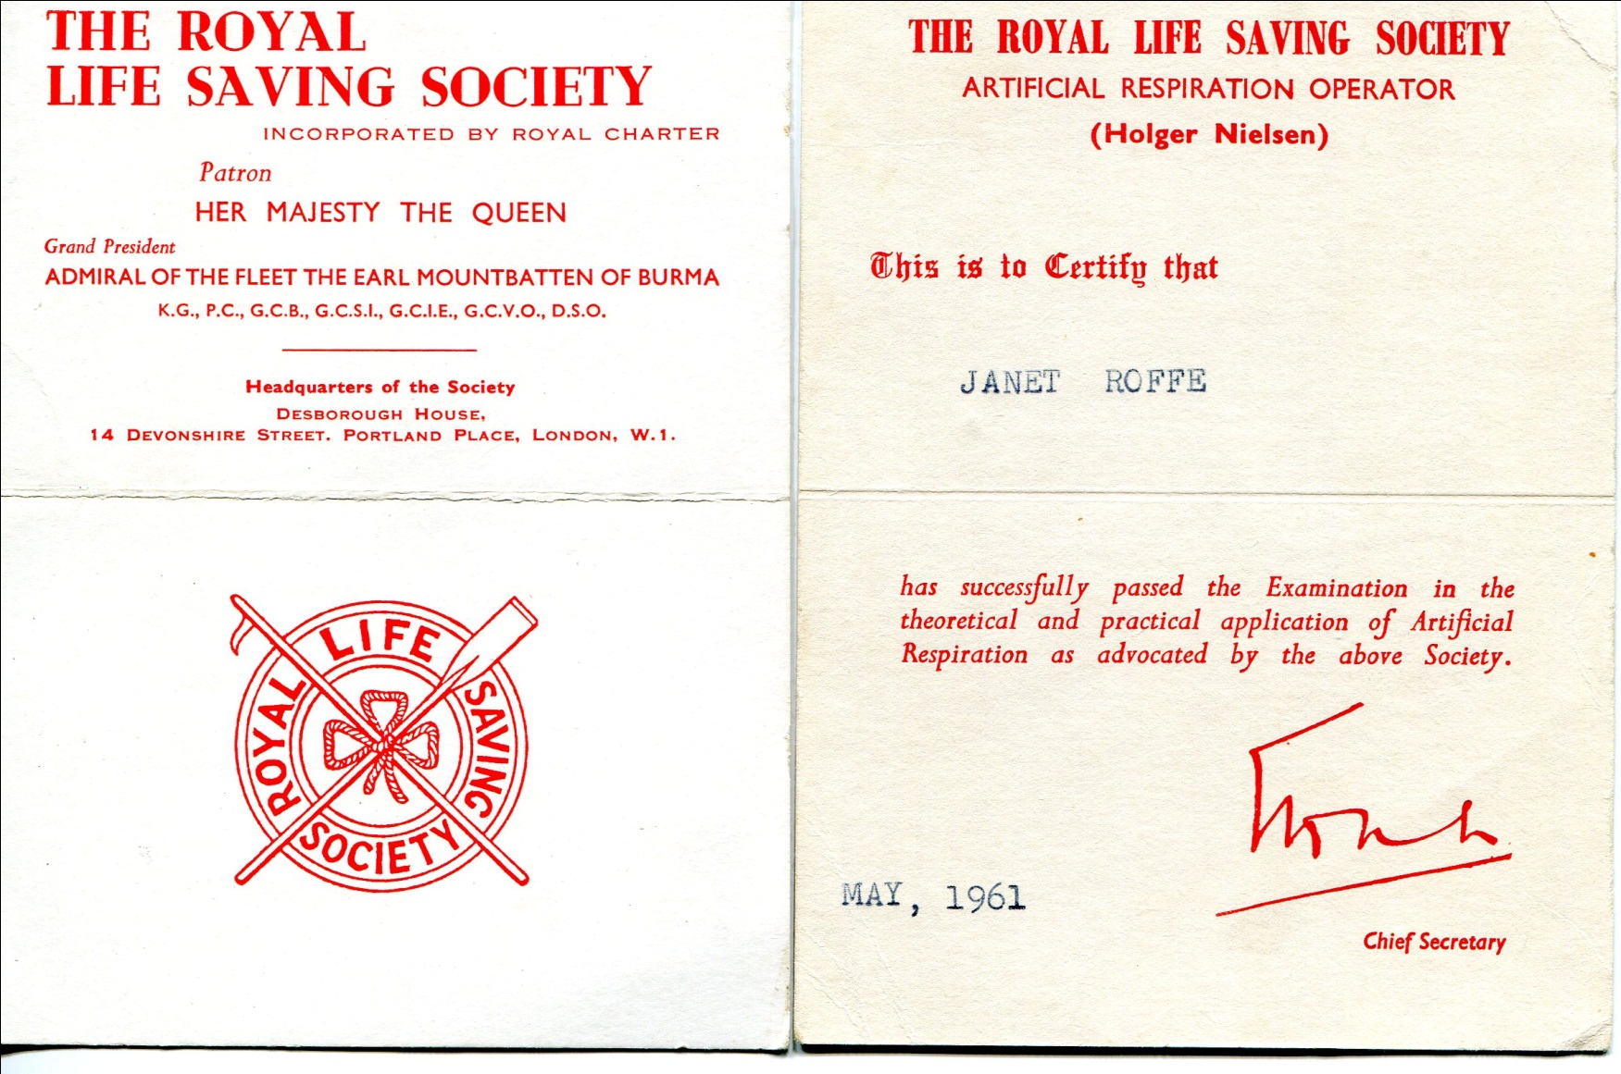  …… and certificate

A Joint Effort
23 June 1961

Our Senior Scouts join with members of Toc H to clean up the War Memorial at St Paul’s Church.

Kent County Boy Scout Camporee  Rusthall participate in the Camporee. | 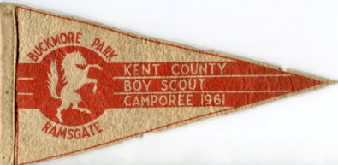

Researchers’ note – The pennant gives two different locations – Buckmore Park and Ramsgate. Was it produced specifically for Thanet District and somehow fell into the hands of our lads ? If not, then the reason is a mystery. We also have yet to determine the dates on which the Camporee was held. Have you any knowledge ? If so, please click HERE.

Three First Class Badges
July 1961

First Class Badge are awarded to Trevor Barker, Richard Boxall and Kevin Sheldon.

An Anglo-French weekend
22 & 23 July 1961

Our Senior Scouts hold a weekend camp with a group of four visiting French Scouts.

St Barnabas Garden Fete
16 September 1961

Members of the Troop assisted with the organising and running of the St Barnabas Garden Fete.

A major attraction was the inter-troop trek cart competition.

A Tour de France
September 1961

Malcom Coppard and Dave Masters spent two weeks on a cycling tour of France.

District Swimming Gala
11 October 1961

Robin Boxall, Norman Redhead and Robin Snook represented the Senior Scouts at this event.  Robin Boxall and Norman Redhead achieved respectable placings in their events and Rusthall was placed 3rd in the Senior Scout Section.  Robin Snook excelled in the two lengths backstroke and came first, despite being up against Stuart Marsh, a Skinners’ Scout, a Monson Swimming Club member who represented Kent in National Championships. Stuart, however, beat Robin in the Gala diving competition. | 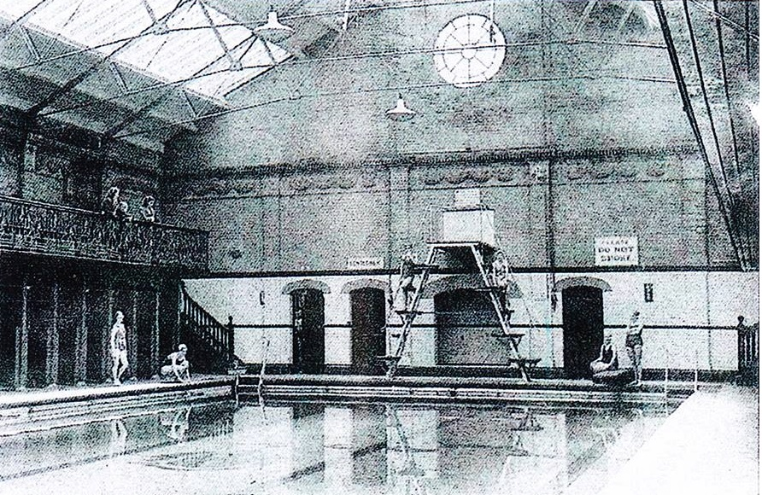  The Monson Pool  (Courtesy of The Courier)

Robin was subsequently selected to represent Tunbridge Wells District in the Kent Scouts Championships at Eastbourne – in the four lengths freestyle. However, not being one for the effort required to swim crawl for such a distance, he swam backstroke – and came last in the final.

He suffered a similar experience in 1967, when representing Kent in the Police National Life Saving Championships in London. Although the Kent team performed their final event in by far the quickest time, the Leicestershire Police Women’s team won the Championship – gaining more points for style.

Operation Challenge
Dymchurch Area
October 1961

This Kent County weekend challenge event for Senior Scouts was held in the Dymnchurch area.

The object was for teams of three to undertake an overnight hike, visiting a number of checkpoints at which they would be expected to undertake various tasks. Further tests were arranged for teams to complete on the Sunday morning.

Teams assembled at Dymnchurch on the Saturday evening and were taken by Romney Hythe and Dymnchurch Railway to various drop off points.

The first task was to collect seashells from the beach and make a necklace – in the dark.

Each team had to pick up a 12-foot wooden builder’s plank which had to be carried throughout the weekend exercise and was used in various ways, such as making a bridge over a dyke and as a makeshift stretcher.

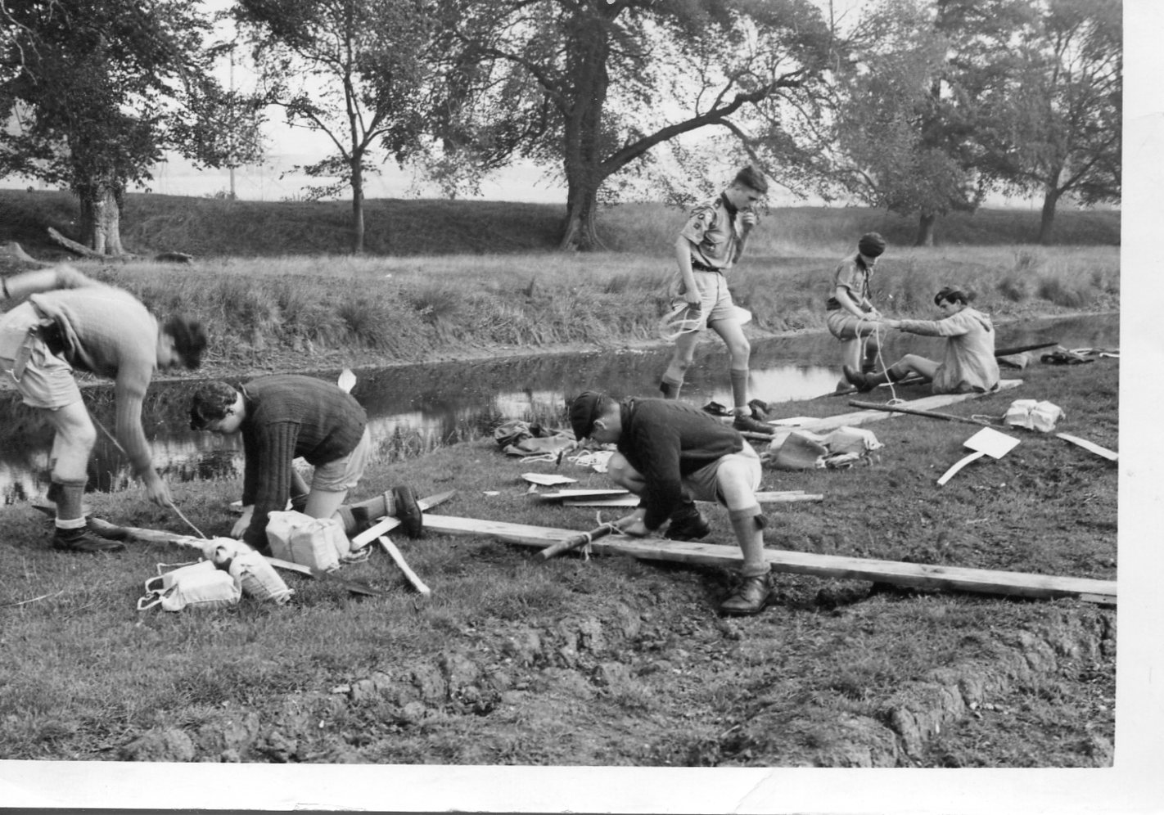  Raft building | On the Sunday morning the plank was used with Scout staves to form a raft, with inflated polythene sacks as floats. The completed raft then had to be paddled approximately along a one mile stretch of the Royal Military Canal - not quite as straightforward as it seems, since the canal was partially clogged with weed which hampered progress. | 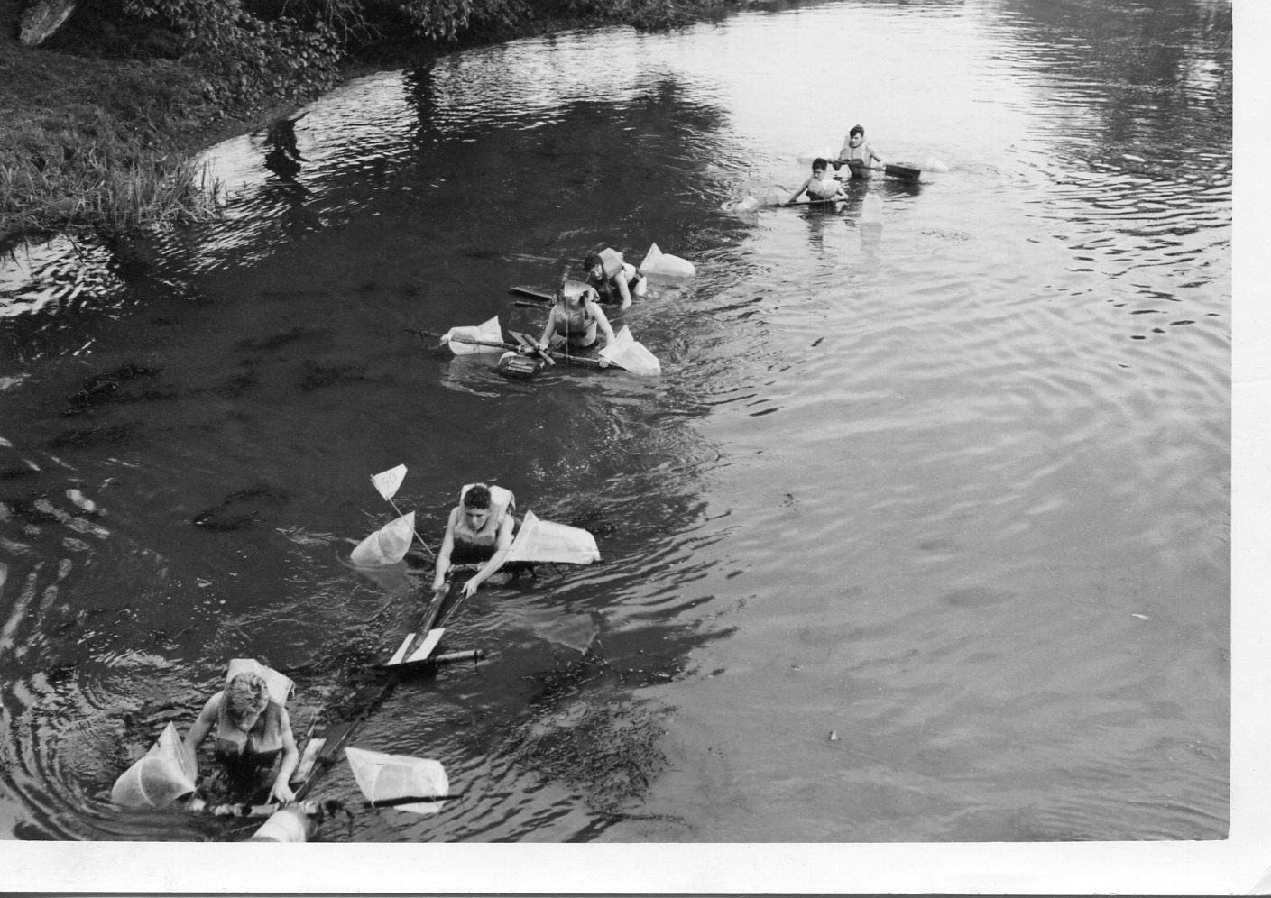  Rafts afloat

Rusthall entered three teams. Two were made up of experienced ‘Challenge’ participants and the third ‘novice team, of Scouts who were soon to move up to Senior Scouts from the Troop.

The event attracted one hundred and fifty teams and all three teams from Rusthall acquitted themselves well. One Senior team (Robin Boxall, Norman Redhead and John Bridger) was placed 6th and the second Senior team (David Simpson, Dave Masters and Brian Perkins) came 19th. Both teams were awarded the coveted ‘Challenge’ pennant presented to the top 20 teams. The ‘novices’ (Robin Snook, Mick Priest and Bill Biffin) did well and achieved 100th place.

A subsequent issue of the national Scout magazine published an account of the event – making specific mention of two old, well-known Groups taking part – Rusthall and Loose Swiss (Maidstone) – stating that both entered three teams, two of which came very high in the rankings – the others much lower.

Researchers’ note – Do you have a copy of the magazine ? If so, please click HERE.

Shorts or trousers ? That is the question !
November 1961

Long trousers become alternative wear for Senior and Rover Scouts – Rusthall still prefers and continues to wear shorts.

Bonfire Night
4 November 1961

The group held a bonfire party in the grounds of the Beacon Hotel

New Rover Scouts
November 1961

Malcolm Coppard, Dave Masters, David Simpson and Mike Redhead moved up to the Rover Crew from the Senior Scout Troop.

Scout Movement Milestones - 1961

July | Baden-Powell House opened by The Queen.
 | Soap Box Derby grows up, now National Scoutcar Races.
November | November - Long trousers become alternative wear for Senior and Rover Scouts.
 | Seventh World Rover Moot, Australia.

Click HERE if you have any further information regarding this year
or
HERE to return to our Navigation page


