Scouting in Rusthall
1962

“Correcting bad habits cannot be done by forbidding or punishment”

Lord Robert Baden-Powell
(1857 to 1941)
? | We are seeking :  - Further events that occurred this year.  - Copies of the Kent & Sussex Courier for this year.  - Any knowledge that you may have of this year.

Can you help ? Please click HERE if you can

District Senior Scout Gathering
Pathfinders’ Scout Hut
February 1962

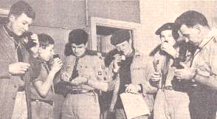 | Mr W.S Muffet (extreme right) joins (from left) Peter Dawson (7th Tunbridge Wells, Skinners’ School), David Stapley (St Peter’s), Robin Boxall (Rusthall) ‘Foxy’Fowler (1st Lamberhurst), Peter Smith (1st Tunbridge Wells) in a competition at the Senior Scout gathering.  (Copyright Kent and Sussex Courier)

Rusthall Senior Scouts joined Senior Scouts from nine other Troops at a District evening gathering at the Pathfinders Scout Hut in Quarry Road, Tunbridge Wells.

A number of special competitions were arranged and Assistant County Commissioner, Mr WS Muffett, gave a talk on the need for closer unity between small troops and how this might be achieved.

The highlight of the evening was the slide show and cine film of ‘Operation Challenge 61’ (produced by Rover Scout and photographer, Vivian Payne-Jenkins). The trials and tribulations of the participants in this gruelling event were revealed to everyone.

Three one-act plays
The Mission Hall
9 & 10 March 1962

A group of Scouts, Senior Scouts and Leaders staged three one-act plays in the Mission Hall on 9th and 10th March following a dress rehearsal for the Derby and Joan Club on 8th March.

The thespians had been rehearsing over the past 8-10 weeks under the guidance of producer Mrs Jeanette Stacey.

The plays were ‘The Perfect Alibi’, ‘Spring-song Singers’ and ‘Way Out West’. The production raised £10 towards Group funds.

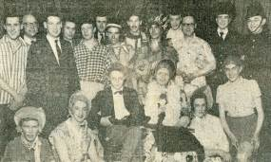 | Back row (from left) – Mick Priest, Sub Simpson, Norman Redhead, Eric Simpson, John Bridger, Terry Wale, Mick Redhead, Peter Bass, Ricky Jones, Cy Simpson, Brian Perkins, John Twort.  Front Row (from left) – Dave Hogben, Rod Bavin, Roger Graber, Trevor Barker, Peter Farley, Malcolm Coppard.  (Copyright – Kent and Sussex Courier)

Wedding of John Twort and Jean Tucker  St Paul’s Church  31 March 1962  The wedding ceremony took place at St Paul’s Church, Rusthall. Scouts and Cubs were on hand to provide a guard of honour for the couple outside the Church after the service. |  | 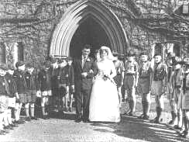
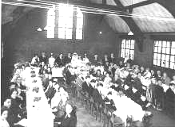 | 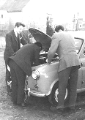 | 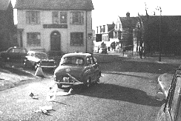

Two First Class Badges
March 1962

First Class Badges were awarded to Stephen Hogben and Chris Woodward

Scouts join St Paul’s Rusthall Servers’ Guild
April 1962

The Servers’ Guild was the brain-child of Ross Baxter who, with his family, joined St Paul’s Rusthall after moving to the area from Canada. Members of the Servers’ Guild provide assistance at the Church Parish Communion Services.

Easter Hikes
April 1962

A Troop hike was arranged on Good Friday and some of the older members of the Troop and Senior Scout Troop joined members of the Youth Fellowship on Easter Monday for a second hike.

The latter took in Groombridge, Eridge and Eridge Park, Frant, Bells Yew Green and Hawkenbury.

District St George’s Day Parade
St James’ Church, Tunbridge Wells
May 1962

This year’s service was held at St James’ Church, Tunbridge Wells. The Troop flag was carried by Robin Snook and the Senior Scout flag by Robin Boxall. Senior Scouts and Rovers from Rusthall were on duty to assist in marshalling in and outside of the Church.

After the service, the Mayor of Tunbridge Wells presented a Duke of Edinburgh’s Silver Award certificate to Robin Boxall.

Whitsun Activities
May 1962

Alan Welch and Barry Pride volunteered to organise the Whitsuntide ramble to the Speldhurst, Fordcombe and Langton area for the Youth Fellowship.

A barbecue was held on Whit Saturday in the grounds below the Beacon Hotel. A team of Scouts took turns at cooking and it was estimated that well over 100 sausages were cooked. A joint Scout/Guide/Youth Fellowship dance was held in the Parish hall in the evening.

“Thank you” Dinner
The Mission Hall
19 May 1962

The Senior Scouts joined with the Ranger Guides to arrange a dinner at the Parish Hall as a form of ‘Thank you’ to members of the Scout and Guide parents committees and other friends of the two organisations.

Scout Patrol Competition Results
May 1962

1st - Panthers - PL Robin Snook. - 25 points
2nd - Woodpigeons - PL Richard Boxall - 24 points
3rd - Eagles - PL Rick Jones - 15 points
4th - Woodpeckers - PL Trevor Barker - 10 points
5th - Ravens - PL Mick Priest - 6 points

County Commissioner’s Challenge
The Beacon
May 1962

The County Commissioner’s Challenge took the form of a Patrol Camp. Patrols were judged on the standard of camping, menu, cooking (including preparation of a backwoods meal) and a general range of activities. The camp was held in the grounds of the Beacon Hotel.

Certificates were awarded to the Woodpigeon Patrol for the Patrol Camping, Patrol Expedition Cooking, and Pioneering Challenges.

A Certificate was awarded to the Woodpecker Patrol for the Backwoods Cooking Challenge.

Official Opening of the Rusthall Rover Den
Denny Bottom Headquarters
1 June 1962

The Rover Crew Den at the Headquarters, Denny Bottom, was officially opened on 1 June by Mr LE (Jackie) Jackman (ADC Rover Scouts).

The den includes a small chapel which was dedicated by the Reverend NJ Mantle.

Mike Redhead was invested as a Rover Squire.

Two Venturer Badges
June 1962

Robin Snook and Norman Redhead are awarded the Venturer Badge – a requirement for the Bushman’s Thong which, in turn was a requirement of the Queen’s Scout Award,.  The Bushman’s Thong was a leather thong worn on the right shoulder of a First Class Scout who also held the Venturer Badge and two of the following proficiency badges - Astronomer or Meteorologist, Camp Warden, Forester, Hiker, Naturalist, Senior Pioneer and Tracker. | 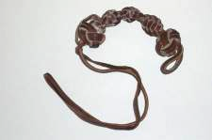

The Bushman's Thong, along with four Senior Public Service Badges, of which the Ambulance Badge was obligatory, were the necessary requirements for the award of the Queen's Scout Award.

Norman and Robin went on to earn both the Bushman’s Thong and Queen’s Scout Award.

Four Senior Scouts take on the South Downs
2 to 4 August 1962

A transcript from Robin Snook’s Hiker Badge Log Book

Troop | 1st Rusthall |  |  | 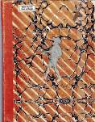
From | RF Snook
To | The Tunbridge Wells District DC
Date of Journey | 2 - 4 August 1962
Address | 1 Allan Close, Rusthall, Tunb ridge Wells
Accompanying Scouts | Robin Boxall, Richard Boxall, John Atherall
Map Used | OS 1” 183
Distance | Approximately 39 miles
Kit List
Complete Scout uniform |  | Mug | Fly-sheet
Rucsac |  | Knife, fork, spoon set | Torch
Sleeping bag |  | 2 enamel plates | Small trenching tool ●
Pyjamas |  | Notebook & pencil | Plimsoles
Spare socks |  | Map (OS 183) | Gilwell ●
Sweater |  | Compass | 2 primuses ●
Anorak |  | Groundsheet | 2 canvas water buckets ●
Boots |  | Tent (2) ●
Washing kit |  | First Aid kit ● | ● Carried by the others

Log – 30 Mile Hike – Thursday 2nd August

Weather : Hot all day. SSE breeze on high ground. Cloudless sky.

Report :

Map Ref | Time | Miles
 | 8.15am  8.30am |  | We met at the West Station, Tunbridge Wells and caught the train to Lewes.
416098  423096 | 9.25am |  | On arriving at Lewes we turned left down the A275. 200 yards down this road we turned left along a track. We followed the track for 200 yards, turned right at a junction, and carried on along the track until we passed under the railway line, via a tunnel
424093 | 9.45am | 1 | We turned right along the footpath, crossed a dyke with som e trouble, went through a gate, and carried on parallel with the railway line until we came to a place where the River Ouse passed under the railway line. We edged along the walls of the tunnel that the Ouse was passing through, keeping away from the crumbling chalk banks
422095 | 9.40am |  | Before passing through the tunnel, we could see to our left the Eastwood’s Lewes Cement Works, behind which was a great chalk face, towering 150 feet above the works.
We followed the Ouse for about a hundred yards until we came to a dyke that branched off from the river. We followed along this dyke for 300 yards until we reached a junction of dykes. We crossed the dyke that we had been following. We walked SE until we came upon a track, carved out of the chalk valley floor.
408073 | 10.05am |  | We followed this track (which crossed many dykes) for about on and a half miles until we came out onto a recently gravelled road to the west of Iford Church. About half way along the track to Iford Church we had passed a great fire that was burning up much of the rubbish that had been left there.
 | 10.45am | 3 | We dropped our rucsacs under a yew tree outside of the church and went inside.

Iford – The Place Names Society derives the name from “Yew Tree Ford”, and gives the spelling Yford as occurring in William II’s reign, and Iford (e) in 1091 to 1125. The Domesday Book of 1087 mentions a church here, so there was probably a Saxon church before the present mainly Norman one. In Domesday, Iford is called Niworde, which probably means “New Estate”. By the 13th century it had become Hyford.

Another 100 years were to pass before the name took its present form, and yet another century before the waters of the Ouse ceased to lap the churchyard walls. It is quite possible that ships tied up here at one time, and that the church was dedicated to St Nicholas, because he is the patron saint of sailors as well as of children.

The windows in the east wall were once covered by a wall which was removed in 1868. Even the fact that the wall had the Ten Commandments inscribed on them is no excuse for hiding such lovely features. All three windows are probably late 12th century.  The axis of the church is not straight. When the church was first built the chancel was where the tower is now, and it was not quite square with the nave. When the present chancel was built in the late 12th century, it also was built at an angle to rectify the slant of the first chancel. The latter was now transformed into a tower, which had to be twisted as it was raised so that should be rectified at roof level. The arches which can be seen in the north and south walls of the tower were built to carry the additional weight. | 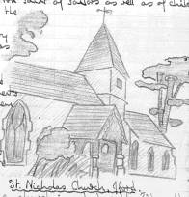

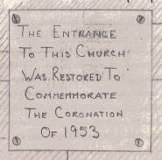 | The tower contains three bells of about the 15th century; the bell-ringers stand in view of the congregation. There was at one time a chapel to the north of the chancel where the modern vestry now is. The church possesses a Communion chalice and paten dated 1674.  In the late 12th century a north aisle was added on to the nave. About a century later the aisle was demolished and the arches filled in and covered over.  Iford Church belonged to St Pancras Priory for a long time up to the Dissolution of the Monasteries. The present patron is the Bishop of Chichester.

Restorations of the Church were carried out in 1868, 1874, 1949 and 1957. In 1957 £1,200 was given within two months towards the cost of repairs.

405072 | 10.50am |  | We left Iford Church and turned right down the path as the A275.
 | 11.00am |  | On reaching the road we saw a sign sating that the path had brought us out of the entrance of Iford Manor.
406070 | 11.05am | 4 | We turned left down the main road for about a quarter of a mile, whence we turned to the right up an extremely steep track almost to the summit of Front Hill.
405062  410055  422053 | 11.20am  11.45am  12.10pm | 6 | Here we rested and then followed the footpath past a tumuli, over Mill Hill and on to Southease. We crossed the main road and walked a hundred yards down the opposite road to Southease Church, where we halted.

Southease Church – A little 12th century Church. It is famous for its round tower. The tower possibly served as a beacon to the ships which, before the Ouse valley was reclaimed, passed by on their way to Lewes, the quaint shingled spire being added later.  That there was an extension on the north side is apparent from the foundations which are still traceable. On the outside of the north wall are the remains of a piscine. The chancel opening is formed by an arch of Tudor oak. One of the two bells in the tower bears the date 1310. | 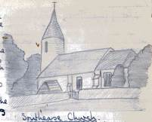
During the restoration of the building in 1918, a window which is believed to date from 1100 was discovered. At the time of the Domesday Survey (1086) it was stated that Southease Church belonged to the Hyde Abbey Monastery near Winchester.

428053  431056  434055 | 12.25pm  12.35pm  12.40pm  12.45pm | 6.75 | We left Southease Church and continued downhill for approximately 500 yards until we reached a bridge crossing the River Ouse. We crossed the bridge and followed the road for approximately 500 yards to Southease and Rodmell Halt. We crossed the level crossing, continued up the road for 100 yards, turned right along a track through Itford Farm to the B2109.  On crossing Southease Bridge, we estimated the width of the Ouse at that point as 35 yards. We came to the conclusion that the tide was coming in as the flow of the river seemed to be away from the sea. While passing through Itford Farm we saw a remarkably tame peacock (possibly a peahen) strutting about the farmyard. |  |  |  | 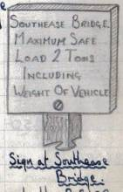
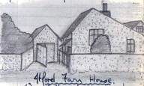
 | 12.45pm |  | We crossed the B2109, dumped our rucsacs at the beginning of a track up Itford Hill, and sat down for a rest. Richard went to the farmhouse to refill the water flasks.
436054 | 12.50pm  1.00pm |  | We followed the track up Itford Hill for about 300 yards. Here we stopped to have our dinner. We climbed a barbed wire fence to our left so that we could sit and have our dinner in the shade of a hawthorn tree. The sun at this time was directly overhead.
446055 | 1.30pm  2.05pm | 7.5 | Having finished our sandwich dinner we continued uphill. To the right we saw a pipeline supported by blocks of wood. (We had seen the beginning of this pipeline at the summit of Mill Hill, where it started.) We noticed that the pipeline ran over a more gradual slope than that of the footpath that we were following. So we decided to walk alongside the pipe. We climbed the hill to the trig point at Red Lion Pond, climbing 500 feet in 1,100 yards, ie a slope of 1 in 6. Red Lion Pond was dry and the bottom filled with hard-baked mud.
454058  458059 | 2.30pm | 8 | We then bypassed White Lion Pond, climbed Beddingham Hill, and walked along the footpath south of Firle Plantation. To the left of the footpath we saw a great machine that was digging a trench in which to put the pipe that we had been following. Just past White Lion Pond we saw a radio station past which the pipeline was running | 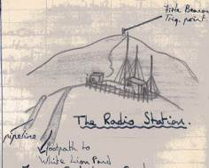
From Red Lion Pond we could see Newhaven and the lighthouse on the end of the breakwater. We could also see the Ouse winding its way through the valley to the sea,
458059  485059 | 3.05pm | 10 | We continued past the radio station and along the track, past many tourists’ cars parked at the base of Firle Beacon. On our right we could see the Seven Sisaters, 8 miles in the distance. We then climbed to last 100 feet to the summit of Firle Beacon, 712 feet above sea level. We thought that the beacon would be marked by a small heap of flint stones, but we could not find the caiorn. Firle Beacon is 5 miles north of Seaford and is the highest point of this length of the Downs.
493051 | 3.15pm  3.50pm | 11 | We came down off Firle Beacon and took the footpath through the Long Barrow as far as the Southdown Gliding Club. At the top of Bostal Hill were two gliders, one of which had just taken off. We rested at the gliding club’s headquarters (outside of one of the hangers). |  | 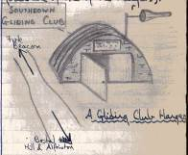
497048 | 3.55pm  4.00pm |  | While we were outside of the hanger we saw the glider return to Bostal Hill, and the other take off. We then went through the gate and followed the chalky track up Bostal Hill. From here we could see three small villages (Alciston, Berwick and Alfriston). We continued along the track, through a wood, and onto a road. |  |  | 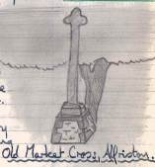
521031 | 3.00pm | 13 | We continued along the track until we came to the B2108. We were now in Alfriston. We walked through Alfriston High Street, past the Star Inn and past the Old Market Cross.

Alfriston – The Star Inn dates from the late 15th century. It is supposed to have been the reasting place of the many pilgrims who passed on the way to and from the shrine of St Richard of Chichester. Inside and outside the inn are curious old contemporary wood carvings, including representations of St George and the Dragon, St Giles and the badge of St Richard. In the course of repairs in 1912, the plasterwork which had long covered the front of the building was removed, and the hostelry appears now with a timbered front, as in its earlier days. Three windows were discovered.

Alfriston is famous for its Church, “The Cathedral of the South Downs”. Another relic of bygone days is the Market Cross House, an old inn taking its name from the Market Cross opposite. The Cross is 500 years old, though the original top had disappeared by 1787. In 1833 it received its present top and the steps removed from the base. The structure still remains as the only village cross in Sussex.

Having passed the George Inn we turned right down the B2108. On our right was a field. We searched for the farm that the field belonged to unsuccessfully.

We then went to a house opposite and asked if there was any place that we could camp. The owner told us to go for about half a mile down the road to Burnt House Farm, where we could probably camp.

519022  519021  522017 | 5.25pm | 13.75 | On arriving at Burnt House Farm we were told by the farmer that we could not camp there as there were too many young cattle about. Burnt House Farm is 50 yards past Place Cottage. To the right of the farmhouse was a footpath which took us through a field of cows, through an area of tall grass an d across the Cuckmere via a bridge. On our way through the last field a woman told us that, if we were looking for somewhere to camp, we were to ask at Litlington Post Office.
523017 | 5.45pm  6.00pm | 14.5 | At the Post Office we were told that we could camp on the east bank of the Cuckmere, by the bridge. We went to our site, changed into our plimsoles, pitched the tents, and Richard and John collected some water from the back door of the Post Office. We pitched the tents parallel to the river. We did it in the way shown in this diagram.
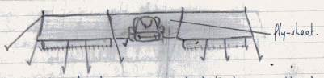 |  |  |  | The fly sheet was supported between the two tents by the two tent poles, in order to provide a place for cover for our kit, and therefore leaving more space in the tents.

While getting the water Richard got the Camp Permit signed.

Report of the Camp Site

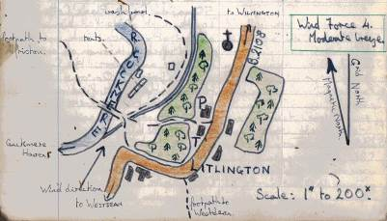 | (i) Water - Plentiful supply for washing, drinking, etc.  (ii) Fuel – Ample supply available for cooking, but none for pioneering.  (iii) Aspect – Protection from winds, not far from road, public footpath through site.  (iv) Ground – Firm, chalk allowing drainage, long grass.  (v) Supplies – From stores & Post Office.

Time
6.30pm  7.00pm  8.00pm  8.30pm | We then prepared a dinner of baked beans, sausages, coffee, bread, butter & honey. We then washed up and layed our beds down, Robin and Richard in one tent, John and I in the other.  We then decided to have a look round Litlington. We went up the footpath to the right of the Post Office. We went up the road as far as the Church. It dates from 1150, though the nave is 14th century and the chancel roof late 15th century.  We went back down the road, past the Post Office and down to the “Plough and Harrow”, a pub, where Robin tried to phone Skip to tell him where we had got to, but nobody answered the phone.  We continued down the road, turned the corner, carried on for 200 yards, whence we took the footpath on the right back to camp.  We then looked around the site to see that we hadn’t left anything. We slackened the guy lines and went to bed after an enjoyable but tiring day.

Opposite the site could be seen the great White Horse carved out of the SE face of the hill. Just below there can also be seen a small horse head.

Log (continued) – 30 Mile Hike – Friday, 3rd August

Weather : Over-clouded. Rare sunny periods. Warm. Rain around midday. SW wind, light.

Report :

Time
7.00am  9.00am | We awoke quite early. About half an hour later we got up, packed what kit we could, and cooked a breakfast of eggs, bacon, coffee, bread, butter and honey. We washed up, took down the tents and shook them to remove any moisture. We packed the tents and the rest of our kit, and buried our rubbish. We then had a final wash and brush-up and left the site. On our way we popped into the Post Office to thank them for allowing us to camp there and return two empty lemonade bottles.
Map Ref |  | Time | Miles
523016  522006 |  | 9.05am  9.20am | 14.5  15.25 | We turned south down the road for about 200 yards, where we turned left up a track and then right over a stile, up a field and down the outside of a wheat field, over a barbed wire fence to Charlston, which is an old mansion.
525997 |  | 9.30am  9.35am | 16 | We then went uphill through a wood and followed the footpath to a road, where we turned left in order to get to Westdean’s All Saints’ Church. We went into the churchyard, dropped our rucsacs in the Church porch and entered the Church.

Westdean – The Westdean Church of All Saints has a Norman nave and a 14th century chancel. The tower has a Norman arch. There are two ancient canopied tombs on the north wall of the chancel, a shell-shaped piscine, and a square font supported on a circular pedestal in the centre and four octagonal pillars at the angles. The Church was built in the 11th century an d restored in 1878. The font is of Saxon origin.  The Rectory, like the Church, is of flint with stone dressing, and is said to be the oldest inhabited parsonage in the country, though the Rector lives at Litlington. The eastern wing was built about 1220 and is a rare specimen of ancient domestic architecture. The walls, which are 2½ feet thick, are pierced by corbel-headed windows. A newel stone staircase leads to the upper floor. | 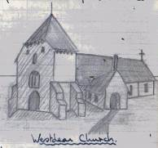

In the farm buildings opposite the Church may be seen a circular dovecote, minus its roof and the ruins of the Old Manor House which stand on the site of the palace of King Alfred.

523996 | 9.45am  9.50am |  | We turned right outside of the Church and then left 100 yards on. After continuing down this road for 100 yards we came to a junction. We crossed the road and took the footpath directly opposite.
520995  522984 | 10.00am  10.15am | 16.5  17.5 | We followed this footpath for a quarter of a mile, and skirted the woods as far as the A259. Below us we could see the River Cuckmere winding its way through the valley to Cuckmere Haven. We crossed the main road and continued gradually uphill as far as Foxhole.
523974 | 10.35am | 18 | We then climbed a very steep hill, crossed a field, skirted a corn field, went down into a valley and climbed an extremely steep hill to the edge of the chalk cliffs at Cliff End. From here we could see the Seven Sisters.

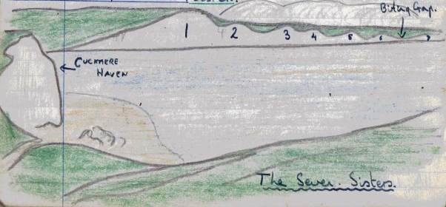

523974  530972 | 10.35am  10.45am | 18  19 | At the summit of Cliff End we rested, 300 feet above sea-level, with the sea murmering far below us. We walked for about a quarter of a mile down the hill and then up a very steep hill to the summit of the first of the Seven Sisters. Here we rested by a stone monument.

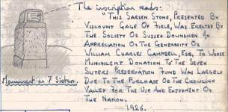 | Just before we reached the Seven Sisters we went through a gate with a notice on it. | 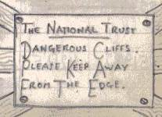

550962 | 11.45am | 20.75 | We continued over the Seven Sisters until we reached a rough track to Birling Gap.
553960 | 11.50am | 20.75 | We carried on along the track until we arrived at the Birling Gap Café, on our left. Outside were two automatic machines (a rocking horse and a flying saucer) on which small children could have sixpenny rides. We dumped our kit outside, entered the café and ordered a coffee and a couple of sandwiches each.
Birling Gap – It was formerly a favourite haunt of smugglers. There is a short flight of steps cut in the chalk which gives easy access to the shingly beach. A submarine telegraph cable crosses the Channel from Birling Gap to Dieppe.
Having finished our snack we left the café and turned right up the track for about 100 yards, until we reached a footpath leading up Went Hill, on our right.
553975  551982  551983  552984  572004 | 12.30pm  12.45pm  1.00pm  2.00pm | 22  23  25.5 | We turned to the right up this footpath and carried on over Went Hill for approximately a mile. Here we lost the footpath. We picked up a different track which brought us to a more developed track, where we rested. Richard went to a house to get some water. There was a National Trust notice opposite.  We turned right along the track as far as the A259. We turned north up the B2105 for about 300 yards. Here we turned up a track, through some woods, into the open and up Willingdon Hill as far as Hill Cottages. |  | 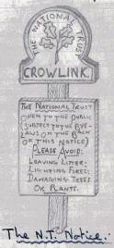  We looked for the footpath that should have been there, that was marked on the map. We could not find it, so we followed around the east side of a corn field, down a steep hill of burnt gorse, and attempted to get through a barrier of gorse to get to the track that led to Jevington. We did not succeed..
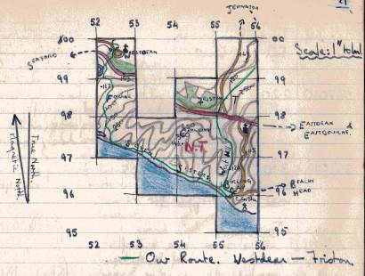
567010  563013 | 2.20pm  2.55pm  3.10pm | 26.75 | We returned to the valley and had our late dinner of hard-boiled eggs, bread and butter. We skirted round the gorse (on the way seeing an adder) and reached a track that led us to the B2105 at Jevington. About half a mile before Hill Cottages it started to rain. It finished when we stopped for dinner.

Jevington – The stone and flint Jevington Church of St Andrew is very old. Its massive Saxon tower was possibly built 1,000 years ago. The rest dates from the 13th century. The larger bell was cast at the close of the 15th century, and the small one probably came from a shipwreck. The massive square font is 14th century. Above the south door is a Saxon carving, found under the floor of the tower, possibly representing Christ bruising the serpent’s head. | 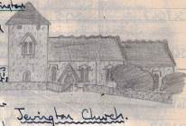

At Jevington we had in mind to buy our provisions for tonight’s tea and tomorrow morning’s breakfast, but we could find no shops in the village. We decided to walk along the B2105 to Wannock, in order to buy some provisions.

565022 | 3.20pm  3.35pm | 27.5 | Half a mile past the Church we saw a house on our right that had eggs for sale. We dumped our rucsacs on the grass verge and Robin crossed the road to buy half a dozen eggs. Half a mile further on we saw a Southdowns milk van. From this van we bought a tin of tomato soup, a tin of condensed milk and two tins of peaches.
576034  571032  566038 | 3.50pm  4.20pm | 28.5  29.25 | We continued along the road until we came in sight of Wannock Tea Gardens. Here we turned left through a new building site and walked across several fields (not following a footpath) until we came to Stud Farm.
569047  562048 |  | 30.5  31 | We tried to ask the farmer if we could camp there, but we could not find him. So we followed a track to a road, where we turned right to the A27. Opposite was a track to Wootton Manor. We turned westwards along the A27 as far as the second track to Wootton Manor.
561041  563047 | 4.30pm |  | Richard and John rested on the bridge while Robin and I walked up the road opposite to Folkington Manor. We asked if there was anywhere to camp, and they told us to try at the farmhouse at the bottom of the road that we had just come up. We returned to the A27, went to the farmhouse, but there was no-one in.
551049  552053 | 4.50pm  5.10pm  5.20pm | 32  32.25 | We returned to Richard and John, picked up our rucsacs and turned along the road towards Wilmington. On our right, three quarters of a mile along the road, was a track leading to Wilmington Farm. John and Richard remained at the gate while Robin and I went to the farmhouse to see if we could camp there. We could, so we returned to the gate, and took John and Richard to the site. The farmer’s wife told us that we could get water from the cowshed and that there were also flush lavatories there. She also offered us milk and eggs, but we already had enough.

Time
5.30pm | We changed into our plimsoles. Robin and I pitched the tents in the same way as we had the previous night, while Richard and John went in search of water
6.00pm | When they returned with the water we cooked and ate our tea of tomato soup, bread, butter, honey, peaches and condensed milk. We then washed up, layed our beds down, and made a wind break out of bales of hay, as there was a wind of near gale force whipping across the field.
9.00pm | We then made a billy of coffee which we drank before looking round the site. Robin and I looked round the cowsheds, etc and then went back to camp, loosened the guys and went to bed. A quarter of an hour later it started to pour with rain.
Opposite our site could be seen the Long Man on Windover Hill, one mile away.

The Long Man – The Wilmington Giant, or Long Man, is a figure 80 yards in height, cut in the face of the Downs on Windover Hill (600 feet high). The arms are extended upwards, and in each hand is a long staff. This is the largest representation of a human figure in the world.  Its origin is unknown. According the some authorities the figure is Balder, the God of Peace of our Saxon forefathers – “rising from the dead to his eternal triumph”, after being killed by Hoder, the Blind God of War, through a trick played upon him by Loki. The staves in his hands are the posts of Vastrond, the Saxon Hades. | 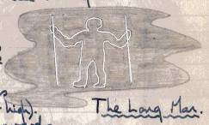
On the other hand, the earliest reference to the figure is in a manuscript of 1766, where the staves are shown as a scythe and rake.

Probably the figure was periodically scraped or renewed, as was the Great White Horse of the Berkshire Vale. In 1873 the outline had become almost obliterated and, to secure permanency, it was filled in with bricks.

The Duke of Devonshire conveyed the Long Man to the Sussex Archaeological Society, in trust for the Nation.

Report of the Camp Site

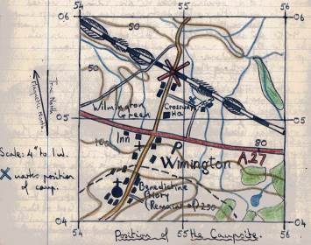 | (i) Water – Plentiful supply for washing and drinking.  (ii) Fuel – Little wood for cooking, none for pioneering.  (iii) Aspect – No wind protection, always open to sun, ideal hiking and Scouting area.  (iv) Soil – Firm, chalk allowing drainage.  (v) Supplies – Fresh eggs, milk, etc from farm. Other supplies from Alfriston and Polegate.  (vi) Extras – Permanent toilet, no need for latrines.  (vii) Address – Mr Skipp  Wilmington Farm  Wilmington  Sussex

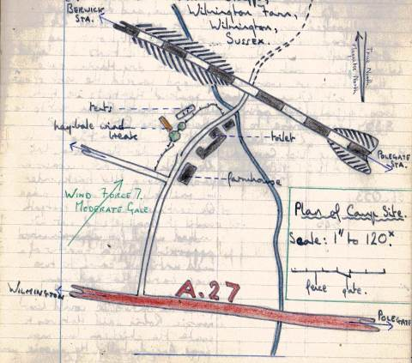

Log (continued) – 30 Mile Hike – Saturday, 4th August

Weather : Overcast, brightening later. Light SW breeze. Warm.

Report :

Time
7.00am | Having got up, washed and dressed, we packed as much kit as possible. We then had breakfast of boiled eggs, bread, butter, honey and coffee.
8.00am  8.30am | We then took down the tents and layed them out in the sun to dry. Having done this we washed up and packed the rest of our kit. When we had packed the tents we took a final look round the site, while Robin went to the farmhouse to get the Camping Permit signed. When he returned we were waiting at the bridge under the railway line.

Map Ref | Time | Miles |  |  |  |  |  | 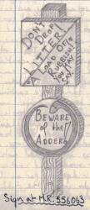
552053 | 8.45am | 32.25 |  | We picked up our rucsacs and passed along the track, under the railway line via the bridge. We continued along the footpath until it finally petered out.
We walked uphill for approximately a quarter of a mile until we came to two large barns that had many chicken coups in them. Coming from the barns we could hear music. Robin said that this was to make the chickens lay more eggs. Incidentally, the music was “Let’s Twist Again” (probably resulted in scrambled eggs). We passed through a gate before reaching the barns.
555062 |  |  |  |  | We then walked directly north across the field until we came to the road, which we got onto by climbing a barbed wire fence.
556063 | 9.00am |  | 33.5 |  | We turned right along the road for about 100 yards, where we came to a very sharp bend. Opposite was a track that we took. This track took us through Nate Wood, gradually going uphill.
576081 | 9.30am |  |  |  | Halfway through Wilmington Wood, we rested on a pile of logs. Just to our right was a group of men loading cut trunks onto a large lorry.
 |  |  |  |  | We continued along the track to the road. Before reaching the road was an infant school, on our left. We turned right along the |  | 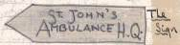
579087 | 9.45am |  | 35.75 |  | road to the A22. At the corner was a sign pointing along the road in a westerly direction. |  |  |  | 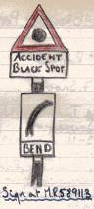
581081  583096  584103  587112 | 9.55am  10.10am  10.20am |  | 36.5  37  37.75 |  | We crossed the A22, a dual-carriageway and continued along the opposite road for about 150 yards. Here we turned left along a footpath that passed between two fences. We continued along the path until we came to a track passing through Diplock’s Farm. We continued along the track as far as Diplock’s Farm and took the footpath on the right. This track led us to a road that took us northwards to Leap Cross. At Leap Cross we turned right at the crossroads and continued over the bridge where the A22 crossed our road.
588115  585120 | 11.00am  11.25am  12.06pm |  | 38  38.75 |  | We continued across the crossroads and along the road for about 300 yards. On our left we crossed a stile and followed the footpath round a beautiful field of flowers to a gate opposite Hellingly Station. We went through the gate, up some steps, turned left over the railway bridge and left down some more steps to the station, where we bought tickets for the next train to Tunbridge Wells. The station master was obviously a Scout Master. He told us of a group of Scouts that were going to America on a course, as part of an exchange visit.
 | 12.55pm  1.10pm |  |  |  | On arriving at the West Station, Tunbridge Wells, Skip collected us in his car and took us and our kit home, after a very interesting and enjoyable hike. | 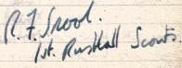

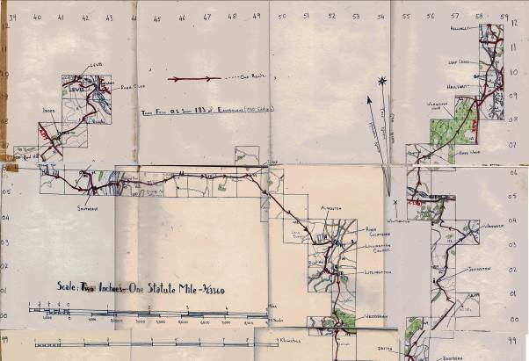

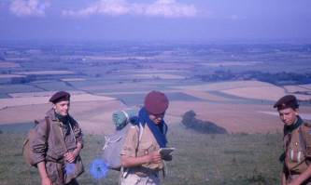
John Atherall, Richard Boxall & Robin Snook

Volunteers Lay Pipeline to Churchyard

From The Kent and Sussex Courier, August 1962

For 39 years people tending graves in Rusthall churchyard have had to carry water from the village a mile and a half away. The hard labour has now been cut out with the completion of a pipeline to the churchyard.  The pipeline project had been discussed for many years. But until this year the only water available was in a small rain tank that ran dry in the summer.  Mr John Stenning of Sunglow, Westwood Road, Rusthall, a London University lecturer and a churchwarden who has been directing the operation said : ‘Two years ago the vicar launched an appeal for funds to lay the pipeline and £59 was given – just sufficient for the materials’. ‘The Parochial Church Council later decided that no more money could be granted and that the job would have to be done with voluntary labour’. ‘We were promised help from the senior Scouts and Rovers and the Toc H and started work at the beginning of my holidays in July.’ | 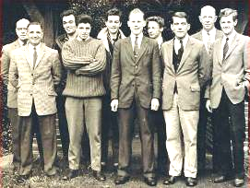  We dig a pipeline trench to the New Churchyard  Sub John Bill John Alan  Twort Biffin Bridger Witt  Skip Robin Rod John Bob  Boxall Norman Stenning Marks

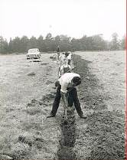  We dig !  ‘ | In that first fortnight, working sometimes until 10 p.m., we dug the trench between the churchyard and the supply at Mr Leslie Harris’s farm. He allowed us to run the pipe across his land.’ | 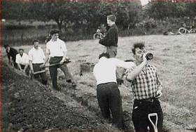  John Twort pauses for a drink
‘We dug about 25 feet a day, working whenever we had time. The vicar helped.’ ‘The task of pushing the soil back after we laid the pipe in the trench would have taken us a long time too, if Mr Harris had not adapted a back rake which was a great help.

We estimate that the cost of labour would have been about £250, possibly more. The Scouts did a fine job.’

Those taking part were: Ken Alexander, Peter Bass, Rod Bavin, Ross Baxter, Bill Biffin, Noel, Richard and Robin Boxall, John Bridger, Malcolm Coppard, Dick Fowler, Cyril Graber, Roger Graber, Leslie Harris, David Hogben, Ricky Jones, Norman Mantle, Robert Marks, Pat Moorman, Rodney Norman, Brian Perkins, Michael Pole, Charles Simpson, Robin Snook, John Stenning, John Twort, Arthur Witt.

Scouts Win Duke’s Awards

From The Kent and Sussex Courier - August, 1962

 | The Duke of Edinburgh's Gold Award has been won by two Scouts in the 1st Rusthall Troop, and a third has only to send off his log book to know if he has won. The two who have won are Michael Redhead aged 19, of Stanham Road, Pembury. and Brian Perkins, aged 18, of Camden Avenue, Pembury. The ‘possible’ is 18-year-old Robin Boxall, of Manor Road, Rusthall.  All three are Queen's Scouts. The test for the award was divided into four sections : Rescue and public service training, Expedition (50-mile journey plus passing for their hiker's badges), Pursuits and projects, Fitness.

For public service training, Michael worked as a part-time porter at Pembury Hospital, and Brian helped with a local Cub pack. Both found themselves amply prepared for the fitness tests, as they have each been on one of the rugged ‘Outward Bound’ courses.

The tests for the award had to be completed before the boys were 19, and Michael only just made it, with two weeks to spare. The last part he passed was for life-saving, which he took up after his brother became keen. He timed it even closer when he gained his silver award - he finished his athletics test a matter of hours before his 18th birthday.

Brian and Michael are to receive their awards from the Duke of Edinburgh in December.

Their achievement is one of which they are understandably proud. For the Duke of Edinburgh's Gold Award is no easy task, and for two perhaps three boys in the same troop to have won it is a triumph.

Scout Summer Fete
Girls’ School, Rusthall
August 1962

This year’s Summer Fete was held in grounds of Rusthall Girls’ School.

Appointment of the Reverend Denys Crouch as Curate
September 1962

The Reverend Denys Crouch – soon to be known amongst the Rusthall Scouting family as ‘Con – arrived in Rusthall with his family from Malacca, Malaysia.

Summer Camp
Kingsdown, near Deal, Kent
1 to 8 September 1962

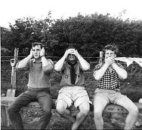  3 Wise Monkeys  John Skip John  Cotton Bridger | This year’s very successful Summer Camp was held at Kingsdown near Deal between the 1st and 8th September.  There were about 20 boys in camp and about a dozen Seniors and Rovers.  Memories of the steep cliff path leading down to the barracks below – watching and listening to the marvellous Royal Marines Band. | 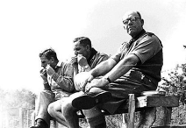  Sub on guard  - whilst Vic & Skip eat

The week was not without incident – Philip Tilford of the Panther Patrol painfully slicing his hand with a hand axe whilst chopping wood for the fire. Not a word of complaint from Phil, despite stitches being required at the local hospital.

A patrol competition, run throughout the week, was won by Woodpigeon Patrol. The weather, apart from Thursday morning was good.

Parents’ Day was on Wednesday and in the evening we welcomed Mr Mantle who stayed until Friday ‘mucking in’ with the lads.

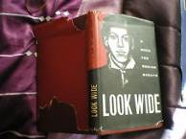  A Book for Senior Scouts  Towards the end of our camp, Skip presented Robin Snook with a still-treasured hard-backed book, signed with his best wishes for his imminent moving on to become a Senior Scout. | 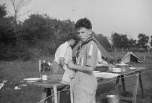  Robin Snook

As if that wasn’t enough, Skip then quietly told Robin that, in rhe summer of 1963, he would be attending the 11th World Scout Jamboree in Greece ! For Robin, that was a never to be forgotten summer’s afternoon.

As this was an official Scout Camp Site the camp was inspected by the Bailiff according to an official checklist that covered various aspects relating to the standard of camping. The assessment required the marking of 15 areas such as, equipment, kitchen layout, kitchen and site cleanliness, first aid arrangements and food storage, as Good, Fair or Bad. Once again Rusthall’s reputation for a high standard of camping was recognised since the inspection produced 8 Good and 7 Excellent scores.

In his report the Bailiff remarked that ‘The standard of camping, Scouting activities, behaviour and general atmosphere of this Troop are most impressive. A credit to your District and to the Movement. We would be pleased to see you again one day’. The Troop was expected to carry out a ‘good turn’ and was commended for its work on site and especially for keeping the site latrines in good order.

Kent Challenge
October 1962

The Senior Scouts entered two teams in the Kent Challenge held this year in the Chatham-Maidstone area. Out of 83 teams taking part, Rusthall came 21st and 22nd.

District Swimming Gala
13 October 1962

At the swimming gala on 13th October, the Cubs came second in their class and the Scouts 5th in theirs - whilst the Senior Scouts took 1st place (and the swimming shield).

Farewell to the Reverend Brian Birchmore
The Mission Hall
October 1962

A number of Scouts, parents and friends of the Group attended the Harvest Supper which served as a farewell party for the Reverend Brian Birchmore and his wife Judith.

Scouts go to the Palace
Buckingham Palace
Wednesday 5 December 1962

From the Kent and Sussex Courier - 7 December 1962

The 1st Rusthall Troop of Boy Scouts have gained a hat-trick of Gold Awards under the Duke of Edinburgh's Award Scheme.

On Wednesday their three successful members, Robin Arthur Boxall, of Manor Road, Rusthall, Michael John Redhead, of Stanham Road, Pembury, and Brian Perkins of Camden Avenue, Pembury, were presented with their awards at Buckingham Palace by the Duke of Edinburgh, along with 533 other gold award winners from all parts of the country.

All three Rusthall Scouts are 18 years old. Robin is a research assistant, Brian an insurance clerk and Michael an optician. All have been members of the senior troop for nearly four years.

Skip’s Way

To this day, two old Patrol Leaders of the Panthers and Ravens patrols vividly recall a Tuesday evening in 1962 – yet another fine evening of Scouting in the Mission Hall.

At the end of the evening, following flag down and prayers, Skip quietly asked the two Patrol Leaders to join him in the upstairs kitchen.

Unusually, Skip was rather sombre – unusually, he did not ask the two lads if they minded if he lit his pipe. On this occasion he kept his pipe in his pocket.

In the privacy of the kitchen, unheard by any other Scouts or Leaders, he quietly informed the Patrol Leaders that a very serious matter had been drawn to his attention – that they had been seen in the street, smoking – and, in fact, had been heard to swear !

Certainly a very serious matter - not to be expected of two Patrol Leaders of the Rusthall Scout Troop.

Certainly a salutary lesson to two keen Patrol Leaders – no punishment, no firm reprimand – Skip knew his lads well enough to know that “for them to know that he knew” was sufficient – that they had let Skip, their Patrols, Troop and themselves down..

Scout Movement Milestones - 1962

June | Air Scout Branch comes of age.
 | Annual Soap Box Derby renamed as National Scout Car Races( sponsored by British Motor Corporation and later Unipart)
 | World Scout Membership - 9,366,962.

Click HERE if you have any further information regarding this year
or
HERE to return to our Navigation page


