Scouting in Rusthall
1966

“It is important to arrange games and competition so that all Scouts of the Troop take part”

Lord Robert Baden-Powell
(1857 to 1941)
? | We are seeking :  - Further events that occurred this year.  - Copies of the Kent & Sussex Courier for this year.  - Any knowledge that you may have of this year.

Can you help ? Please click HERE if you can

Scout News
From the St Paul’s Parish Magazine – March 1966

We are very pleased that our Vicar has accepted the post of Chaplain to the Tunbridge Wells District Scouts.

I would like to thank all parents and friends who gave of their time to help with all the Scout and Cub parties, which were a great success.

Michael Redhead, of our Rover Crew, was chosen to represent the District at the Baden Powell Memorial Service in Westminster Abbey on February 19th.

Congratulations to Bryan Welch on gaining his Scout Cord, and to Peter Richardson who now has his Backwoodsman Badge.

Our District Chaplain
April 1966

The Reverend Norman Mantle is appointed District Chaplain

Bob-a-Job Week
11 to 16 April 1966
From the St Paul’s Parish Magazine – April 1966

Dear Friends

During this week our Scouts will be offering their services once again under the Bob-a-Job scheme, and I trust that you will give your full support as you have always done in the past.

One of the principles of the Movement is that the boys are trained to earn the money for their Scouting. Bob-a-Job is one of the ways that they do it.

A few points to remember :

- Make sure the boys are really Scouts.
- See that the jobs are done properly.
- Choose jobs suited to age.
- Pay them what the job is worth.
- Enter the amount on the card.

So please help the Scouts to help you, and so assist in their training.
Yours sincerely
NA Boxall, S/M

Skip is elected to the position of People’s Warden
From the St Paul’s Parish Magazine – May 1966
From the Reverend Mantle’s introductory letter

At the Annual Meeting I reported that Mr Woodthorpe Brown is retiring as People’s Warden.

It is particularly happy for me that my dear friend Noel Boxall (Skip) has been elected as successor to Mr Brown. He is in every way a most worthy choice. Skip is eminently well suited to hold the office of People’s Warden.. it would be difficult to overestimate the contribution he has made to the life of our Parish with his work among young people. We are indeed blessed at St Paul’s to have so man y people of such excellent calibre.

 | Michael Holmwood  26 April 1966 | INSERT SPRYF LOGO OR PHOTO OF MICHAEL

From the St Paul’s Parish Magazine – June 1966
From the Reverend Mantle’s introductory letter

It is only a matter of a few months ago that I rejoiced to tell you all in the Parish Magazine that Michael Holmwood had offered himself for the Ordained ministry of the Church. He was to start his training at King’s College, London this autumn/

Most people will have heard that he was taken ill during the early hours of the 26th April, and died at 6pm the same day. It was one of those very rare, unfortunate illnesses which had the doctors puzzled, but which can occur from time to time. All that could have been done was done, but Michael just could not be saved.

He was just 19 years old. A member of the Youth Club, a Server, a bell-ringer and oh so many other things. Greatly loved and admired by all. The most that we can say is that “our disappointment may be God’s appointment”.

What we do know is that Michael was met by the Lord Jesus and gently led to our Heavenly Father’s House, to begin an even greater ministry. He has lit a light among us that can never be extinguished. We must not mourn, but honour his memory in a practical way by carrying that light forward. We shall meet again, never fear.

To Mabel, who gave him her life, her love, her all, we give our love and our prayers.

Researchers’ note – Robin Boxall (Assistant Senior Scout Master at the time) invited Michael to join the Unit shortly prior to his death. Michael gave much thought to the possibility, but decided that it was not for him. He was never a Scout, but was a good friend to many.

More Scout News
From the St Paul’s Parish Magazine – June 1966

The Scout Group wish to thank all who gave the jobs during this week and helped us to raise £65.15.6.

I am delighted that Chris Woodward has decided to take his warrant as ASM with the Group. I am sure that he will make an excellent Scouter.

I was very proud to accompany Robin Snook to Windsor Castle, where he represented the Tunbridge Wells District at the St George’s Day Queen’s Scout Parade in the Queen’s presence.

Our first Camp this year will be at Whitsun, at the Beacon. Our grateful thanks to Mr Dean of the Beacon Hotel, who so kindly often allows us to use the grounds for our Scouting activities

Preparations are in full swing for our Summer Camp, which will be held from August 6th to 13th at Erringham Farm, Shoreham-by-Sea.

Congratulations to Peter Richardson gaining his Jobman Badge and also his Scout Cord. Well done, Peter !

And I would like to convey the Group’s good wishes to Philip Cotton and Robin Snook in their new service, Philip as a Military Policeman and Robin as a Police Constable.
Skip
Jumble Sale in aid of the USPG
Saturday 16 July 1966
From the St Paul’s Parish Magazine – July 1966

A Jumble Sale will be held on Saturday 16th July in the Parish Hall at 2.30pm. We would be grateful for any good jumble. It is hoped to raise £15 for the USPG.

Tunbridge Wells District Cubs Rally
18 June 1966
From the St Paul’s Parish Magazine – August 1966

Our Pack had a very successful day at the Tunbridge Wells District Cubs Rally held on 18th June at Southfields Playing Field, Southborough, when we gained second place – and, in addition, 18 certificates were gained by individual Cubs.
County Commissioner’s Camp
24 to 26 June 1966 – Buckmore Park
From the St Paul’s Parish Magazine – August 1966

Two Patrols attended the County Commissioner’s Camp at Buckmore Park on 24th to 26th June, which was a challenge of Patrol skills, games and camping. Both Patrols enjoyed a good weekend, and the one led by Peter Stenning gained sufficient points to qualify for a pennant.

Only 11 patrols out of the 31 taking part gained one of these. Peter’s patrol was K Worsell, J Jeffrey, S Mantle and G Temple.

County Commissioner’s 4 Scout Challenges
From the St Paul’s Parish Magazine – August 1966

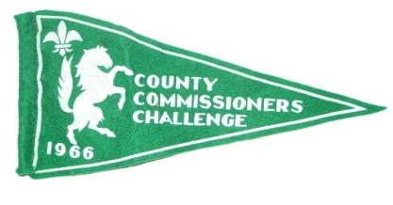 | All four patrols entered this and three were successful and gained pennants. The Woodpeckers only just missed the pennant by one challenge.  - Woodpigeons P/L P Richardson  - Panthers P/L G Ongley  - Eagles P/L D Bray

The National Scoutcar Races  Cleethorpes  9 July 1966  After a successful entry in the National Scoutcar Races at Weston-Super-Mare it was thought that ‘Rushalong II’ should have another outing at this year’s event. The car was considered to be almost as good as it could get and would only require minor adjustments to make it fit for racing again. A major concern was the need to adjust the seat to accommodate the varying leg lengths of Cubs, Scouts and Senior Scouts.  Michael Chapman (shown right in the pits) competed in the Cub races | 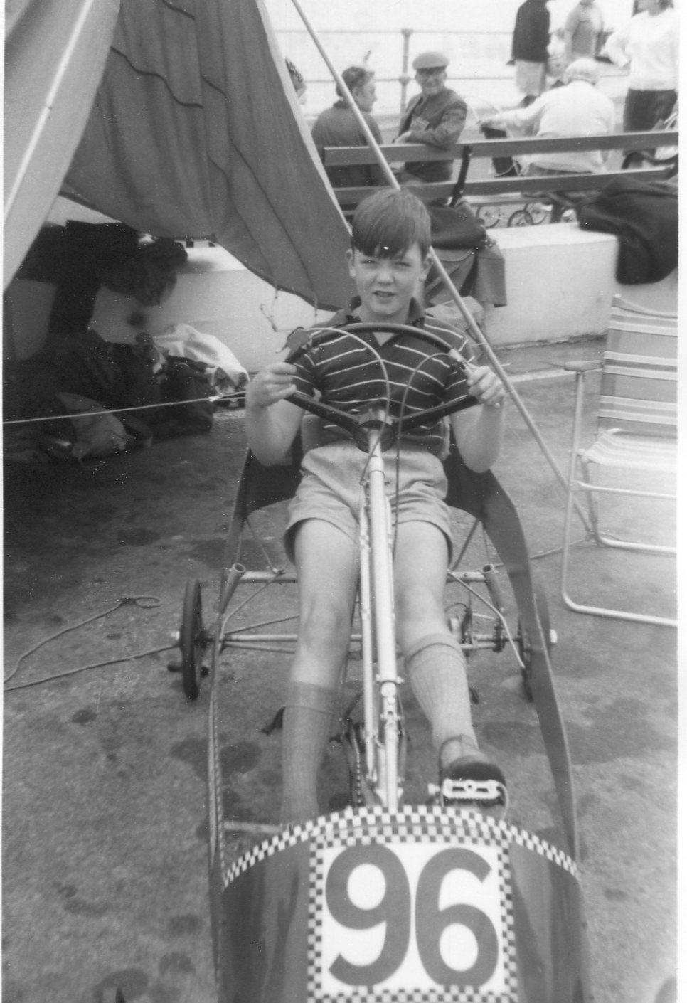

Once again, Andrew Marks remembers going to a cold and windswept Cleethorpes as the Scout driver for this year’s racing. He recalls travelling to the event with another Scout family in their car and adds : “Unfortunately, the car had a habit of boiling its radiator water whilst climbing hills, which meant that travel was a bit like hitch hiking - you knew you'd probably arrive at your destination eventually - but even roughly when, was a mystery”. | 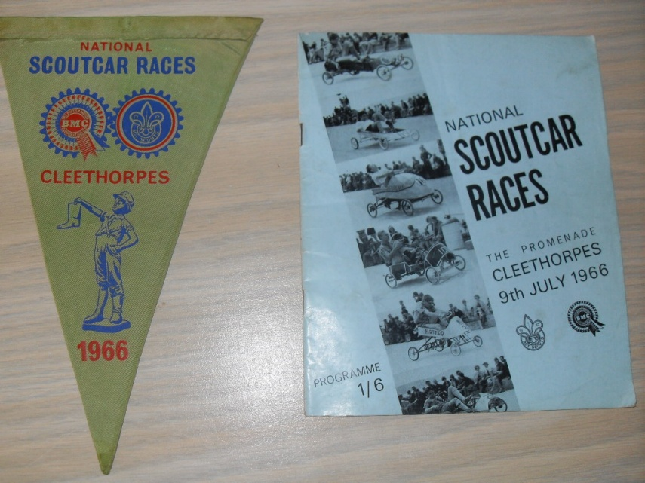

News from the Group
From the St Paul’s Parish Magazine – August 1966

The Scouts have been busy again this year helping with clearing the Common of litter, and it is amazing how much litter there has been found. This has been a great help to the Common Conservators as it frees the men normally employed on this for grass cutting duties.

The Group congratulates John and Jean Twort on the birth of their daughter. (Jean, you had better approach Brown Owl re a vacancy in the Brownies !)

Congratulations to Timothy Milton on gaining third place in the Scout Section of the National Scoutcar Races held at Cleethorpes on 9th July. Many thanks to F Ongley for all he did to make the effort a success, particularly for transporting the car to Cleethorpes.

Congratulations to M Marks and J Jeffrey on successfully passing their First Class Journey and log.

Our Cubs. Ian Chapman, Graham Adcock and Christopher Bray recently went up to the Scouts. We wish them every success and plenty of good Scouting in the Troop.

Congratulations to Michael Chapman who did so well in coming fourth in the Finals of the National Scoutcar Races, and also to Christopher Ward on gaining his Collector’s Badge.

Summer Camp
Erringham Farm, Shoreham-by-Sea
5 to 13 August 1966
From the St Paul’s Parish Magazine – October 1966

This year’s camp was held from 5th to 13th August at Shoreham, Sussex.

There were 16 boys, 2 Scouters and 4 Seniors in camp. Skip was unable to be with us for the whole week, but he did visit us on three occasions. Con and Robert Crouch were able to be in camp with us for three days and they both enjoyed their stay.

During the week the boys participated in various activities, including a “Scouts Own” on Sunday, a “Camp Sports”, a “Night Stunt” and numerous camp fires.

One of the highlights was the day out in Brighton.

Several boys were invested and others passed tests and parts of badges. Well done !

Thanks are due to Robin (Bosun), Chris and the Seniors for all the hard work they put in at Camp to make it a success.

More News from the Cubs
From the St Paul’s Parish Magazine – September 1966

This month has been a good one for Christopher Ward, Michael Chapman and Jeffery Twort, who have gained their House Orderly Badges.

During August Bank Holiday the Sixers and Seconds were off to camp with the District at Lamberhurst. We hope to have a full report of their activities in next month’s magazine.

The Beacon Scheme

Rusthall Rover Crew stage the fourth Beacon Scheme competition for Tunbridge Wells District Scouts. The competition is won by a team from 7th Tunbridge Wells (The Skinners’ School).

2 First Class Badges – and a Thanks Badge
From the St Paul’s Parish Magazine – October 1966

Scouts restarted on 6 September. It is hoped that great strides will be made with badge work during the winter.

Congratulations to Michael Marks and John Jeffreys on gaining their First Class Badges.

On 16th August we said “au revois” to Con (Rev D Crouch) and presented him with the Scout Thanks Badge for all the good work he did for the Group. We sincerely hope that he will have God’s Blessing in his new Parish.

Our Senior Scouts
From the St Paul’s Parish Magazine – October 1966

Andy Marks, Algis Cininas and Peter Tovey have started work on their Hiker Badge by taking part in a 3-day, 30 mile hike, between Uckfield and Lewes.

It is hoped that other Seniors will follow suit as this badge is one of the requirements of the Queen’s Scout Badge and Duke of Edinburgh Award (Silver).

Two teams have entered this year’s Operation Challenge which is being held on the 1st and 2nd October at Ashford. We hope both teams will win a pennant.

The Kent County
Rover Scout Hike Challenge

The first competition for the Kent County Rover Scout Hike Challenge Trophy was held in 1932, when it was won by the King Street Rover Crew of Maidstone. The competition was held annually except during the war years, 1939 – 1945. It was not until 1962 that the Trophy came to Tunbridge Wells, when it was won by the District Rover Crew. The Crew retained the Trophy in 1963. In the following two years it was held by a team from Dover and District.  In 1966 ??? the trophy was won by Rusthall Rover Crew who retained it until the Rover Section was disbanded in 1968. | 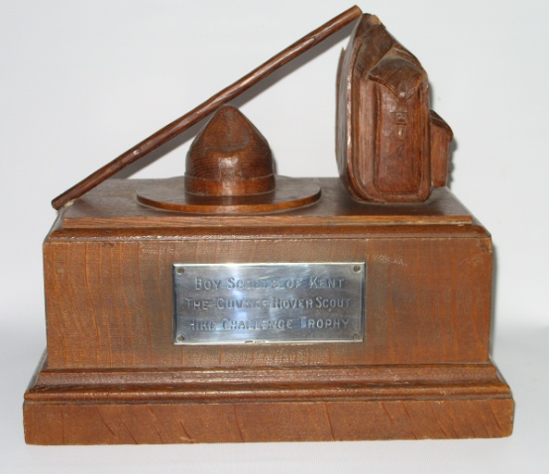  The Guv’nor Kent Rover Scout Hike Challenge Trophy

Miss Brankston to stand down after 38 years
Annual General Meeting
Tuesday 27 September 1966 – in the Parish Hall
From the St Paul’s Parish Magazine – November 1966

Miss E Brankston, who has served as Cub Master with the Rusthall Group for 38 years, announced at the General Meeting that she wished to hand over the leadership of the Cub Pack (now the Cub Scouts) to John Twort, who has been the Assistant Cub Master for several years. Miss Brankston passed on her best wishes for the future of the Pack.

Resignation as Cub Master does not mean that she will no longer be involved in Rusthall Group affairs, for we hope that she will always be available to give advice to those whose job it will be to train the new Cub Scouts.

The Group would like to take this opportunity of thanking Miss Brankston publicly for all her past services, and we hope she will continue to come to all our future activities.

The first part of the meeting consisted of reports from Scouters, election of a new Group Committee and a talk on the Advance Party Report.

The second half, following refreshments, included movie films and slides of Scouting activities in the last three years. There was also a display of camp gear, certificates, trophies and photographs.

It is with great pleasure that we announce that two more First Class Badges have been gained by members of the Troop – congratulations to Tim Milton and Derek Bray.

Kent Messenger 50 Mile Walk  Some take part in the event – again from Margate to Canterbury, to Ashford and on to Maidstone.  Researchers’ note – Did you take part ? Have you any recollections of the event ? If so, please click HERE. | 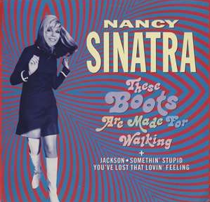

Our Senior Scouts succeed in Operation Challenge
1 & 2 October 1966 - Ashford
From the St Paul’s Parish Magazine – November 1966

Held in the Ashford area on the 1st and 2nd of October during the hours of 9pm and 6am, teams cycled 40 miles and completed 10 incidents, which included swimming across a river carrying a fire on a metal sheet – carrying an injured person through a river – and scaling a steep quarry.

Two teams entered from Rusthall :

- Team A – Richard Boxall, Howard Lea, Bryan Welch and Algis Cininas.
- Team B – Peter Tovey, Andrew Marks, Peter Richardson and Ralph Ashby (a Senior from Fordcombe).

Awards went to the first 30 successful teams of the 80 competitors, who came from all over the county. Our Team B took 11th place and 21st place went to Team A. Well done, lads !

Teddy Bears’ Picnic
17th December 1966

The Senior Scouts organised a night activity entitled Teddy Bear’s Picnic for the Scout Troop.No further details are available of the event or the location. However, it is likely to have included a test or tests of Scouting skills and, the title suggests that some outdoor eating must have occurred!

More News from the Group
From the St Paul’s Parish Magazine – December 1966

We would like to take this opportunity to congratulate Robin Boxall on his engagement to Janet Roffe, and to wish Robin every success in his new job.

Scouts – Michael Marks has gained his Swimmer’s Badge, and Roger Dunn and Roy Coppard their Second Class Badges. Robert Jeffery has been invested and John Jeffery has been made the Second of the Eagle Patrol.

At the District Swimming Gala the Troop gained 3rd place and the Seniors 2nd.

Congratulations on this continued success.

At last Skip’s ambition of a Scout Headquarters at Denny Bottom is nearing completion. Only a need to refurbish remains. Any help with curtains, etc ?

Seniors – Bryan Welch has completed his 30 mile hike which is part of his Hiker Badge. Congratulations.

A meeting has been held with the Rovers to discuss joint activities, Venture Scouting and the Advance Party Report.

Cub Scouts – Intensive efforts at two meetings a week, Tuesdays in the Parish Hall and Thursdays at Denny Bottom, have earned these good results :

- First Aider Badges – C Ward, M Chapman, R Scholar, K Barden, K Tettmar, A Poile and J Twort.
- Swimmer Badges – K Barden, J Barden, S Strutt, P Richardson and M Chapman.

Well done, Cubs !

Special congratulations to Chris Ward on gaining his Leaping Wolf.

The Advance Party - The Chief Scout's Advance Party was formed in January 1964, when 24 Scout Leaders under the age of 45 were invited to "study all aspects of the future of Scouting and to make recommendations, after consultation with the Movement, to the Chief Scout as to the development of the Movement, both in the immediate future and for the 1970s."  The Advance Party met as a body for six weekends, with various sub-committees holding an additional 166 meetings and the Chairmen of these committees meeting on three occasions.  The Report – The final report to the Committee of the Council was 200,000 words long. This was reduced to 50,000 words in a published "Popular Edition" through summarising and omitting many of the arguments relating to the 409 recommendations. | 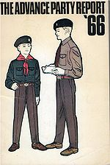

Key recommenddations :

1. That the Boy Scouts Association be renamed as The Scout Association.
2. Wolf Cubs be renamed Cub Scouts.
3. That the Scout and Cub Scout Promise be the same, with the removal of the phrases "On my
honour" and "at all times".
4; That the original Scout Law be re-written, becoming :
- A Scout does his best to honour his promise.
- A Scout is to be trusted.
- A Scout is loyal.
- A Scout is friendly and considerate.
- A Scout is a brother to all Scouts.
- A Scout has courage in all difficulties.
- A Scout makes good use of his time and is careful of possessions and property.
- A Scout has respect for himself and others.
5. That a new training and advancement scheme be introduced.
6. All Sections should use the same Scout salute.
7. That "Be Prepared" be the motto for the whole Scout Movement.
8. That the minimum age for entry into the Scout Movement be 8 years, with no pre-Cub training.
9. That the maximum age for membership of a Training Section of the Movement be 20 years.
10. That there be three Training Sections in the Movement;
- Cub Scouts (ages 8 to 11)
- Scouts (ages 11 to 16)
- Venture Scouts (ages 16 to 20)
11. That Scout Troops of approximately 36 members be formed by amalgamation or pooling of
resources of smaller troops.
12. That the registration of Lone Scouts be discontinued.
13. That a set of minimum standards be introduced, with Groups failing to meet these standards being
closed :
- Minimum number of young people (Cub Scouts: 12, Scout Troop: 12, Venture Scouts: 9)
- Minimum number of leaders (At least 2 adults for each section)
- Minimum level of progress made by members of each section
- Appropriate programme being operated by each section
14. That a maximum age-limit for Scouters and Commissioners be introduced.
15. That there be an increase in the number of paid Scouters.
16. That shorts will only be worn as part of the uniform by members of the Cub Scout section.

Implementation - Following the publication of the Report a further document called Design for Scouting was published, outlining which of the Advance Party's recommendations had been accepted by the Committee of the Council. Only a few of the proposals were amended. Notably, it was decided against the deletion of "On my honour" from the Scout Promise; this obviated the need for the first of the proposed eight Scout Laws, leaving only seven. The suggestion that the Wood Badge insignia (for adult leader training) be replaced by a cloth emblem was also not adopted.

The first changes to be implemented were the adoption of the new Laws and Promises in October 1966 followed in May 1967 by the formal name change from The Boy Scouts' Association to The Scout Association. In October of that year, the new uniform was introduced along with the new training schemes, including the launch of the Venture Scout section.

Outcomes - Such radical change was not welcomed by all members and a reply, "A Boy Scout Black Paper", was produced in 1970 by "The Scout Action Group". This provided some alternative proposals for the development of the Movement and asked for Groups that wished to continue to follow Baden-Powell's original scheme to be allowed to do so. The content of this paper was not accepted by The Scout Association, resulting in a split developing in the Movement and the formation of the Baden-Powell Scouts' Association.  The front cover of the Black Paper featured a photograph of a Scout Group in South East London which, according to the forward of the document, was forced to close under APR due to the leader being aged 65 despite no replacement leader being available. The Paper concludes with a copy of the letter from North and Central Lambeth Scout Council refusing to re-register and, therefore, forcing the closure of the Group. | 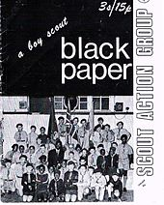

Following several years of reduction in overall numbers, the annual census of 31 March 1969 (18 months after the implementation of the Report) showed modest increases across two sections of the Association. The total of 531,011 included 249,561 Cub Scouts, 188,379 Scouts and 21,698 Venture Scouts in 11,704 Scout Groups. The total number of young people in the Association who were within the reduced Statutory Youth Service age range of 14 to 21 was over 81,000.

The Advance Party Report failed to recover the losses of older boys, with 55,206 Senior Scouts and Rover Scouts recorded in 1966 having been replaced by 21,698 Venture Scouts in the 1969 figures. The highest recorded membership of the Venture Scout section was 39,307 in 1989 (after the 1976 admission of girls into the Venture Scout section).

By March 1978, a decade after implementation, the overall Scout Association total had risen to 636,148, including 308,152 Cub Scouts, 207,276 Scouts and 27,905 Venture Scouts (of whom, 2,218 were girls). The number of Scout Groups had fallen to 11,464, reflecting the policy of amalgamating smaller units which had been proposed by the Advance Party. By 1998 the majority (68%) of members of The Scout Association were under 11 years old.

Further reviews - The training schemes of the Scout Association were reviewed several times in the succeeding decades. A new training scheme and proress awards for the Scout section were launched in April 1985, Against the recommendations of APR, the Beaver Scout section for 6 and 7 year olds launched in April 1986 after a trial scheme and in February 1990, it was decided in principle that the Association would become fully co-educational. A new training scheme for Cub Scouts was launched in September 1990.

In May 2000 a new report called simply 'The Programme Review' was received by the Committee of the Council after extensive consultation with members of the Association and focus groups. A uniform review was conducted shortly afterwards. The new uniforms were launched during London Fashion Week in 2001 and implementation of the new training programmes began in 2002. This included splitting Ventures back into two sections, Explorer Scouts (14−18) and Scout Network (18−25); effectively restoring the pre-APR age boundaries by December 2003.

Scout Movement Milestones - 1966

January |  | The Wolf Cubs' Golden Jubilee Year commences.

February |  | The Scout & Guide Founders Day Service forms part of Westminster Abbey's 900th Anniversary Celebrations.

June |  | The Chief Scout’s Advance Party Report is published by the Boy Scout Association in the United Kingdom, intended to modernise the Scout Movement. The report was attempting to address falling numbers within the Movement.

October |  | The new Promise and Law are introduced.

World Scout Membership - 10,462,385.

Click HERE if you have any further information regarding this year
or
HERE to return to our Navigation page


