Scouting in Rusthall
1967

“Fun, fighting and feeding ! These are the three indispensable elements of the boy’s world”

Lord Robert Baden-Powell
(1857 to 1941)
? | We are seeking :  - Further events that occurred this year.  - Copies of the St Paul’s Church Parish Magazine for this year (except June & October).  - Copies of the Kent & Sussex Courier for this year.  - Any knowledge that you may have of this year.

Can you help ? Please click HERE if you can

Diamond Jubilee Year of Scouting

1967 was the Diamond Jubilee Year of Scouting and would see a wide range of celebratory events at National, County, District and Group levels. It was reported in the Scout News Section of the January edition of the St Paul’s Church Parish Magazine that the Group would be making plans for a number of special events.

A change of title

The title of 1st Rusthall Group is amended to St Paul’s Rusthall, 2nd Royal Tunbridge Wells. | 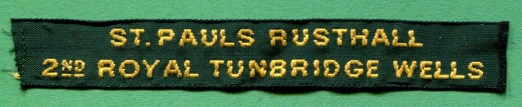

An Old Time Games Evening
In the Parish Hall
Tuesday 3 January 1967

The first event of the year was an Old Time games evening held in the Parish Hall on Tuesday 3rd January.

A New Fund Raising Activity

The Senior Scouts began a new fund raising activity in the form of a car cleaning service. The charges were 7/6d for a car wash and 10/- for a wash and wax.

Badges Awarded this month
January 1967

- Scouts
  - Swimmer - Michael Marks
  - Second Class – Ian Chapman, Roy Coppard
  - Tenderfoot and investiture – Mark Fouracres

- Senior Scouts
  - Despatch Rider and Venturer – Bryan Welch

5 County Commissioner’s Challenge Awards  were presented to :  Peter Richardson, Andy Marks, Bryan Welch,  Peter Coppard & Algis Cininas | 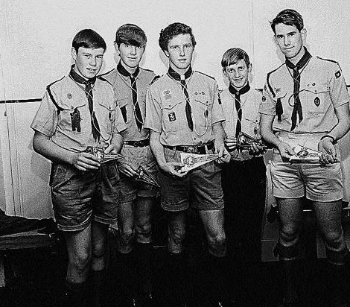

Five teams entered the County Commissioner’s Challenge held in the Bayham Abbey area. Overnight activities included tackling a commando course, construction of a coracle and a derrick and building a polythene shelter. Pennants were awarded to the first ten teams; five of these were gained by Rusthall.

Cub News from St Paul’s Church Parish Magazine
March 1967

The Pack football team (formed to play in a District Competition) was successful in reaching the semi-finals.

Badges Awarded
  - Jeff Twort and Michael Chapman – Collectors Badge
  - Jeff Twort was also awarded the Leaping Wolf Badge

Senior Scouts Dinner
Beacon Hotel
11 March 1967

On 11th March the Senior Scouts and their guests met for an evening dinner at the Beacon Hotel. The evening was rounded off with a film show.

Plans to form a District Service Team
March 1967

Arrangements are well in hand for the formation of a District Service Team, to replace Rovers.

Skip becomes Group Scoutmaster
April 1967

After several months badgering, Skip agreed to have his Warrant amended, promoting him from Scoutmaster to Group Scoutmaster. After all, he had been performing this role for sometime and the change in Warrant really just regularised the position.

Senior Scouts Visit to London
1 April 1967

The Senior Scout Troop undertook a trip to London and visited the Inland, Continental and Long Distance Telephone Exchange.

Patrol Leaders’ Training Weekend
8 & 9 April 1967

A training weekend for Patrol Leaders was arranged at the Scout Headquarters. Whilst training focussed on the requirements of the First Aid and Guide Badges the opportunity was taken to brief PLs on the new Scout training scheme arising from the recommendations of the
Advance Party Report.

The existing Scout training programme will continue for some time whilst the new badges of the progressive training scheme are phased in.

The New Look Scout Badges

Scout Badge | Scout Standard | Advanced Scout Standard | Chief Scout’s Award

Senior Scouts Hike to Biggin Hill
April 1967

A small group of Senior Scouts undertook an overnight hike from Rusthall to Biggin Hill to visit the Rev. Denys Crouch, former Curate of St Paul’s Rusthall and newly appointed Vicar of St Mark’s Church Biggin Hill. The Scouts camped in the field behind the vicarage and attended evensong before returning by car to Rusthall.

St George’s Day Parade
23 April 1967

The District’s annual St. George’s Day Parade was held at the Baptist Tabernacle, Tunbridge Wells.

Peter Tovey attended the National St George’s Day Parade at Windsor. He was selected as one of the two Senior Scouts from Kent who joined the bodyguard for HM The Queen.

New Group Quartermaster
April 1967

A recommendation arising from the Advance Party Report was that Groups should encourage greater involvement of non-uniform support. In keeping with this recommendation, Mr Ron Welch took on the role of Group Quartermaster.

Senior Scout First Aid Training
May 1967

Four Senior Scouts began training in first aid as a first step towards gaining the Ambulance Badge. Instruction was given by Mrs Rita Tovey.

Badges Awarded This Month
May 1967

- Cubs
  - Collector Badge - A. Poile, K. Tettmar, R. Hatton, M. Fitzgerald, C.Smith , S.Gordon and K. Barden.
  - Leaping Wolf Badge - K.Barden..
- Scouts
  - Cyclist Badge - Peter Ward, Simon Mantle and Michael Cornford.

Diamond Jubilee Camp
Somerhill Park
May 1967

Two Scout Patrols participate in the Diamond Jubilee Camp at Somerhill Park, Tonbridge (a joint Tunbridge Wells and Tonbridge District event).

Scouts assist at Guide Camp
Rolvenden
28 May to 3 June 1967

Chris Woodward, Bryan Welch, Peter Richardson and Gordon Ongley joined the Rusthall Guides’ Camp at Rolvenden

A new Assistant Scout Leader

Peter Tovey appointed Assistant Scout Leader.

From St Paul’s Church, Rusthall, Parish Magazine June 1967
Scout News
On Tuesday 9 May the Scouts entertained and waited on a party of old people from the Lambeth Mission.

We are sending two patrols to take part in the Diamond Jubilee Camp which is being held in conjunction with the Tonbridge Scouts at Somerhill Park, Tonbridge on 26th - 29th May.

Three of our Scouts are going with the Guides to their camp to help Captain and the other Guiders.

During the month, Martyn Stenning, Graham Adcock and Chris Bray have gained their 2nd Class Badges; Peter Coppard his 1st Class Badge; Michael Marks and Gordon Ongley their Guide Badges; Roger Dunn. Simon. Mantle and Ian Chapman have been invested as Seconds and Robert Hall has recently been invested as a Scout. Congratulations !

We welcome the following lads who have joined the Troop from the Cubs: Chris Ward, Jeffrey Twort, Alan Priest, Kenny Harden, Michael Chapman, Graham Thomas, Alan Saunders and Andrew Willard.

It was reported in the Courier on the 12th May that a Scout had been accused of stealing from a house in Rusthall. We would like to point out to parishioners that this scout is not a .member of the Rusthall Troop.

Senior Scouts - Four of the Seniors have attended a lecture at the St. John's Ambulance Brigade Headquarters, where they were instructed on artificial respiration and cardiac resuscitation.

Patrol Leaders’ Training Weekend
17 & 18 June 1967

The aim of this training weekend was twofold : firstly to give instruction in first aid and mapping for the Patrol Leaders and, secondly, to allow PLs to brief their Secnds and other selected members of their Patrols in the new Scout training scheme.as recommended in the Advance Party Report.

Scouts Assist at Guide Camp 28th May – 3rd June
Chris Woodward, Bryan Welch, Peter Richardson and Gordon Ongley joined the Rusthall
Guides Camp at Rolvenden.
June
17th - 18th June – Patrol Leaders’ Training Weekend
The aim of this training weekend was twofold: firstly to give instruction in first aid and
mapping for the Patrol Leaders, and secondly to allow PLs to brief their Seconds and other
selected members of their Patrols in the new Scout training scheme as recommended in the
Advance Party repo
Venturer Incident Hike 24th June
Two Senior Scouts took part in an incident hike as part of the requirements for the Venturer
Badge. Other members of the Senior Scout Troop were responsible for running a ‘rock
rescue’ incident at Bull’s Hollow.
Venturer Incident Hike 24th June
Two Senior Scouts took part in an incident hike as part of the requirements for the Venturer
Badge. Other members of the Senior Scout Troop were responsible for running a ‘rock
rescue’ incident at Bull’s Hollow.
Venturer Incident Hike 24th JuneTwo Senior Scouts took part in an incident hike as part of the requirements for the Venturer Badge. Other members of the Senior Scout Troop were responsible for running a ‘rock rescue’ incident at Bull’s Hollow.

Venturer Incident Hike 24th June
Two Senior Scouts took part in an incident hike as part of the requirements for the Venturer
Badge. Other members of the Senior Scout Troop were responsible for running a ‘rock
rescue’ incident at Bull’s Hollow.
Venturer Incident Hike
24 June 1967

Two Senior Scouts took part in an incident hike as part of the requirements for the Venturer Badge. Other members of the Senior Scout Troop were responsible for running a ‘rock rescue’ incident at Bull’s Hollow.

Scout Badges Awarded
Peter Coppard, and John Jeffery were awarded the Guide Badge
Scout Badges Awarded
Peter Coppard, and John Jeffery were awarded the Guide Badge
Scout Badges Awarded
June 1967

Peter Coppard, and John Jeffery were awarded the Guide Badge.

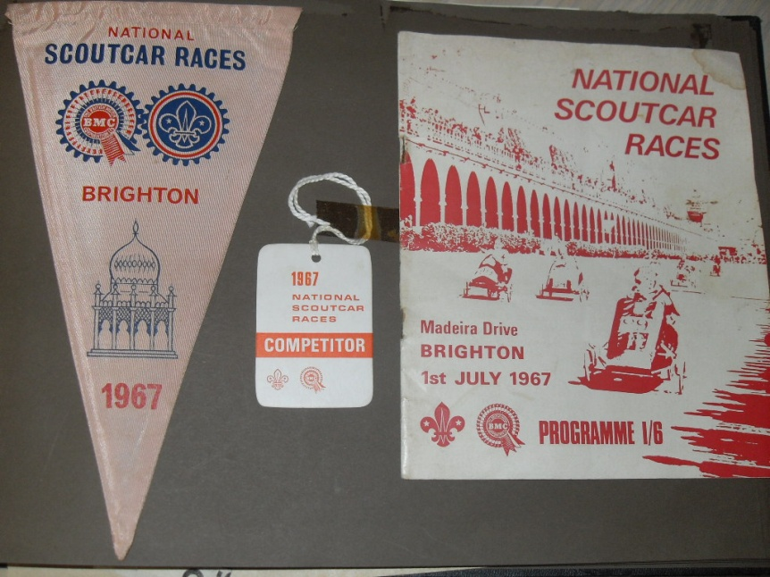 | The National Scoutcar Races  Brighton  Saturday 1 July 1967  Rusthall returns to Brighton to compete in the National Scoutcar Races with Rushalong II – with racing number 104. Michael Chapman remembers participating as driver in the Scouts Premier Class and achieved third place, winning the princely sum of £5 for Group funds.

From the Brighton Evening Argus - Saturday 1st July 1967

Speedy Scouts  Scouts from all over the country converged on Brighton today for the National Scoutcar Races.  A record number of cars - 169 - raced along Madeira Drive, driven by Scouts from as far afield as Swansea, Huddersfield and Bristol.  Featuring as many as nine gears, the cars can reach speeds of more than 25 miles per hour.  The meeting is sponsored by the British Motor Corporation and BMC officials inspect the cars for roadworthiness before the start of each race.  Comedian Tommy Trinder, in town for his summer show, presented the awards.. | 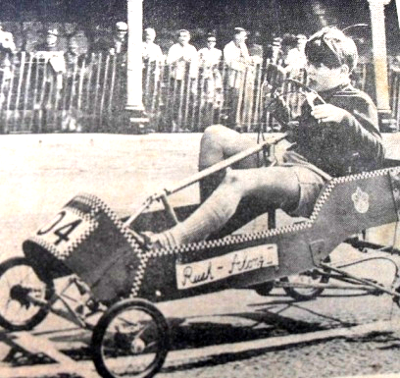  Michael Chapman  at the finish line

Scavenger Hunt
16 July 1967

Members of the Scout Troop joined with the Guides in a scavenger hunt. The competition
was won by a Guide Patrol. The event was rounded off with a sausage sizzle at the Beacon
grounds

Bryan Welch attends
the 12th World Jamboree
Farragut State Park, Idaho, USA
31 July to 9 August

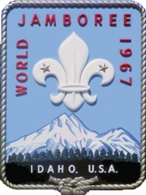 | The second World Scout Jamboree in North America. 12,011 participants from 105 countries. Theme: "For Friendship". Arena shows, Skill-o-Rama, adventure trail, water activities on Lake Pend Oreille, the thrills and spills of a real Western Rodeo, all amid the splendour of the Rocky Mountains.  Personal Memories from Bryan Welch.  The following vivid account was published in the October 1967 issue of the St Paul’s Parish Magazine.  Howdy friends ! That was the first greeting we received on arrival and indeed it was the greeting we received all the time we were there; everyone was everyone's friend.

Where else in the world could you have breakfast with your English patrol, have dinner with some Japanese, have tea with the Argentineans and in the evening attend a campfire where over 100 countries are represented? This was friendship, the jamboree motto.

After a few days in which we became acclimatised and at home in new surroundings, the motto, ‘For Friendship’ became a reality. It was necessary always to carry spare badges and a pen and pencil with you when you were out of your campsite; swapping and collecting addresses was the usual thing after you had dined with another patrol. After the first three days a rule was made in our troop, allowing only four people from each patrol to exchange meals at any one time. This became necessary because we were getting into the situation where there were more visitors in the Kent campsite than residents.

Activities at the jamboree were also numerous; archery, swimming, fishing, boating, conservation trails, adventure trails and campfires were among the everyday events.

A silver mine, sauna baths, skillorama and a rodeo were some of the activities arranged to take up some of our ‘spare time’ which, of course, we never had if we hoped to see everything.

Yes, I enjoyed every minute at the jamboree, from arrival at six o'clock one Monday morning until departure ten days later. The ‘town’ at Idaho, where over 100 countries were represented was a message-to everyone that all nations could live together with no language, racial or religious barriers.

I wish to thank the Parish for giving me this opportunity to experience such a friendly atmosphere and I wish all of you could have been there too.

Summer Camp
Seniors’ Expedition to the Lake District
12th to 19th August

From St Paul’s Church, Rusthall, Parish Magazine – October

On Saturday August 12th at 3:15 am the party of eight assembled outside the Mission Church at the start of their journey to the Lake District where they .arrived twelve hours and 350 miles later.

Our camp site was just above the village of Braithwaite near Keswick and we had some marvellous views of Bassenthwaite Lake and Skiddaw Mountain. We spent the best part of Saturday evening, and Sunday pitching camp, we did however attend evensong at a church in Keswick. After the service we drove over the Whinlatter Pass which runs between Braithwaite and Cockermouth.

The bad weather prevented us carrying out our proposed programme on Monday and thus we viewed several of the lakes and passes ending up at Lake Derwent where we spent some time on the boats.

The following day we spent at Maryport, where we toured the docks and were entertained in the evening by some friends of Skip.

Wednesday was ‘Hike Day’. We set off in glorious sunshine to climb the “hill” behind our campsite, but as soon as we reached the top we were caught in a hail-storm and from then on we had to battle with a high wind. We eventually climbed to a height of 1,400 feet from which we had a magnificent view of the surrounding countryside. We finally hiked about ten miles over some very hilly country.

On Thursday we drove to Bowness-on-Windermere where most of the time was spent on Lake Windermere itself, and fortunately the weather was fairly good throughout the day.

When we awoke the next morning it was pouring with rain, and as we had previously decided, we broke camp and moved on to Maryport where we managed to dry out in preparation, for our return home.

We left Maryport on Saturday morning at 7:30 a.m. and arrived-back in Rusthall at 7:00 p.m. Despite the bad weather everyone enjoyed themselves and hoped to return to the Lakes at a later date.

The members of the party were: Skip, Sub, Chris Woodward, Peter Richardson, Peter Coppard, Peter Tovey, .John Jeffrey and Gordon Ongley.

Leaders’ Wedding
9th September 1967

Cubs, Scouts and Senior Scouts were on hand to provide a guard of honour outside St Paul’s Church following the wedding of Robin Boxall (Assistant Senior Scout Leader) and Janet Roffe (Assistant Cub Scout Leader).

The Beacon Scheme

Rusthall Rover Crew stage the fifth Beacon Scheme competition for Tunbridge Wells District Scouts.

The trophy is retained by last year’s winners from 7th Tunbridge Wells (The Skinners’ School).

Operation Challenge

Our Senior Scouts enter the County Competition - Operation Challenge – held in Tunbridge Wells District this year.

Formation of the District Service Team
1 October 1967

The unit designated as the Tunbridge Wells District Service Team was founded on 1 October with 18 members, several of whom had previously been members of the Rusthall Rover Crew.

Rusthall Venture Unit

Rusthall Venture Scout Unit is in operation – one of only three in the District - the others being at The Skinners’ School and 1st Royal Tunbridge Wells (Pathfinders).

The Opening of our new Scout Headquarters
14th October 1967

Extract from Reverend Norman Mantle’s Introduction

From St Paul’s Church, Rusthall, Parish Magazine – October 1967

One of the most important events in the life of this parish for many a long year will take place on Saturday the 14th of October at 3.15pm when the new Scout Headquarters will be officially opened in what used to be variously known as the ‘Denny Bottom Club House’, or ‘The Coffee House’.

As many will know, this fine building completed in the opening decade of this century was intended as a centre of recreation for the people of Denny Bottom where ‘sober and moderate entertainments’ might be had. Hence I suppose the name ‘Coffee House’. With the advent of the motor car, the ‘telly’' and a greater degree of sobriety the need for such an establishment had completely declined with the result that when I arrived in 1958 it was almost totally derelict and virtually unused except by a tiny band of faithfuls who two years later no longer felt able to carry on.

Until 1962 I didn't know what to do with it. I felt that it could become a valuable parish asset but how and where in any case were the pennies coming from? Two events happened at once. We sold a piece of waste land at the bottom of Southwood Road very advantageously with the invaluable help of Messrs. Bernard Thorpe and Partners, and the Scouts under Mr Boxall accepted my invitation to take over the ‘Coffee-House’ as their HQ.  Funds from the sale of the land have been applied to the total renovation of the old ‘Coffee House’ with the result that it is now possibly the finest HQ in the south of England.  Our Scouts thoroughly deserve such splendid premises and it will be a great moment for me when they are officially handed over on the 14th. I would ask please that we should now bury all former designations, ‘Coffee House’, etc., and refer to it only as the Scout Headquarters. | 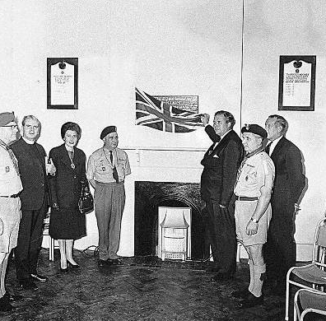  Left to right :  Sub Vic ? Mr Godfrey Phillips  Mr CJ Maples Skip Bob Moffat

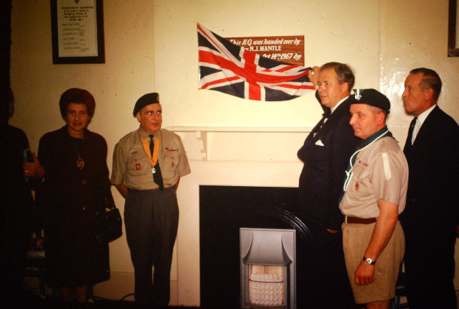  ? Mr Godfrey Phillips Mr CJ Maples Skip Bob Moffat | Incidentally the building is not now ‘lost’ to the general public as I know it is the intention of the Scouts it should play a part in the wider social and cultural life of the whole parish in a way it could not when it was a wreck. Visitors will be welcomed. Do go and have a look at it. If you knew it in the old days you will get a shock. It has undergone a transformation. | 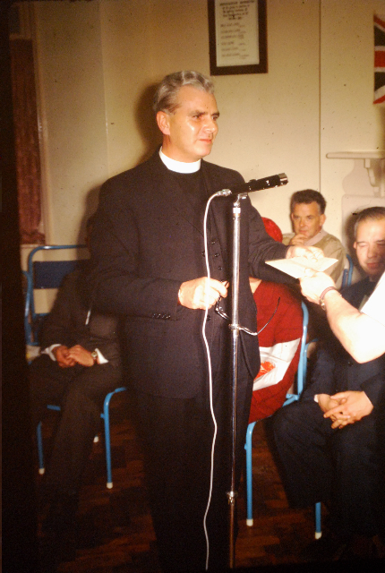  Vic takes the mike

And so ……

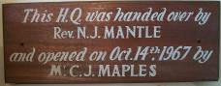

A very special  “Thank You” !  Miss Brankston is presented with a very special  ”Thank You” award.  Left to right :  Fred Ongley  Bill Muffet - ACC Senior Scouts  Miss Brankston - Cub Leader  Marjorie Maxwell - ADC Cubs  Sub Simpson - Senior Scout Leader  Bob Moffat  Skip Boxall - Group Scout Leader | 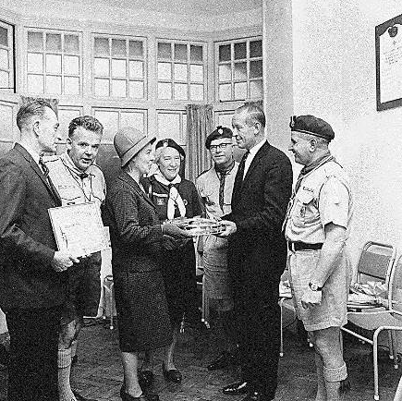

From St Paul’s Church, Rusthall, Parish Magazine October

We would like to take this opportunity of thanking Madeline Quarrinton for her help with the Cubs and wish her every success in the future.

Scout News - Ten of the Scouts are at present attending training evenings in preparation for their Pioneer Badge, the actual badge weekend is September 30th - October 1st, and we wish them every success in gaining this badge.

Seniors - Congratulations to Bryan Welch, Algis Cininas, Peter Richardson and Andrew Marks on gaining their Ambulance Badge.

Operation Challenge 1967. We are again entering a number of Seniors in this year's Challenge which is being held in the Tunbridge Wells area. We are acting as cooks to the judges.

Indoor Camp
11 & 12 November 1967

Eighteen Scouts took part in an indoor camp at the Scout HQ, Denny Bottom. The aim was to provide training and some fun and games. Activities included a traffic census, an incident course and a hike.

Scout Movement Milestones - 1967

May | The Boy Scouts Association renamed The Scout Association.
 | Equipment Department moves to Lancing, West Sussex.
31 July to 9 August | 12th World Jamboree, USA.
August | Changes in uniform.
October | Implementation of new training schemes for Cub Scouts, Scouts and Venture Scouts.
 | Duke of Edinburgh visits Baden-Powell House.

Click HERE if you have any further information regarding this year
or
HERE to return to our Navigation page


