Scouting in Rusthall
1973

“In Scouting you are combating the brooding of selfishness”

Lord Robert Baden-Powell
(1857 to 1941)
? | We are seeking :  - Further events that occurred this year.  - Copies of the St Paul’s Church Parish Magazine for this year (except February and April).  - Copies of the Kent & Sussex Courier for this year.  - Any knowledge that you may have of this year.

Can you help ? Please click HERE if you can.

The February 1973 Parish Magazine records our following leaders

 | Group Scout Leader | Mr NA Boxall, 37 Manor Road
 | Venture Scout Leaders | Mr CE Simpson, 25 Sunnyside Road
 |  | Mr R Bavin, Central Stores, Rusthall
 | Scout Leaders | Mr PG Tovey, 4 Mercers
 |  | Mr C Woodward, 64 Grange Road
 | Cub Scout Leaders | Mr JP Watson, Westwood Road
 |  | Mrs M Cunningham, 43 Westwood Road

A new District Commissioner

Will Hinton is appointed as District Commissioner.

Do you have any memories or photos of Will Hinton ? If so, please click HERE.

From St Paul’s Rusthall Parish Magazine
February 1973

Friday, 16 February - Scout Group AGM and presentation of Queens Scout award to Michael Marks, by Gen Sir Rob Lockhart, KCB. CIE. MC. in the Parish Hall.

Supporters’ Coffee Morning
April 1973

The Coffee Morning raises £40 for camp funds.

Scout Job Week
18 to 24 April 1973

Did you take part and have memories to share ? If so, please click HERE.

District Service Team Grand Prix

Rusthall Scouts are winners.

Do you have any knowledge of the Grand Prix ? If so, please click HERE.

A new Assistant Scout Leader
April 1973

Eddie Tasker is appointed Assistant Scout Leader.

Do you have any memories or photos of Eddie Tasker ? If so, please click HERE.

Supporters Association Sponsored Hike
13 May 1973

The Supporters Association sponsored hike was organised by Mr P Irwin,

The aim was to raise sufficient funds to ensure that every Scout had the opportunity of attending the forthcoming Summer Camp in Germany. The event raised £321.

Mrs Frances Smith of Holts Farm, Fordcombe provided lunch for the hikers.

Do you have any memories or photos of the Sponsored Hike ? If so, please click HERE.

Car Rally Treasure Hunt
30 June 1973

The car rally treasure hunt was organised by Geoff Standen of the Supporters Association.

Starting at 4.30pm, the rally ran for about 4 hours, finishing at the Mission Hall for a supper and social gathering.

Do you have any memories or photos of the Car Rally ? If so, please click HERE.

Further preparations for Summer Camp

As part of the preparations for camp, Mrs Terry, a resident of Rusthall, kindly provided some tuition in German language skills for all participants.

This undoubtedly made the boys feel more able to cope in a what for most would have been a new environment.

Summer Camp
Wiesbaden, Germany
2 to 16 August, 1973

On Thursday 2nd August 1973 the party of 36 (25 Scouts, 5 Venture Scouts & 6 Leaders) assembled in Rusthall for the start of the journey to Wiesbaden in Germany. After farewells from the Mayor, parents and friends we set off for Dover. From Dover we travelled by boat to Ostend and then by train to Mainz, passing through Belgium and into Germany via Aachen. We arrived at Mainz at 23:29 hours where we were met by our hosts - the Wiesbaden "Stamm" Seeadler Bund der Pfadfinder. From here we all went our different ways into Wiesbaden where we stayed in homes for three days. | 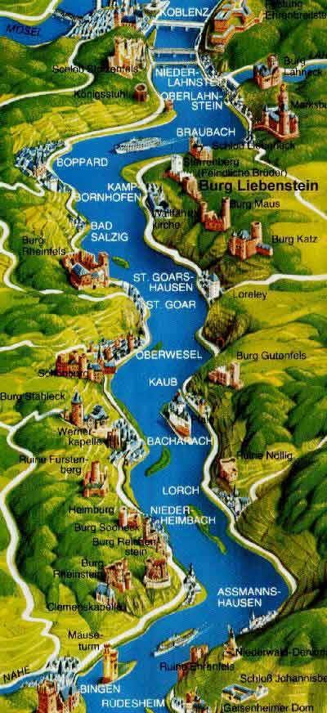
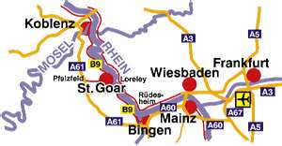

Our first day was spent sightseeing in Wiesbaden -we all assembled outside the Rathaus and then split up into small groups. We visited all the famous land-marks including the Kurhaus and its magnificent gardens, the Museum, some of the springs and the State buildings. The day finished on the bank of the Rhine.

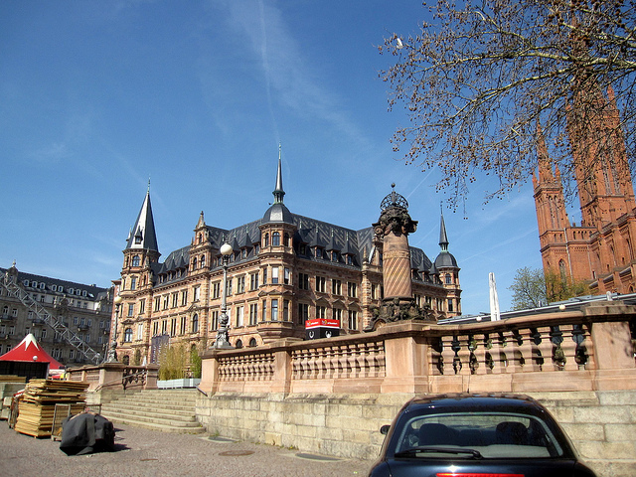  The Rathaus | 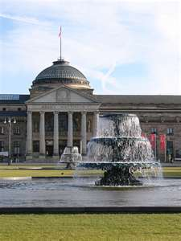  The Kurhaus | 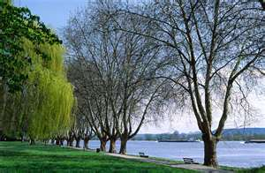  The Banks of the Rhine

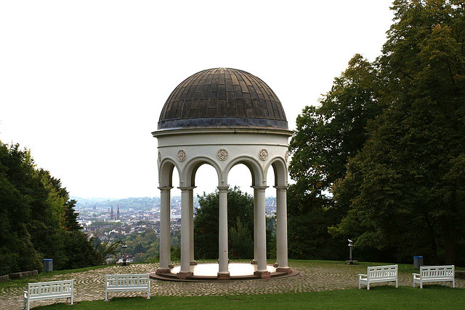  The Neroberg | Our second day of sight seeing took us to the more rural parts of Wiesbaden - after ascending the funicular we visited the Neroberg and the Greek Chapel with its splendid gold domes. | 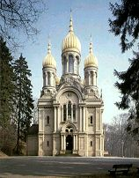  The Russian Orthodox Church  (also known as the Greek Chapel)
From here we went through the woods to a Zoo which contains most of the animals to be seen in Germany and from here we concluded our walk at the Scout Group’s Hut

In the evening we attended a Welcome Evening, this was one of the highlights of the Camp, which was organised by the Wiesbaden Rotary and Lions Clubs and the Wiesbaden/Tunbridge Wells Association. Our scouts came along with their hosts and throughout the evening a great feeling of friendship could be felt. It was during this evening that we realised how much the German Scouts like singing and playing guitars etc. both of which they do very well. The evening started with various greetings being read out from local organisations and then followed speeches from both sides. After an interlude for singing, gifts were exchanged between the two Groups and Towns. Our lads also had a chance to sing which they did very well. | 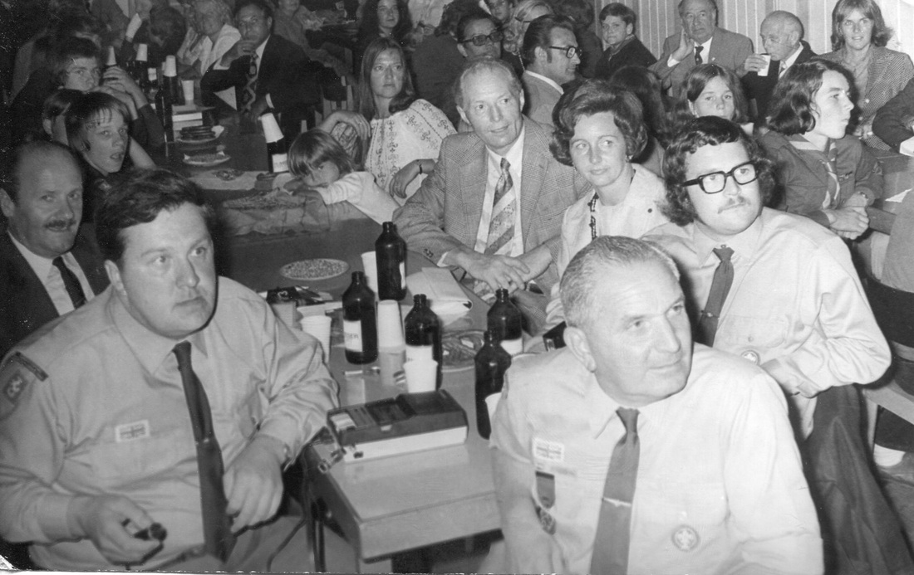  Our Welcome Evening
On Sunday 5th August we all made our way to Gross Gerau for the start of our camp together - in all there were 82 people in camp. The site is in a fairly wooded area about 45 mins. by road from Wiesbaden. The first two days were spent in pitching the camp - building gateways, kitchens, camp fire circle etc. In camp both Troops had 4 patrols and so one patrol from each Troop was put together to form a sub-camp - these two patrols then did everything together - cooking, eating, hiking etc. and on the whole this worked out fairly well and it also gave the lads a chance to get to know each other quicker. Throughout the camp we were very lucky with the weather we only had two wet days at the beginning of our visit

The third day in camp saw our first outing which was to Frankfurt - after an early rise we had flagbreak (this was held daily when the National flags and respective Scout flags were hoisted together (this was repeated at flag down in the evening) and set out on the 1hr. 20 minute walk to the station from where we travelled to Frankfurt. Unfortunately this was one of the days it rained, however we made the best of it and paid a visit to the Zoo where the animals looked even wetter than us.

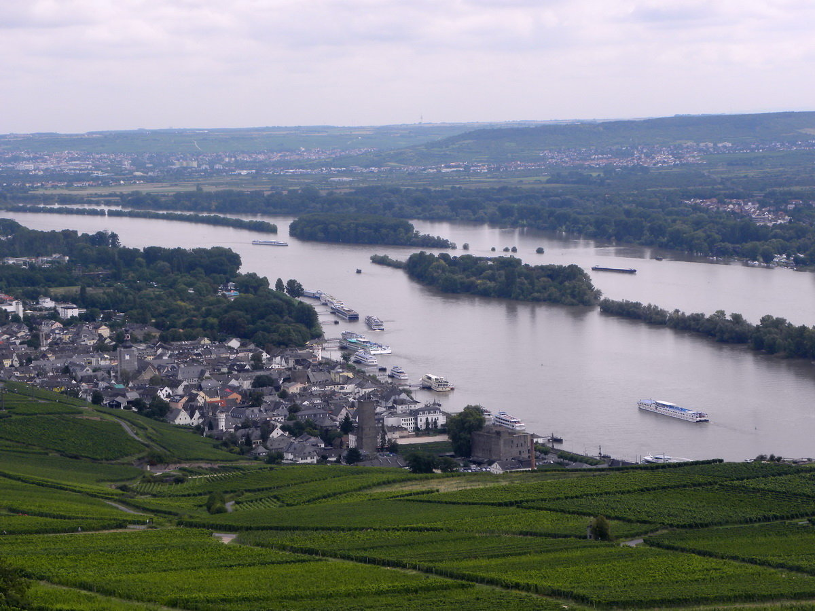  Rudesheim | The next day saw an even earlier start as we had to leave the site by 07.00 hrs. as we were to travel down the Rhine in Wiesbaden. From here we were taken as guests of the German Pioneer Corps up the Rhine to Rudesheim on two landing craft. Rudesheim is a very popular tourist spot as it is in the heart of the wine growing region - we spent about three hours looking around before returning to the boats and camp.  The next day was entitled "Recreation Day" i.e. quiet games etc. and

the programme was left to us to organise. So in the afternoon 'It's a Knockout’ took place between the two troops both of which seemed to enjoy the chance to throw water about. After playing six games the result was a win for our Panther Patrol.

On Friday we had our first hike - we were taken by bus to the top of the Taunus Mountains from where in small groups we hiked along a Roman Wall, through pine forests, to Saalzburg Castle which is a reconstructed Roman Castle. The Castle contained a museum which included some of the Roman articles discovered in that area.

The following day the camp site was opened to visitors and most of the parents came from Wiesbaden to see the camp. During the course of the afternoon a competition was held to build a hot air balloon and launch it. Some of them were very successful but others ended up in flames. A large camp fire was held in the evening.

On Sunday a Scouts Own was held on the site. This was taken by a visiting Scout Leader from the Christian Scout Association.

The main activity on the Monday was an Incident Course -the patrols had to visit various parts of the camp site and complete tasks e.g. mapping, first aid etc. for which they were given points - our Woodpecker Patrol gained first place. In the afternoon a visit was made to the local Swimming Pool one hour’s walk away !

The next day (Tuesday) saw our second hike. This time we were taken by bus to Jugenheim which is in the area of mountains known as the Obernwald. The hike was organised as Patrol hikes and each Patrol had to navigate itself around a pre-set route and undertake various tasks en route. The minimum distance covered was 13 miles and again the scenery was excellent. Points were awarded for the Hike and the Eagle and Woodpeckers gained first place with their German counterparts. | 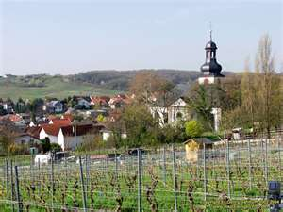  Jugenheim
Wednesday was our last day in camp, so it was mainly spent breaking camp and packing. However most of the lads did manage to get in another swim in the afternoon. At the last flag down we presented the Wiesbaden Scout Leader, Dietrich, with our National and Association flags as a token of friendship and to signify the strong link that we feel has grown between our two Troops. Later in the evening our final farewells were made at a small camp fire and this was concluded by everyone linking arms and singing Auld Lang Syne in English or German.

We left the camp site at 05.00 hrs. the next morning and returned home leaving behind us many new friends and bringing away the thoughts of a most memorable camp.

As with any camp the success depends on the efforts of all those involved in the organisation - this year was no exception and thanks are due to all those in the team of Scouters and Venture Scouts who worked hard to make the camp such a success.

Do you have any photos of the camp ? If so, please click HERE.

Group Treasurer stands down
October 1973

Ken Smith stands down as Group Treasurer after five years service.

Do you have any memories or photos of Ken Smith ? If so, please click HERE.

A  “Thank You”  Social  Parish Hall  3 November 1973  ….. a “Thank You” to the many parents and friends who help the Supporters’ Association in their fund raising efforts.  Do you attend or help organise the social ? If so, please click HERE. | 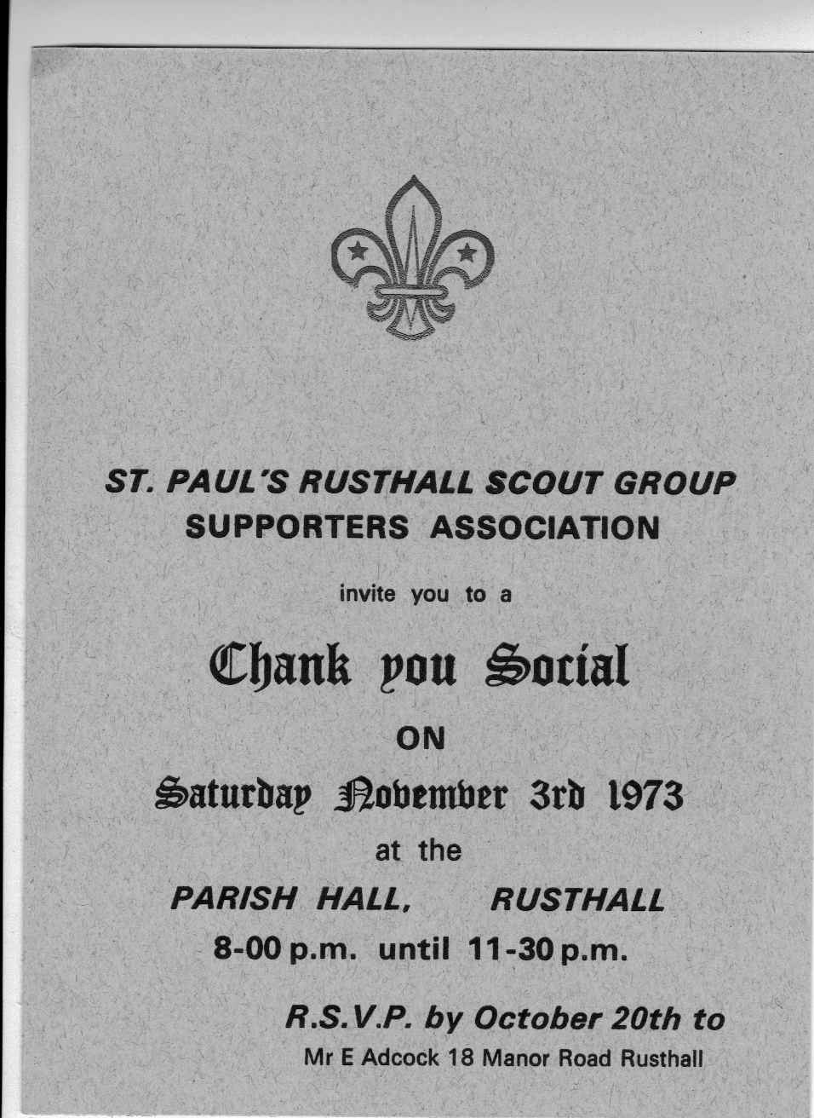

Ron Welch is awarded Honorary Life Membership
November 1973

Ron Welch is awarded Honorary Life Membership of the Supporters Association in recognition of his long service to the Group and the Association.

Do you have any memories or photos of Ron Welch ? If so, please click HERE.

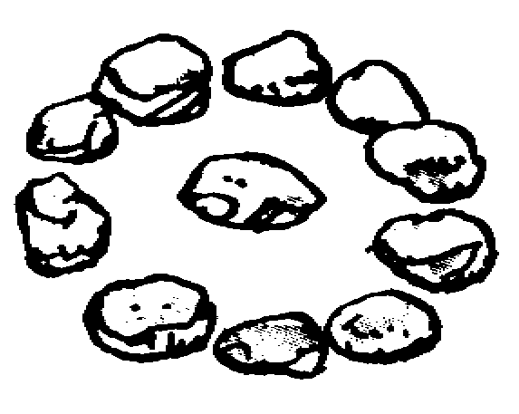 | Mr CJ Maples  December 1973  Of Rusthall House, Langton Road  First President, Long term supporter and benefactor of Rusthall Scout Group

Do you have any memories or photos of Mr Maples ? If so, please click HERE.

Scout Movement Milestones - 1973

September | More than 30 European Scout Public Relations Officers attended a Conference on Scouting's public relations, Baden-Powell House.

Click HERE if you have any further information regarding this year
or
HERE to return to our Navigation page


