Scouting in Rusthall
2013

“For those who have eyes to see and ears to hear, the forest is at once a laboratory, a club and a temple”

Lord Robert Baden-Powell
(1857 to 1941)

? | We are seeking :  - Further events that occurred this year.  - Copies of the St Paul’s Parish Church magazine for this year.  - Copies of the Kent & Sussex Courier for this year.  - Any knowledge that you may have of this year.

Can you help ? Please click HERE if you can.

Family Camp
Adamswell
Saturday 22 & Sunday 23 June 2013

Did you take part ? Do you have any memories or photos to swhare ?
If so, please let us know by clicking HERE.

Group Annual General Meeting
3.00pm, Sunday, 23 June 1913
Adamswell Scout Campsite

Researchers’ note – The AGM coincided with a Group Family Camp that was held on 22 & 23 June. In due course, we hope to include an account of the camp and the minutes of the AGM. For the present, the AGM agenda.  1. Welcome & Apologies  2. Minutes of last meeting (to be agreed by the meeting, signed and dated by the Chairman.  3. Matters Arising from minutes of previous AGM. | 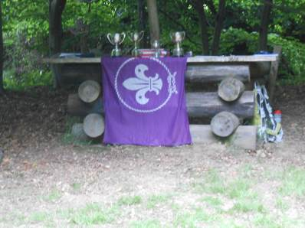  The Adamswell Altar
4. Approval of :
a. The Annual Report (in the Charities Act Format) as previously agreed by the Group
Executive Committee (The Trustees) and signed by the Chairman and Treasurer
on its behalf.
b. Annual Accounts.
5. Approval of the Group Scout Leader’s nomination of :
a. Chair.
b. Members of the Group Executive Committee.
6. Election of :
a. Group Secretary.
b. Group Treasurer.
7. Election of Parent Representatives – ideally two per section.
8. Approval of independent scrutineer (or examiner) for the coming year’s accounts.
9. Performances from Beavers and Cubs.
10. AOB :
a. Brian Hobden, District Commissioner.
b. Discussion on the provision of uniform for Leaders, Helpers and members of the
Executive.
c. Projects for 2013.
d. Presentation of Awards.
e. Investiture.
11. Performance from Scouts.

From a “fly on the Chapel wall”

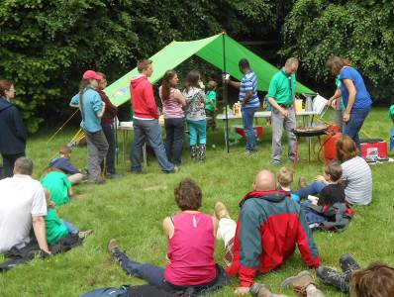  Pre- AGM burgers | The AGM was very appropriately held in the open-air Adamswell Chapel, thankfully on a fine afternoon. Those who attended found the entrance flanked with an inspiring display of photos of the past year’s activities. | 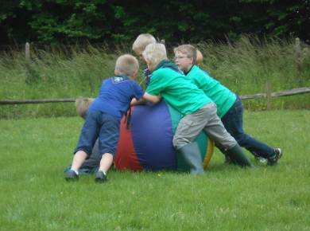  Pre-AGM games

The generous amount of bench seating in front of the log-built alter was soon filled, leaving standing room only for some.

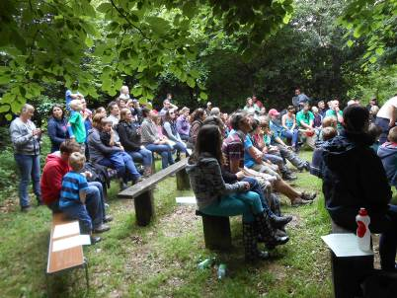 | 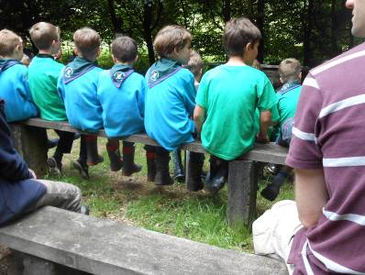  Standing room only for some | 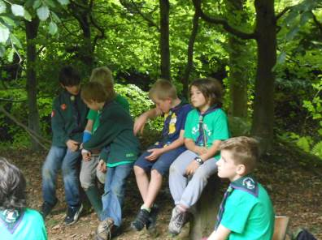
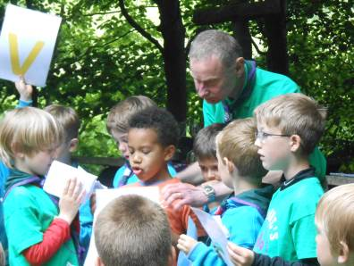  XXXX ? helps the Beavers | Mandatory business was kept to an absolute minimum, ensuring that there was ample time for “more important” matters – thanks to our Leaders, Helpers, parents and young people for making it such a successful year – presentations of very well-deserved awards – pleas for help and plans for the future. The entertainment performed by all three sections was second to none, certainly worthy of any camp fire or national Scout Gang Show.

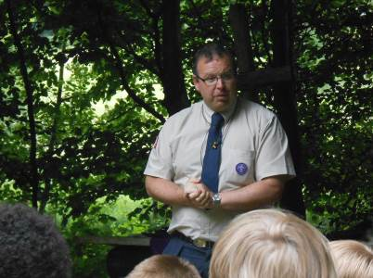  DC Brian Hobden speaks  …. | 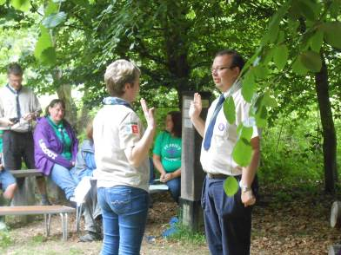  …. and invests XXXX as …. Leader ? | 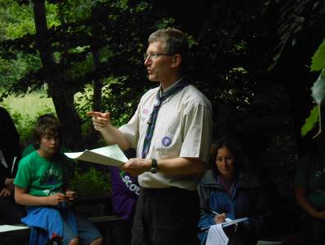  GSL Kevin Powley speaks and ….
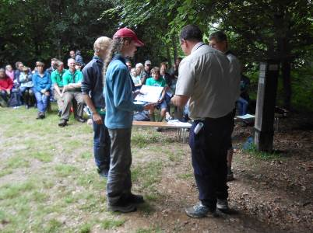  ….. with Brian Hobden, presents the XXXX to XXXX …. | 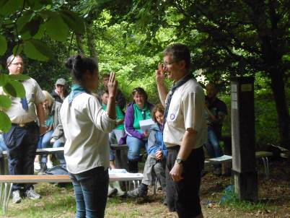  …. and XXXX to XXXX | 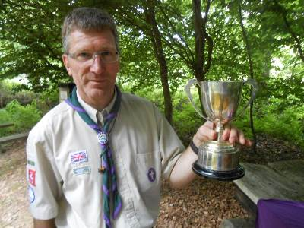  Kevin holds the XXXX Cup – which is to be presented to XXXX at a later date

Researchers’ note – It was a privilege for one of us to be present - to see the Beavers, Cubs, Scouts, Leaders, Helpers, parents and District Commissioner in such good spirits – clear evidence that the Group is thriving.

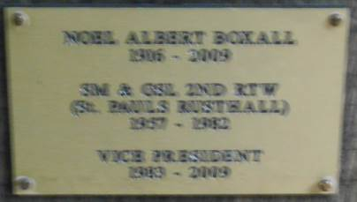 | At the end of the meeting, as all departed on a high, a moment for one to reflect. Beside the alter stands a stout, square oak pole, bearing brass plaques commemorating the lives of some old, loyal friends of our Group – Noel “Skip” Boxall and Harry Cook. | 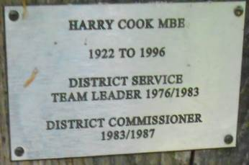

They are in the good company of some old District friends - Robert Smith, Richard “Dux” Gosling, Paris Anderson and Ralph Constable.

We had no idea that these plaques were here. There may be more to be discovered when we next visit.

Laurence Frederick Foster – RIP
4 May 1922 – 24 May 2013

 | Scout 1933 ? to ?  Troop Leader ? 1939 ?  Assistant Scout Master 1936 ? to 1939 ?  Scout Master ?  Exact dates to be confirmed | INSERT PHOTO OF  LAURIE FOSTER

Do you have any memories of Laurie ?
If so, please let us know by clicking HERE.

Researchers’ note – Until August 2013, all we knew of Laurie was that he had been a very active member of the Troop in the 1930s – that he, with Freddie Crundwell, had been an Assistant Scout Master under “Blondie” Hughes in the 1930s. Until then, our very limited knowledge had been reliant upon The Courier and the memories of Dennis Pink, one of his old Scouts.  But “out of the blue” we received a very welcome letter from his daughter, Mrs Jane Page – very welcome, but sadly bringing us news of Laurie’s death on 24 May. | 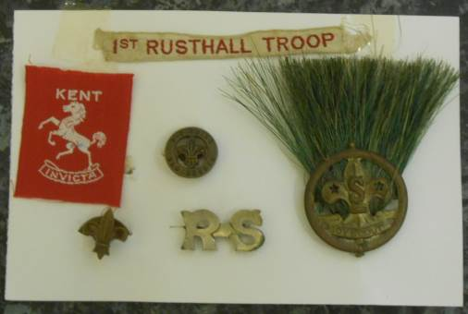

Since then, Jane has sent us her father’s treasured Scouting memorabilia, for safe-keeping in our archives – photos, books, badges, epaulettes, St Paul’s Parish magazines and a personal log book – the latter is undated, but extracts may be seen in our account of 1949.

Very fortunately, Mrs Page has been able to share with us some of her late father’s very full life.

Whilst serving in the Far East with the Commando Serving Unit, in 1944 he married Henrietta Joy Woolford of Rusthall. The couple lived at 13 Ashley Park Road. On his discharge, Laurie trained at the Home Office to be a probation Officer.

The couple moved to Derby in 1950, where a local Groop soon benefitted from his love for Scouting. In our archives we have a sincere letter of thanks from the 79/126 Derby (Centaurs) Scout Group. Dated 12 May 1954, the letter says :

“At a meeting of the Scout Group Committee held last night, I was asked to write to you to express our thanks and very warm appreciation of all that you have done for the Scouts whilst you have been in Derby.

“We all hope that you and family will be very happy in your new home, and that your memories od Derby will be happy.”



Laurie subsequently worked in Eastbourne, Gloucester and Bristol, retiring in 1982 as Chief Probation Officer, Training, South West Region. Following Mrs Foster’s death in 2004, he moved home from Bath to North Yorkshire, where he and his two daughters had many happy times.

Mrs Page recalls that, throughout their lives, her parents often shared happy memories of their Scouting and Guiding days in Rusthall – of the trek cart, High Rocks and Shadwell Woods – we wonder if Laurie was one of those who fought in the woods on Saturday 29 April 1939, an account of which is in our document of that year.

In time, images of Laurie’s treasured Scouting memorabilia may be seen in an Appendix that relates to memorabilia held in our archives.

Researchers’ note – Please let us know your memories of your old Scouting friends and Leaders – help us to record them in our history – for future generations.

Kent International Jamboree  Kent County Showground, Detling  27 July to 3 August 2013 | 

Around 6,500 Scouts and Guides from all over Kent, the United Kingdom and thirty countries from around the world descended on the Kent County Showground at Detling, near Maidstone between the 27th July and the 3rd August 2013 for a week of adventure, friends and fun. Amongst the participants was a contingent from Rusthall.

The event featured more than 100 activities, from climbing to curling, archery to microlight-flying and wood-turning to woggle workshops. There was an international café, a radio station, a cinema, an exhibition of Scouting history and dance and performance facilities.

Chief Scout Bear Grylls and comedian and former Scout David Walliams flew in by helicopter on the final day to spread a little inspiration to the gathering.

There were six sub-camps entitled: Empower, Inspire, Survive, Evolve, Resolve and Protect (the sub-camp of the Service Team). Rusthall joined the Empower sub-camp and were close neighbours to the contingent of Gloucestershire Guides.

The first day was rather wet and the opening ceremony due to start at 7 pm but was put back to 8 pm because of the poor weather forecast. The weather deteriorated and even though participants had congregated on Empower’s green, it was decided to postpone the ceremony until Sunday. On returning to camp the Gloucestershire Guides found that their tent was leaking. Fortunately, they had made friends with the Rusthall Scouts next door who came to the rescue by offering them the use of two of their smaller tents which they quickly erected thus ensuring that their neighbours had a dry night’s sleep after all. | 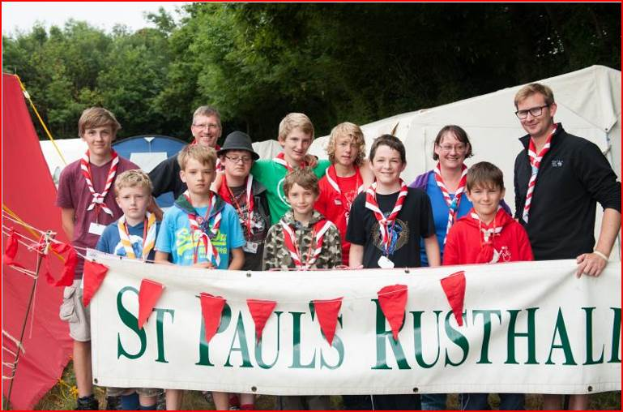  Can you put any names to the faces ?  If so, please let us know by clicking HERE.

Scout Movement Milestones - 2013

Milestones yet to be identified

Click HERE if you have any further information regarding this year
or
HERE to return to our Navigation page


